Funeral practices and animal sacrifices
in Mongolia at the Uigur period:
archaeological and ethno-historical study
of a kurgan in the Egyin Gol Yalley
(Baikal region)
E. Crubezy, H.Martin, R-H. Giscard, Z. Batsaikhan,
S. Erdenebaatar, J.P. Verdier & B. Maureille*
The nomadic peoples of central Eurasia are famous for their elaborate burial customs - both as those are known ethnohistorically and evident in the frozen tombs ofPazyryk. The Mongolian chambered grave reported here is of the 9th century AD. To that era the ethnohistorical record may have relevance in inferring its ceremony, alongside a considered knowledge in experimental spirit of just what must have taken place at the grave in order to create the certain pattern seen on excavation.

Funeral practices in central Eurasia
Our knowledge of funeral practices among the ancient peoples of central Eurasia comes mainly from written documents (Roux 1963), and also from archaeological findings (Gravilova 1965: Konovalo 1976), including the famous excavations of S.I. Rudenko and M.P. Griaznov (Rudenko 1970) at Pazyryk and those of B.M. Mozolevs'kij (1979) at Tblstaia Moguila. Recently, since excavations have recommenced in the Altai (Polosmak & Van Noten 1995), and as the frontiers of China and Mongolia have opened up, an increasing amount of archaeological evidence has become available.
One direction of research concerns the relationship between man and animal during the last millennia. Funeral practices had a privileged place within this relationship (Roux 1963) because of their collective and ceremonial nature, which found its highest expression in the funeral feast. During these feasts, animal sacrifices
often took place on an extensive scale. As late as the middle of the 19th century, Atkinson (1860), present at the funeral of a Kirghiz prince, witnessed the sacrifice of 100 horses and 1000 sheep. Similarly, at Pazyryk, S.I. Rudenko and M.P. Griaznov uncovered in the first kurgan the bodies of 10 horses killed by a thrust from a round, pointed dagger and deposited outside the funeral chamber. These sacrifices reached their greatest extent in the 'royal' kurgan of Arjan, dating from the 8th century BC, where the remains of more than 160 horses, in full harness, were discovered (Bokovenko 1994).
Apart from the actual sacrifices, the relationship between man and animal during these ceremonies could be complex, In the mid 18th century, Gmelin (1751-1752) drew attention to the union of the living and the dead during these feasts, where the horses were sometimes partly eaten and partly buried in the tomb. Any

* Crubezy & Maureille, Laboratoire d'Anthropologie, Universite de Bordeaux I, Avenue des Facultes, 33405 Talence Cedex, France. Martin, Groupe de Recherches en Prehistoire, Universite de Toulouse-Le Mirail, 3100 Toulouse, France. Giscard, Institut des Deserts, 76 rue d'Assas, 75006 Paris, France. Batsaikhan & Erdenebaatar, Institut d'Histoire de PAcademie des Sciences de Mongolie, Zhuliov Street 77, Ulan Bator 54, Mongolia. Verdier, Geometre-Expert, 91490 Milly-la-Foret, France.
Received 28 February 1996, accepted 8 May 1996, revised 10 September 1996. Antiquity 70 (1996): 891-9

892
CRUBEZY, MARTIN, GISCARD, BATSAIKHAN, ERDENEBAATAR, VERDIER & MAUREILLE
FUNERAL PRACTICES AND ANIMAL SACRIFICES IN MONGOLIA AT THE UIGUR PERIOD
893

Figure 1. Location of the Egyin Gol river and burial sites,
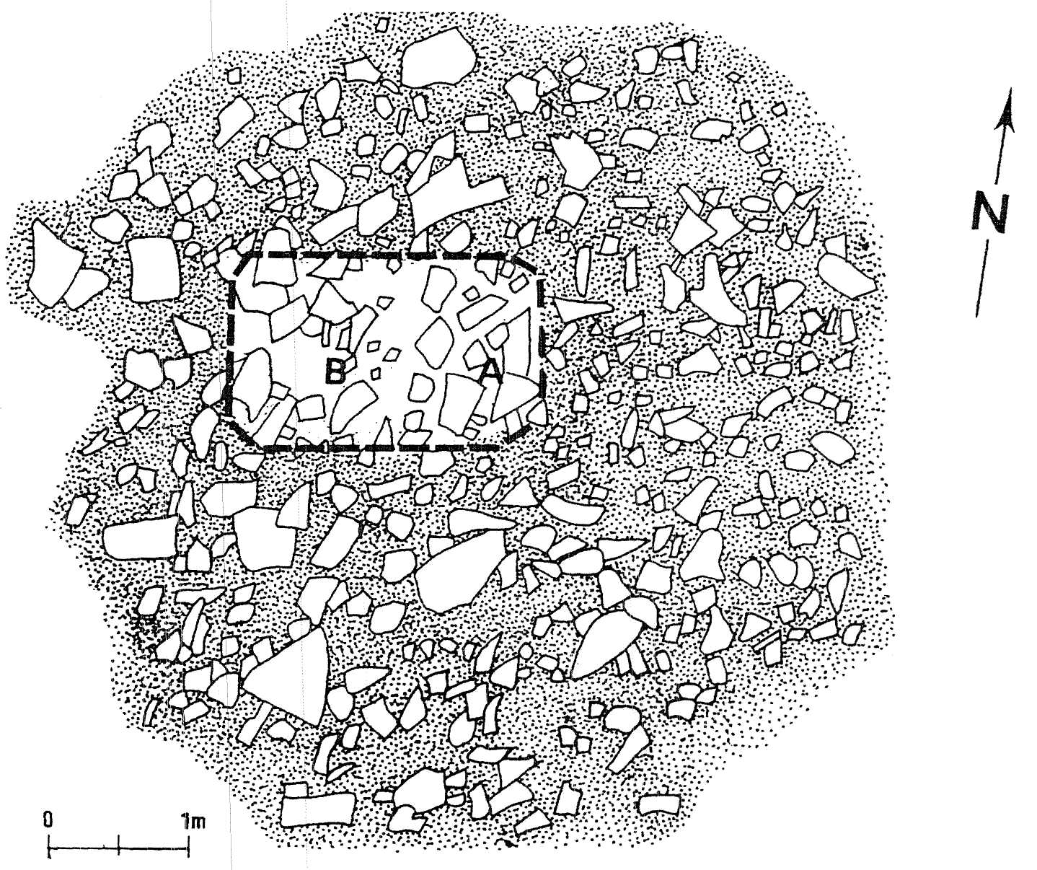
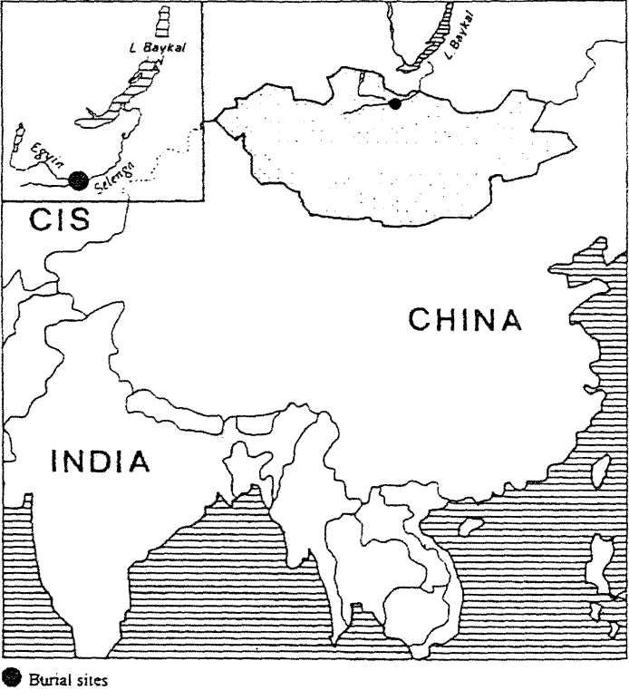
MONGOLIA
settlement remains of this period in Mongolia, with traces of buildings and houses.
On the sides of the valley where the kurgan lies, some tombs have been identified; one (EG IV-1) has been excavated. It was found to be much later, 700±45 b.p. (Ly-6859), equivalent to AD 1255-1388 (maximum probability 1292, 1370). Other tombs, of which some are probably earlier than the first and others later, have been identified on the surrounding hilltops.
The excavations were carried out in a dynamic perspective with the aim of reconstituting in detail the actions and practices that were performed during the burial. Particular care was taken in excavating the bones of humans and
attempt at detailed reconstruction of funeral practices (Roberts 1989; Duday et al. 1990) risks coming up against such elements, almost impossible to interpret in the absence of ethno-historical data. This is the point we develop here, taking for example a kurgan of the 9th century AD, excavated in the valley of Egyin Gol, Mongolia (FIGURE 1), by the first expedition (1994) of the France-UNESCO Permanent Archaeological Mission in Mongolia.
The site, archaeological and historical context
The present study is part of an international research project on the origins of the Mongol people, launched by UNESCO at the request of the Mongolian Academy of Sciences. Pros-pection and soundings were thus carried out in 1994 at various burial sites in the valley of the Egyin Gol river, an affluent of the Selenga, which flows into Lake Baikal (FIGURE 1). Excavations are now being carried out in the 20 km of the Egyin Gol valley upstream from its junction with the Selenga. The most important burial sites are composed of several graves to more than 50 kurgans and they range from to the Bronze Age until the period of Gengis Khan (13th century AD). However, there are some isolated kurgans, most of which seem to belong to
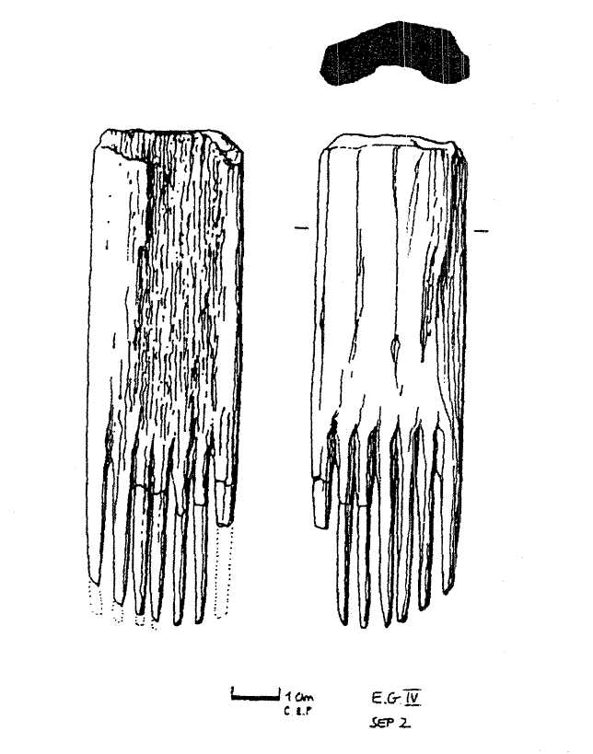
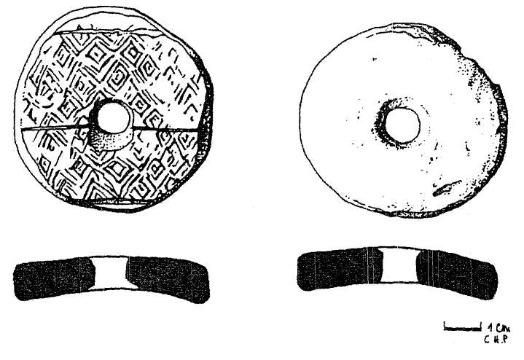
Figure 2. Associated grave goods of kurgan EG IV-2: earthenware spindle whorl, seven-toothed bone comb.
the Bronze Age period with the exception of the one discussed here (EG IV-2) which is, for the moment, unique in Mongolia.
EG IV-2 is isolated in the centre of a small dry valley, (49°31¹42"N, 103°19'47"E, altitude 920 m), at right-angles to the Egyin Gol river. It revealed a mongoloid woman of middle age, and rather robust build, whose height was probably around 160 cm (Maureille etal. 1994). Her skeleton was determined (Ly-6860) to 1185±45 b.p calibrated to between AD 731-964 (maximum probability AD 882, 830, 790). The grave goods were somewhat atypical (FIGURE 2), with

A: Post-Hole
B: Place of the Grave-Pit
Figure 3. Egyin Gol IV, Grave 2. The kurgan after removal of the top-soil.
the possible exception of an earthenware spindle whorl fashioned from a sherd of the bulge of a large vase. The designs on the whorl, incised before firing, suggest an Uigur origin, which does not contradict tt|e dating. Moreover, this kurgan dates from the troubled period when the Uigur empire was founded by a Turkic tribe (ad 744) and then fell (ad 840) after its capital, Qara-Balgasun in the upper Orhon valley (Mongolia), was taken by the Kirghiz, a Turkic horde from the upper Yenisei river (between Minusinsk and Lake Kossol Gol). The Uigur prospered among the nomadic people of central Eurasia, but they had developed handicrafts and metalwork and they were established as a statehood. There are

894
CRUBEZY, MARTIN, GISCARD, BATSAIKHAN, ERDENEBAATAR, VERDIER & MAUREILLE
FUNERAL PRACTICES AND ANIMAL SACRIFICES IN MONGOLIA AT THE UIGUR PERIOD
895

Figure 4. The upper part of the grave. Note the larger blocks at the top and centre. Several horse bones were found between them.
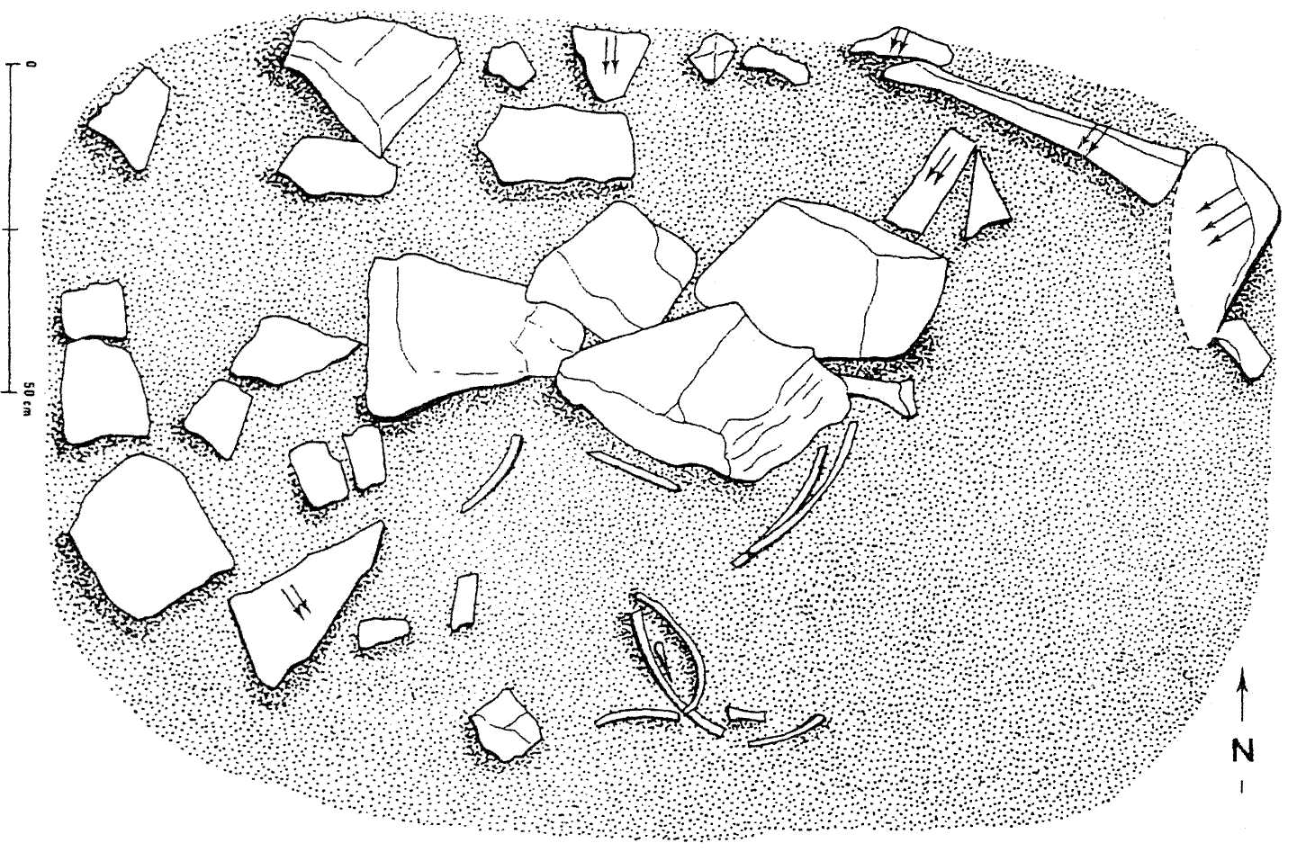
moval of the top-soil showed that a considerable part of the tumulus, which is roughly circular and built of mostly small stones (Figure 3), has been covered by about 10 cm of humus which can be attributed to erosion of the surrounding hillsides.
Several remains of the skull and mandible of a horse and two fragments of hyoid bone, including a fragment of the lingual process, were uncovered around a large stone set on edge, the only one at this level, approximately at the top of the kurgan. A slight depression at the foot of the stone suggested a post-hole. These bone fragments all appear to belong to the skull of a single horse aged about 3 years; in the mandible fragments D4, P3 and P4 have not erupted and Ml is present.
The periphery of this stone-built structure, composed of small and haphazardly placed blocks, rested directly on the soil which was about 20 cm deep. At the centre-west the structure covered a grave pit about 70 cm deep dug in the loess. The filling of this sub-rectangular grave was unusual:
animals (Roberts 1989; Duday et al. 1990). In the laboratory, we paid particular attention to the season at which inhumation had taken place by thin-section study of deposits of dental cement. This analysis was done on the left lower fourth deciduous tooth (the only one suitable for study) of the horse mandible found at the top of the kurgan. Cement deposits are known to be present on both decidual and permanent teeth (Grue & Jensen 1979). The slides were prepared and read according to the method of B. Gordon (1988) taken up by Pike Tay (1989). Of the three sections prepared, only one was clearly readable. The last cement deposit is an an-nulus (dark), indicating that death occurred during the cold season, although it is not possible to specify more precisely whether at the beginning, middle or end.
Archaeological evidence
The kurgan and its fill
The kurgan takes the shape of a mound in the centre of a valley, the tops of the uppermost stones visible in the grass of the steppe. Re-
• In the northeast corner was an enormous
vertical block of stone with the head of the buried individual at its foot.
• Above the buried individual, the filling was
made up of small stones embedded in scorched sediment containing numerous pieces of charcoal.
• In the upper part of the rest of the grave,
large blocks were found laid flat, in particular three much larger blocks (FIGURE 4) at the top and centre. Several horse bones were found between them, two fragments of the diaphysis and one fragment of the distal extremity of the left humerus, together with pieces of left and right radius and ulna bonesi
• To the south of this group were uncovered
several ribs, which can be attributed to an animal of the same species; five of them together with a vertebra were arranged in a bundle.
• The lower part of the grave was filled with
scorched sediment and blocks of stone mingled with horse and caprine bones. The horse bones were: a right scapula which could have originated from the young animal whose remains were found at the bottom of the grave; and two fragments of left and right scapulae which clearly originated from a different animal. The caprine bones were, notably, a tibia (visible line of epiphysio-diaphysial union), a left metatarsal and a left navicular-cuboid bone.
The contours and relief of the bottom of the grave were clearly visible on excavation. The grave was of sub-rectangular shape with rounded edges, the bottom scorched with many pieces of charcoal, some several cubic centimetres in size. The northern part had been dug several centimetres deeper, forming a roughly oval grave with a U-shaped bottom, in which the human skeleton was found. The southern part, also slightly deeper, contained the remains of a horse (Figure 5).
The human skeleton and its relationship with the associated grave goods Except for the thoracic and lumbar spine, the skeleton was relatively well preserved. It was lying on its back with the head to the east and the feet to the west. Traces of organic matter were found on the feniurs, their presence at-
tributable to the good conditions of preservation in a cold environment. Over a long period, the presence of the filling stones must have left gaps which made it easier for small animals to dig burrows (this was observed in other tombs excavated in the valley). The burrows and the passage of the small animals led to disturbances of the human skeleton — phalanges of the right foot were found over 1 m south of their original position, and phalanges of the left below the skeleton of the horse — and of the goods with the body, in particular the spindle whorls and bone objects with them (probably the axes of the whorls) which were found more than 5 cm above the right tibia.
The goods found with the body (FIGURE 2) consisted of a seven-toothed bone comb, two spindle whorls with a piece of bone (spindle axis?), and two very poorly preserved iron objects less than 10 cm long, suggesting tweezers or pieces of bent metal which could be used as clips. The right mastoid process was stained green by copper salts, and traces of red fibres were found on the proximal epiphysis of the left femur. The green stain would seem to originate from an earring which had been completely oxidized (the same phenomenon was seen in another tomb in the valley, in a similar state of preservation). The comb was found beneath the left scapula, its teeth towards the south; initially it must have been in the hair. One of the pieces of metal was below the right part of the skull, the other below the proximal third of the left femur.
In relation to the initial position of the body, the group formed by the head and the first two cervical vertebrae had slipped slightly forward in relation to the rest of the spine; when the soft parts decayed, the skull and the first two cervical vertebrae, whose attachments are known to be particularly resistant (Crabezy & Mazieres 1990; Duday et al. 1990), were drawn slightly forwards, downwards and to the left. Thus the body initially faced west, not towards the remains of the horse as was observed during excavation. Moreover, the very unusual positions of the scapula, the clavicles and the sub-connection of the right humerus are due to the narrowness of the grave at the level of the upper part of the body (Duday et al. 1990). However, the fact that the rib-cage was open and the right femur had slipped slightly to the side could be due to the presence of an empty space

^{v}"' 8SSKS158?

896
CRUBEZY, MARTIN, GISCARD, BATSAIKHAN, ERDENEBAATAR, VERDIER & MAUREILLE
FUNERAL PRACTICES AND ANIMAL SACRIFICES IN MONGOLIA AT THE UIGUR PERIOD
897

external to the body, which certainly also led to the fall of the left os coxae. Yet the disappearance alone of the buttock muscles and the fact that the soft parts of the body were not progressively filled by sediment during decomposition could account for this phenomenon. Other phenomena classically described when decomposition takes place in an empty space (Duday et al 1990; Crubezy et ah 1992), such
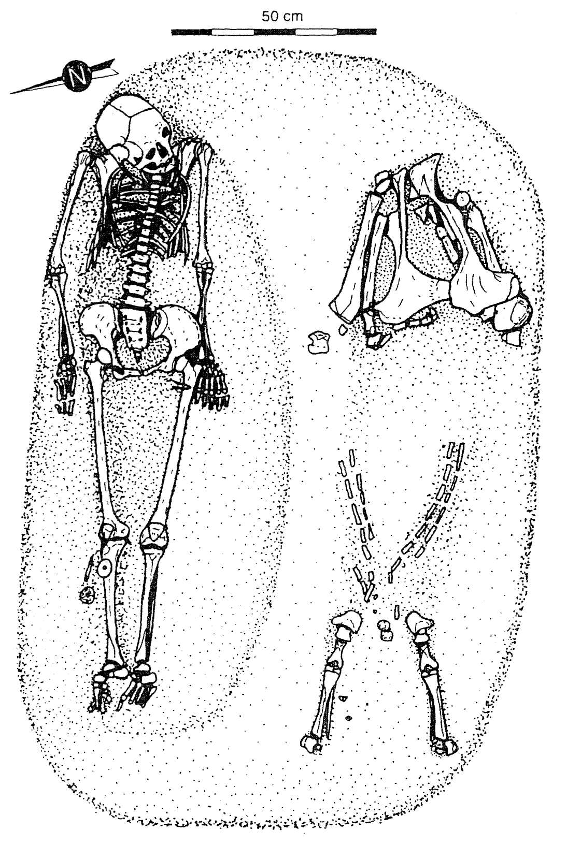
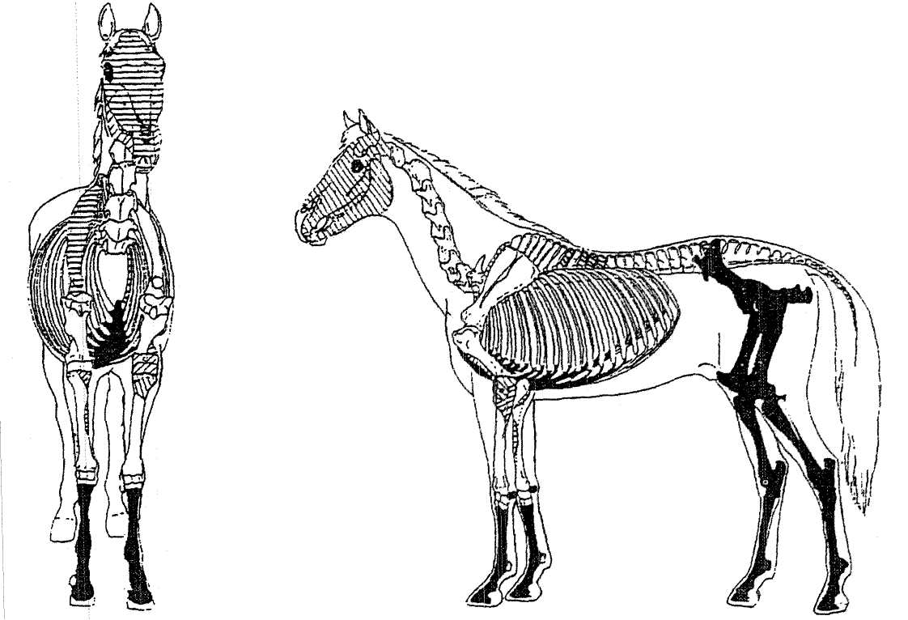
Figure 5. 77ie bottom of the grave with the human skeleton and the remains of a horse.
as disarticulation of the pelvic girdle and fall of the patella, were not observed. This is not necessarily due to the absence of an empty space around the body; all these bones were found wedged against the walls of the grave during decomposition. From the general position of the body, the shape of the grave and the absence of wood (found in chronologically earlier or later tombs in the valley where
Figure 6. Horse remains.
Black: at the bottom of the grave.
Hachured: skull fragments found at the surface and some of the bones found in the upper part of the grave and which could belong to the same animal.
inhumations had been carried out in a similar geological context), we can assume there was no coffin. The remains of fibres suggest the existence of clothing, and the position of the two pieces of iron could favour the existence of a shroud; the second hypothesis does not exclude the first.
Description of the animal remains None of the animal bones show signs of defleshing, disarticulation or burning. However, cutting could have been done with sharp instruments which have not left a mark on the bones, or they may have been boiled, as is still done in Central Asia.
The horse remains (FIGURE 6), can be attributed to three body-parts: ⁸ the hind-quarters, complete and in articulation which appear to be in the position of an animal lying down with its legs folded beneath it. Some bones are loosely connected; with the exception of the patella, displacement of bones occurred within the space occupied by the body, and cannot indicate that the hindquarters were laid in an empty space;
• ossified rib cartilages, in a correct anatomi-
cal relationship, with some bones connected with the lower sternebrae;
• two incomplete forelegs, cannon bones and
phalanges in articulation, with the posterior aspect uppermost and whose sym-
metrical position in the grave suggests, here again, an animal lying down with its legs folded beneath it.
These three groups appear to belong to the same animal which, from the signs of immaturity in the hindquarters, was probably 3 or 4 years old (ossification of rib cartilage, generally seen in older animals, has been observed in animals of this age). The same age is attributed to the skull fragments found at the surface, and could correspond to some of the bones found (Figure 6) in the upper part of the grave (right scapula, parts of a left humerus, parts of radius and ulna). It is definitely excludes the fragments of an other scapula found in the filling.
The first and third body-parts suggest an animal lying down with its legs folded beneath it, with the second body-part corresponding to the ventral part of the skeleton. This gives rise to two possible hypotheses:
• a horse was sacrificed, its hindquarters, rib
cartilages and the lower parts of both forelegs were placed in the tomb in anatomical order;
• a horse was sacrificed in the tomb and dis-
membered in such a way that the parts found remained at the bottom of the tomb. The caprine remains belong to three connected groups. They were not exactly at the bottom of the tomb; from their position, they appear to have been the first elements placed in the filling:

&£^^

898
CRUBEZY, MARTIN, GISCARD, BATSAIKHAN, ERDENEBAATAR, VERDIER & MAUREILLE
FUNERAL PRACTICES AND ANIMAL SACRIFICES IN MONGOLIA AT THE UIGUR PERIOD
899

• Two caprine lumbar vertebrae in articula-
tion were found directly touching the anterior part of the human skull.
• A hip-bone and a right femur from an ani-
mal aged less than two years (indicated by unfused epiphyses), found between the human skeleton and the horse hindquarters, were resting on the raised part separating, at the bottom of the grave, the woman and the horse. The right patella of the horse was resting on these bones; it reached this position only after becoming detached from the femoral condyle.
• A right caprine tibia, with unfused epiphyses,
was found vertically above the left foreleg of the horse.
Interpretation
From the above observations, it appears that
the monument was set up in the following stages:
- choice of site;
- digging of the grave;
- deposit of the human body and of the horse
(see above);
- deposit of the caprine remains;
- refilling of the grave with blocks from the
thalweg about 30 m away and with scorched sediment; at this stage, animal fragments were thrown in or deposited; the blocks directly above the human body are smaller than those above the horse;
• building of the tumulus which covers the
grave and which is slightly off-centre in relation to it;
• at the summit of the tumulus, the horse's
head was placed on a post.
Discussion : the contribution of ethno-historical data
In the present case, study on site and in the laboratory made it possible to determine the order in which actions and rites had been carried out at the funeral and the season at which burial had taken place. Such details were rarely noted by travellers in the last century, and no direct report from the 9th century AD is available. Some travellers' descriptions of Altaic customs and certain contemporary observations give us an understanding of elements we have described. Thus, the particular site of this kurgan is not surprising, as the texts tell us that the ideal site was both hilly and near a river (Roux 1963; 154). The use of a shroud during burial
is also known, in particular among the Turks in ancient times, and also in Mongolia, some distance from Egyin Gol, where a famous inscription from the region of the river Orkhon proclaims, 'he brought the funeral shroud and sewed it' (Roux 1963:148). The same is true of the horse's head placed on a stake after sacrifice, a habit well documented in the 18th century (Pallas 1783). Among the Hiong-nu a horse's head was hung, together with the head of a sacrificed sheep, above the inscription placed near the tomb (Julien 1877; Roux 1963).
It is in interpretation of the scorched sediment and the animal deposits that the evidence of ethno-historical data or present-day ethnological data become of capital importance.
Scorched sediment was found throughout the filling of the grave pit, and the grave bottom showed signs of burning. This may suggest a funeral feast, an event mentioned in various texts. We would have to imagine embers thrown into the tomb, or several successive fires lit in it. Present-day observations in the valley have shown us that because of the freezing temperatures (minus 20°C for several weeks is not exceptional), in order to dig a grave for a winter burial a fire must be lit on the chosen site to thaw the ground; car or lorry tyres are now used for this purpose. In the present case, as we have demonstrated that the horse had been killed during the winter season, the scorched sediment may bear witness only to the digging of the grave — a more satisfactory explanation than a funeral feast to account for scorched sediment throughout the filling.
Regarding the deposit of the horse, the three groups of bones found in anatomical position had not been treated in the same way as the others we unearthed, which had been thrown in or deposited when the tomb was filled. Their juxtaposition suggests an animal lying down, and partially dismembered, hindquarters and breast in articulation. The third group, consisting of the lower parts of the two forelegs, suggests the animal was flayed (Piggott 1962). In flaying, the hide is generally not removed below the cannon bone as skinning is difficult. Dissection at the junction of the ribs and the costal cartilages is traditional in butchery, as one of us has observed with calves in southwest France. Reconstitution at the bottom of a grave of part of a previously dismembered horse has
never been noted by travellers nor by ethnologists (Roux 1963), but the flaying of horses was a traditional practice during burials among Altaic peoples (Roux 1963: 173), as was disembowelling, etc. In the same way, the Dominican Ricold de Monte Croce, at the end of the 13th century, had described how in Mongolia the horses were flayed, stuffed and finally impaled on spikes around the grave (Schiltz 1994). Our observations support the last description, especially the skinning and maybe the stuffing, but here with the horse then deposited into the grave.
References
Atkinson, T.W. 1858. Oriental and western Siberia and Chi
nese Tartary. London. ; i
1860. Travels in the region of upper and lower Amoor. London.
Bokovenko, N.A.1994. Le Kourgane 'Royal' d'Arjan et son temps, Les Dossiers d'Archeologie 194 : 30-37.
Crubezy, E., H. Duday & T. Janin. 1992. L'Anthropologie de terrain: le particularism^ Egyptien, Archeo-Nil 2: 21-36.
Crubezy, E. & G. Maziere. 1990. L'Hypoge II du Mont-Aime* a Val-Des-Marais (Marne) : premiers resultats, Societe Archeologique Champenoise 83 (2): 65-78.
Duday, H., E. Crubezy, P. Courtaud, P. Sellier & A.M. Tillier. 1990. L'Anthropologie 'de terrain': reconnaissance et interpretation des gestesfuneraires, Bulletins et Memoires de la Societe d'Anthropplogie de Paris 2 (3-4) : 29—50.
Gmelin, J.G. 1751-1752. Reise durch Sibirien von dem Jahre 1733 bis 1743. Gottingen.
Gordon, B. 1988. Of men and reindeer herds in French Mag-dalerdan prehistory. Oxford: British Archaeological Reports. International series 390.
Gavrilova, A.A. 1965. Mogil'riik Kudyrge kak istoenik po istorii altajskikh piemen. East' vtoraja: Periodizacija pozdnekoeevnieeskikh mogil Altaja. Glava 5 : Tipymogil. Moscow-Leningrad: Na<ika.
Grue, H.& B. Jensen. 1979. Review of the formation of incremental lines in the tooth cementun of terrestrial mammals, Danish Review of Game Biology 11 (3): 3-48.
Julien, S. 1877. Documents historiques surles Tou-kioue (Turcs), traduits du Chinois. Paris.
The absence of the trunk bones of this horse and the presence of bones from another horse in the filling are more difficult to interpret. Atkinson (1858) stressed that we should not confuse the sacrifices of horses at the time of death with those carried out at the funeral or at the funeral feast. It is probable that here these various elements are intermingled: part of the horse sacrificed may have been eaten; other animals, including a horse, may have been sacrificed during the funeral feast and part of their remains buried.
KONOVALOV, N.B. 1976. Khuny VZabayikale. Ulan-Ude: Aka-demia nauk SSSR, Sibirskoe Otoelenie, Buriatskue Knijnoe izdatelstvo.
Maureille, B., E. Crubezy, F. Houet, P-H. Giscard, Z. Batsaikhan ,S. Erdenebaatar & J.P. Verdier. 1994. Contribution a 1'etude du peuplement de la region peri-Baikal: etude anthropologique des restes humains mis au jour a Egyn Gol (Mongolie) en 1994, Anthropologie 32(3): 251-67,
MOZOLEVS'KIJ, B..M. 1979. Tovsta Mogila. Kiev.
Pallas, M.P. 1783-1793. Voyages en differentes provinces de 1'Empire de Russie et dans 1'Asie septentrionale. Paris.
PIGGOTT, S. 1962. Heads and hoofs, Antiquity 36: 110-18.
Pike Tay, A. 1989. Red deer hunting in the Upper Paleolithic of Southwest France: a seasonality study. Unpublished Ph.D dissertation, New York University.
POLOSMAK, N. & F. Van NOTEN. 1995. Les scythes de 1'Altai, La Recherche 26: 524-30.
Roberts, C.A. 1989. Burial archaeology: the holistic approach, in C.A. Roberts et al. (ed.), Burial archaeology, current research, methods and developments: 1-4. Oxford: British Archaeological Reports. British series 211.
Roux, J-P. 1963. La mart chez les peuples alta'iques anciens et medievaux. Paris: Librairie d'Amerique et d'Orient Adrien-Maisonneuve.
Rudenko, S.1.1970. Frozen tombs of Siberia: the Pazyryk burials of Iron-Age horsemen. London: Dent
SCHILTZ, V. 1994. Les Scythes et les nomades des steppes. Paris: Gallimard.

^?^{l}0W?5^'?^^

