Chapter 4
THE BALKANS AND THE DANUBE LIMES DURING THE SIXTH AND SEVENTH
CENTURIES
No discussion of the early Slavs can avoid the very controversial issue of their role in the transformation of the Roman world that led to the "fall of the old order" and the rise of the new Empire, which historians call Byzantium.¹ The withdrawal of the Roman administration and armies from the Balkans in the early seventh century is viewed by many as a result of the Slavic Landnahme. More often than not, accounts of the early Slavic history focus on the destruction brought by the invading hordes to the flourishing cities of the Balkans. The classical urban culture was unable to survive the strain of the barbarian invasions. As with the Germans in the West, the Slavic "obscure progression" led to the slow dissolution of the Roman frontier and the Empire finally succumbed to the growth of forces beyond its control.
The existing evidence, written or archaeological, does not confirm this over-simplified picture. Long before the first Slavic raid attested by historical sources, the urban landscape in the Balkans began to change. It is clear, however, that some change was also taking place in the Balkans at the time of Slavic and Avar raids. The remaining question is whether or not the Slavs can be made responsible. Emphasizing almost exclusively the Roman side of the story, historians also neglected the equally important question of the Roman influence on the "invading" barbarians. The archaeological evidence of late fourth- and early fifth-century barbarian graves between the Rhine and the Loire suggests that a process of small-scale cultural and demographic change took place on both sides of the Roman frontier.² Can we envisage Roman—Slavic relations in a similar way? This chapter will focus on issues of urban change, with the purpose of showing that the Roman world, as Slavic warriors saw it in the 500s, was very different from the classical civilization many historians have in mind when describing their inroads. Using primarily archaeological evi-
Whittow 1996:69-95.
See Young 1992.
The Balkans and the Danube limes
dence, I will focus on internal mechanisms of change. I will argue that Justinian's building program drastically altered both the network of settlements in the Balkans and the relations with barbarians, specifically with the Slavs. The idea that the implementation of the fortified frontier in the mid-5oos had a profound effect on the making of the Slavs will be further developed in the last chapter.
URBAN CHANGE IN THE BALKANS
More often than not, modern studies of Late Antique cities narrowly focus upon textual evidence of public institutional change within civic urban communities, ignoring the archaeological evidence. On the other hand, archaeologists inspired by the culture-historical approach strive to link archaeological phenomena with historical narratives, with particular barbarian raids or earthquakes, and ignore the historical implication of their research.³ Proponents of both approaches attempt to answer the controversial issue of what happened to the ancient city, the polis, during the fourth to sixth centuries.
Procopius seems to have been aware of a hierarchy of settlements in the Balkans.⁴ In his Buildings, he carefully distinguished between three major categories: large cities, called πόλεις (such as Diocletianopolis in Thessaly and Euroia in Epirus), and new foundations such as Justiniana Prima; cities ranked lower, presumably because of their size, and called ττολίχνια, such as Photike and Phoinike in Epirus Vetus; and fortified sites in the countryside, such as the forts along the Danube, or the refugia-type settlements in Thessaly, all known as φρούρια. A comparison between Procopius and the archaeological evidence yields no clear parallels. The city described by Procopius as Justiniana Prima has been tentatively located at Caricin Grad. The identification is most likely correct, but the entire area of the site at Caricin Grad is no larger than 4.55 ha, slightly smaller than the size of Nicopolis (5.74 ha), which Procopius calls a φρουριον (Table 5). Diana, a πολίχνιον, is even smaller (1.87 ha), while Novae, a φρουριον, covers about 32.5 ha. The only observable pattern is that settlements which Procopius lists as φρούρια tend to be rather small, between one and three hectares.
Another relevant body of evidence is that of the contemporary legislation. The urban administration during the sixth century was gradually shifting from decurions, a social group on the verge of disappearing, to a clique of local notables headed by the local bishop. Emperor Anastasius granted to the committee of local landowners, chaired by the bishop, the
³ Dunn 1994:72—3. ⁴ See Dagron 1984:7—8.

120
121

Table 5 Sixth- to seventh-century sources and Balkan settlements

Name | Procopius | Menander | Theophylact Simocatta | Area | Churches | Other
Tropaeum
Traiani |  |  | ττόλις (ι 8.10) | с 12.5 ha | 4 | HP
Troesmis | φρούριον |  |  | с 2 ha | 3
 | (Buildings iv 11.20)
Noviodunum | φρούριον |  |  |  | 1
 | (Buildings iv 11.20)
Ulmetum | όχύρωμα |  |  | с 2.1 ha | I?
 | (Buildings iv 7.17)
Novae | φρούριον |  | πόλισμα | с 32.5 ha | 2 | HP?
 | (Buildings iv 11.20) |  | (vii 2.19) |  |  | ER
Iatrus | φρούριον |  | ttoAis | с 2.8 ha | I | W
 | (Buildings iv 7.6) |  | (vii 2.16; vii 13.9)
Nicopolis | φρούριον |  |  | 5.74 ha | 2 | w?
 | (Buildings iv 11.20) |  | (vii 13.8)
Abritus | φρούριον |  |  | с 14.9 ha | 2 | w?
 | (Buildings iv 11.20)
Diocletianopolis | — | — | ττόλι$ | с 30 ha | I | HP
 |  |  | (и 17.1)
Philippopolis |  |  | πόλισμα | с 8i.6 ha | I
 | (Wars Vin.21.21; |  | (II 17-2)
 | Buildings 1 v.i 1.19)
Iustiniana
Prima | πόλις |  |  | 4-55 ha | 8 | HP
 | (Buildings iv 1.20) |  |  |  |  | ER
 |  |  |  |  |  | W,T

Serdica | πολι$
 | (Wars.vii.40.1; Buildings iv 4.3) |  |  |  | ■"4
Sucidava | φρούριον | — |  | с. 2.1 ha | 1 —
 | (Buildings iv 11.20)
Ratiaria | πόλις |  | πόλις
 | (Buildings iv 6.24) |  | (ι 8.10)
Castra
Martis | χωρίον
 | (Buildings iv 6.34) |  |  | 1.25 ha
Diana | ττολίχνιον
 | (Buildings iv 6.6) |  |  | 1.87 ha
Novae | όχύρωμα
 | (Buildings iv 6.1) |  |  | 1.8 ha | Τ
Smorna | φρούριον
 | (Buildings iv 6.5) |  |  | 0.2 ha | у
Campsa | φρούριον |  |  | 0.1 ha
 | (Buildings iv 6.5)
Taliata | φρούριον |  |  | 1.8 ha | у
 | (Buildings iv 6.5)
Sirmium | ττόλις | TroXis | ττόλισμα, άστυ |  | — w?
 | (Wars vii 33-8) | (flM2, 5.24; 12, 6.24;
 |  | 12, 7.3; 25, 1.11, etc.)
Notes: HP — house with peristyled courtyard; W — workshop; ER — episcopal residence; Τ - thermae (bath)
The making of the Slavs
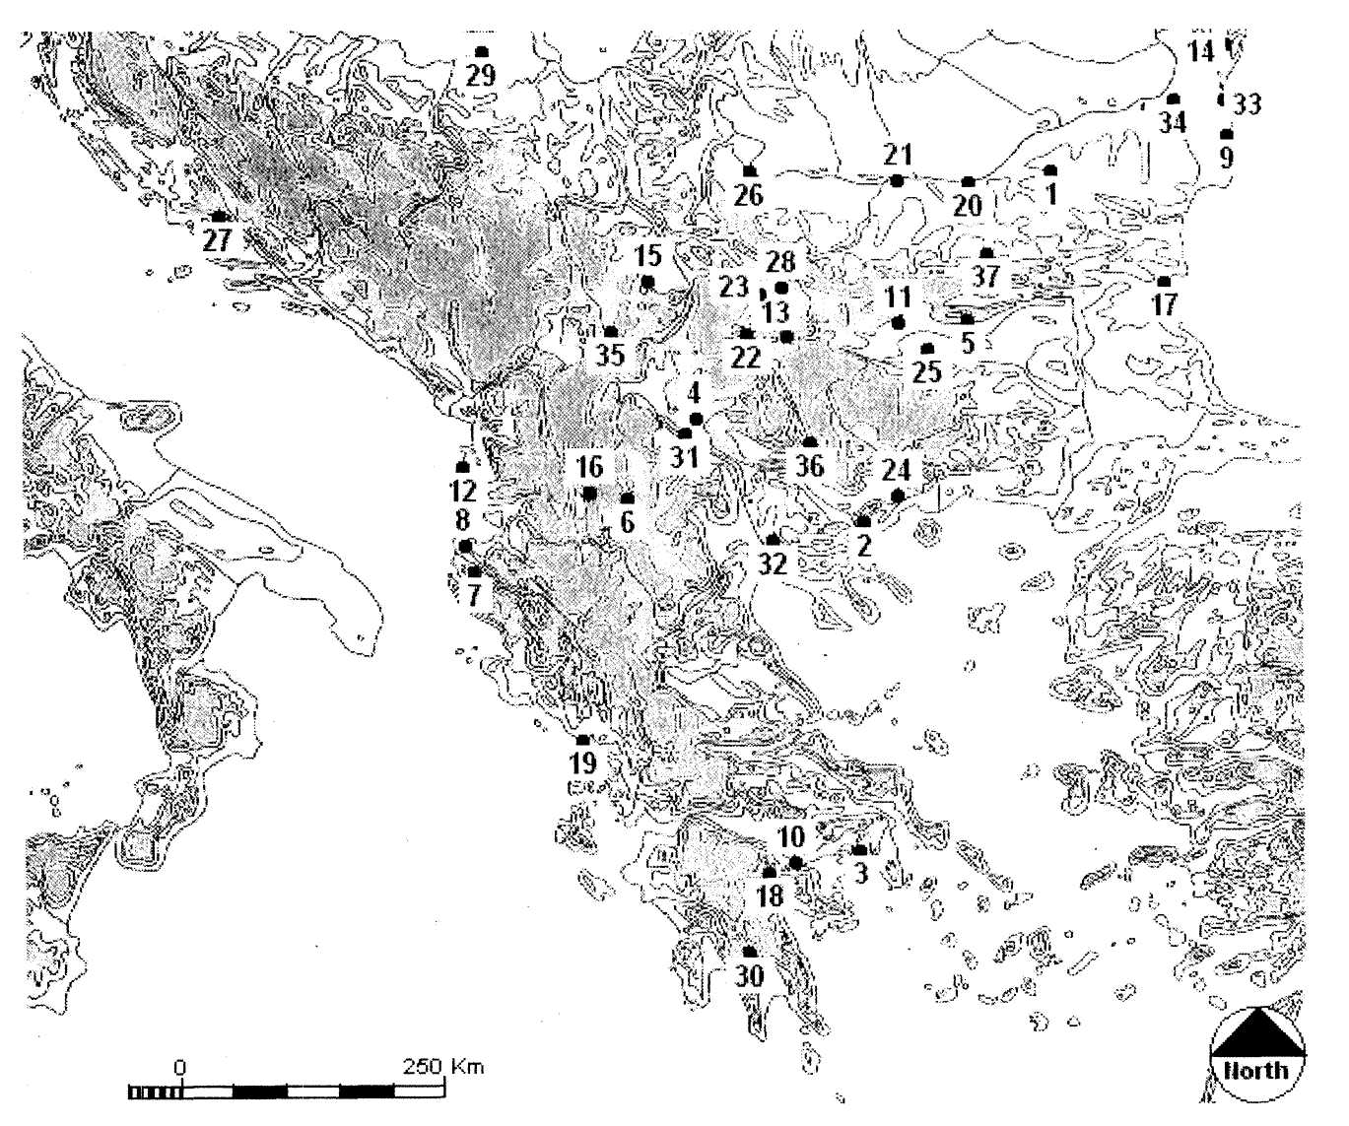
The Balkans and the Danube limes
task of procuring grain for the city. The process continued under Emperor Justinian. Novel 8, of 535, prevented provincial governors from appointing their representatives in cities, while novel 65 of 538 concerning cities in Moesia allowed local committees of notables headed by bishops to replace the curiales in the urban administration. Novel 128 of 545 gave the filial blow to the city councils by granting bishops, together with committees of notables, the right to assume the fiscal responsibilities of the decu-rions. The most important consequence of this series of decrees issued in a relatively short period of time is that they gave bishops considerable powers and enabled them not only to organize the civilian life of the cities, but also to take even larger responsibilities in the organization of the defense of both the city and the surrounding countryside. It is therefore no surprise that provinces as administrative units tend to be replaced by important ecclesiastical centers with their surrounding forts and πολίχνια. There is no Dacia Mediterranea and no Dacia Ripensis in Procopius' Buildings. Both provinces have been replaced by regions centered on important cities, such as Serdica, Pautalia, Naissus, Remesiana, and Aquis.⁵
cities: the archaeological evidence (figure i)
Sixth-century cities on the Black Sea coast display signs of prosperity and economic activity. The presence of merchants from the East is attested by inscriptions found at To mis and Callatis. This economic activity seems to have caused the growth of a middle class of craftsmen and merchants, who undertook most of the traditional tasks of the decurions. An inscription found in the wall at Tomis attests that munera on behalf of the city were carried out in the 500s by collegia: the pedatura of the city wall was erected by the city's butchers. Scythia Minor, on the other hand, was a highly militarized province. The social group most frequently referred to in fourth- to sixth-century inscriptions is the military, while great landowners seem to have been completely absent. The active economic life in coastal cities provided the means for remarkably wealthy individuals. At Histria, excavations carried since 1949 revealed a building boom and a prosperous city. Near the city's western wall a bazaar (tabernae) was erected in the middle of what Romanian archaeologists called the "Commercial Sector." This area has three building phases, the second of which is dated to the second third of the sixth century. Besides two large
³ Maksmiovic 1984:156—7; Dagron 1984:10. Anastasius' legislation: Codex Iustinianus ι 4.17 (505); Velkov 1977:79. Justinian's novel 11 of 535 specifically deals with the power of the bishop of Aquis not only over the city, but also over its territory, torts (castella), and parishes (ecclesiae) (Corpus luris Civilis in: 94). It has been argued that the change from poleis to centers for ecclesiastical and military administration cannot be dated as late as the reign of Justinian. See Poulter 1992:131. While it is true that the origins of this process may be traced back to the third century, its effects became fully visible in the Balkans during the sixth century, particularly during Justinian's reign.
124
Figure 1 Location map of the principal cities mentioned in the text
1 — Razgrad (Abritus); 2 - Amphipolis; 3 — Athens; 4 — Bargala; 5 — Beroe; 6 — Bitola (Heraclea
Lyncestis); 7 — Butrint; 8 - Bylis; 9 - Mangalia (Callatis); 10 - Corinth; 11— Hissar
(Diocletianopolis); 12 — Durres (Dyrrachium); 13 — Germania; 14 - Histria; 15 — Caricm Grad
(Justiniana Prima); 16 — Ohrid (Lyclmidos); 17 — Mesembria; 18 — Nemea; 19 — Nicopolis; 20 —
Svishtov (Novae); 21 — Gigen (Oescus); 22 — Kyustendil (Pautalia); 23 - Pernik; 24 — Philippi; 25
— Plovdiv (Philippopolis); 26 - Ratiaria; 27 — Salona; 28 — Sofia (Serdica); 29 - Sirmium; 30 -
Sparta; 31 — Stobi; 32 — Thessalonica; 33 — Constanta (Tomis); 34 — Adamclisi (Tropaeum Traiani);
35 — Ulpiana; 36 — Sandanski (Zapara?); 37 — Carevec (Zikideva?).
basilicas, it included a large number of small houses with walls of stone and clay, each room with three to seven dolia. Many were interpreted as storage facilities, but two of them served as smithy and bakery, respectively. Small dwellings with walls of stone and clay were also found close to the western curtain, outside the city wall.⁶
⁶ Inscriptions attesting merchants: Popescu 1976:23, 44, and 92—3. In Odessos, the preparation of hides, presumably for export, was an important local industry. Wine seems to have been a major import: a trader from Alexandria supplied large quantities on the local market at Tomis. See Beshevliev 1964:99—100, 102-4, and 126; Popescu 1976:28. See also Velkov 1983:183; Poulter 1992:127. Walls of Tomis: Popescu 1967:170. Presence of the military in Scythia Minor: Barnea 1990:402. Histria: Condurachi 1957:243, 251, and 255, and 1967:167—8; Barnea and Vulpe 1968:473.
125
The making of the Slavs
A wealthy residential area was unearthed in the northeastern sector of the city "Domus I," with two building phases, was a two-floored villa urbana with eight rooms. Its latest phase is dated by a coin struck for Tiberius II. "Domus II," across the street from "Domus I," had a large, central courtyard and an apsed triclinium. A third building, "Domus V," had a bath with caldarium and suspensurae found in situ. In this case, the central courtyard seems to have been used for the needs of the household: an oven was built in its south eastern corner. All three houses produced the only evidence of sixth-century glass windows at Histria.⁷
"Aristocratic" houses were also found on other sites. At Adamclisi (Tropaeum Traiani), excavations carried out after 1968 near the city's eastern gate revealed three buildings, one of which, built on top of older ruins of a fourth-century house, had a central courtyard and a portico. Judging from the evidence found in this house (a stone mold and a small anvil), at least one of its rooms may have served as a workshop.⁸
The urban landscape was drastically modified by new buildings, first of all by churches. No other public buildings were found in any city of Dobrudja. At Slava Rusa (Ibida), the only monumental building erected was the three-aisled basilica with mosaic pavement. Three churches existed at Histria during the sixth century. Three new basilicas were also built at Adamclisi during the period between Anastasius' and Justinian's reigns. At Constanja (Tomis), two basilicas were erected in the late 400s and the 500s in the western part of the city. At Igli^a (Troesmis), older excavations carried out in 1865 by Ambroise Baudry and Gustave Boissiere in the eastern settlement revealed the existence of three basilicas, though it remains unclear whether or not they could all be dated to the sixth century. Salvage excavations at Isaccea (Noviodunum) revealed a basilica built next to the city's northern wall. At Mangalia (Callatis), a fifth-century basilica of Syrian plan, built against the city's northern rampart, was twice renewed during the sixth century, when it probably became an episcopal church. After 600, walls of stone bonded with clay were erected in the interior, the basilica being already abandoned.⁹
⁷ Barnea and Vulpe 1968:427; Condurachi 1957:259 and 254 fig. 3; Pippidi, Bordenache, and Eftimie 1961:238; Condurachi et al. 1970:187—8; Condurachi 1975:174—9, 176 fig. 3, and 179 fig. 4. The apsed triclinium was usually interpreted as a private chapel, which led to the wrong conclu sion that the house belonged to the local bishop. See, more recently, Sampetru 1994:62. For apsed triclinia, see Sodini 1993:148—9.
⁸ Barnea et al. 1979:106; Bogdan-Cataniciu 1979:185; Sampetru 1994:33—53.
⁹ Slava Rusa: §tefan 1977:457—8. Histria: Barnea 1958:287—9 and 291—2 and 19боа:2О5. Adamclisi: Barnea and Vulpe 1968:470—1; Barnea et al. 1979:229. Constanta: Barnea and Vulpe 1968:466. Two lead seals were found in Constanta (Tomis), one belonging to a bishop, the other to a deacon. They must have been members of the local clergy, for ecclesiastical seals rarely moved beyond the area of their production. See Barnea 1984:97 and 99; Morrisson and Cheynet 1990:110. Iglifa and Isaccea: Barnea and Vulpe 1968:425 and 477. Mangalia: Theodorescu 1963; Pillinger 1992:97—8.
126
The Balkans and the Danube limes
A similar picture emerges from Moesia Inferior. The late sixth-century source (the Feldzugsjoumal) used by Theophylact Simocatta for his account of Maurice's campaigns against the Slavs and the Avars in the 590s lists thirty towns in Dacia and Moesia with a cluster of cities between Novae and Iatrus. Theophylact called them πόλεις. At Svishtov (Novae), the excavations carried out since i960 by a joint Bulgarian—Polish team showed that in its last phase of existence, tentatively dated to the fifth or sixth century, the fourth-century building with peristyled courtyard located in the northwestern corner of the city was subdivided into smaller rooms by walls of stone bonded with clay, while its northern portico was blocked. Between 470 and 480, Novae was ruled by Theoderic the Great and it may be during this period that the episcopal basilica was built on top of the city's abandoned thermae (bath). With its long and wide nave, the three-aisled basilica is the largest of all early Christian churches currently known in Bulgaria. Three other basilicas were built in the eastern part of the city, north of the forum, and outside the city's walls, to the west. Around 500 the first intramural burials appeared near the episcopal basilica, probably of some wealthy sponsors. During Justinian's reign, both the basilica and the episcopal residence located on its northern side underwent substantial restoration. To the northeast, some small houses and workshops were built in stone and clay.¹⁰
An important city existed not far from the abandoned site at Nicopolis, on top of the Carevec hill near modern Veliko Tarnovo. It has been tentatively identified with Zikideva mentioned by Procopius. The city was built entirely during the period between Anastasius and Justinian. As a sixth-century foundation, the city plan is characterized by the absence of the forum and of any orthogonal street grid. The main orientation of the street leading to the gates does not coincide with the longitudinal axis. In addition, there is no intervattum (i.e., a ringroad all along the city ramparts). The city was dominated by a three-aisled basilica, which was superposed by the late medieval church of the patriarch of Tarnovo. A sixth-century burial, presumably of some high-rank clergyman or of a wealthy donor, was found outside the church, next to the apse. A single-naved church existed north of the three-aisled basilica, which was later connected with a group of houses built in stone and adobe. A reconstruction phase of the mid-sixth century transformed the small church into another three-aisled basilica, while a large, two-storied building was added to the southeast. The building included a cistern and its ground
¹⁰ Theophylact's account and cities in Moesia Inferior: Schreiner 1985:62-4. For Svishtov, see Press et al. 1973:103—24; Chichikova 1983:15—6; Parnicki-Pudelko 1983:242 and 268—9 and 1984:271 and 301—2; Press and Sarnowski 1990:242—3; Kalinowski 1999.
127
The making of the Slavs
rooms were vaulted. The church and the two-storied building were interpreted as a "monastery compound," but the existing evidence suggests that the building functioned as a hostel, rather than as cells for monks. Finally, a single-naved church to the north was attached to a cruciform building with a common portico, arguably a sixth-century mar-tyrium. A two-storied, "aristocratic" house with peristyled courtyard and vaulted ground rooms was found nearby. Rooms built in stone and adobe were later added to the north and to the south. Other similar rooms, some equipped with cisterns, were excavated in the northern and southeastern parts of the city. The remains of a second "aristocratic" house with an apsed triclinium were found in the northern region. During the second habitation phase, dated to the mid-sixth century, this building was divided into three rooms, and a new triclinium added on its eastern side. A three-aisled church was built in front of the main city gate. The current interpretation of this odd location is that the basilica secured divine protection of that key point in the city defense. The last coin found on site was minted for Constantine IV and Tiberius (659—81), but the site seems to have been already abandoned by the beginning of Heraclius' reign.¹¹
At Razgrad (Abritus), the excavations led by Teofil Ivanov focused more on the city's defenses and very little is known about its internal organization. We only know that walls of stone and brick were erected within the defenses during the fifth and sixth century. A three-aisled basilica existed east of the west gate, but its dating to the sixth century is not certain. Building VII with peristyled courtyard (also known as the "town house") produced a large number of iron implements (plowshares, sickles, pruning knife, woodcarving tools, etc.). However, their dating to the sixth century is doubtful. A wall of stone bonded with clay was erected during this period inside the abandoned horreum, and other similar structures appeared north and south of the horreum. Other buildings of similar fabric were built along the walls during the fifth and sixth century. At Gigen (Oescus), where no basilica was found so far, the portico and the courtyard's vestibule of the temple dedicated to Fortuna were subdivided during the fifth and sixth centuries and rooms were built with walls of stone bonded with clay.¹²
Some cities in Thrace, such as Philippopolis, continued to erect statues of emperors and army commanders as late as the end of the fifth century, which suggests that municipal life may have survived longer than in any other place. But even in Philippopolis, the ancient urban street grid seems
¹¹ Angelov 1962:23—5 and 1986:50-55; Hoddinott 1975:251; Tuleshkov 1988:21-2; Pisarev 1990; Dinchev 1997b.
¹² Razgrad: Ivanov 1980:77; Ivanov and Stoianov 1985:27, 31, and 33. Early Byzantine tools and implements: Popovic 1994—5. Gigen: Ivanov 1974:64; Ivanov 1993:42.
I28
The Balkans and the Danube limes
to have been drastically altered. Salvage excavations in the downtown area of modern Plovdiv unearthed a considerable portion of the ancient city's forum. During the first half of the fifth century, a large three-aisled basilica was built on top of two insulae, thus blocking the decumanus and the cardo between them. By the end of the following century, the basilica itself was abandoned and turned into a cemetery. But the baths of the city remained in use until the late 500s. At Hissar (Diocletianopolis), an "aristocratic" house was accidentally discovered by bulldozers, which destroyed half the remains of the building. The plan was reconstructed from what was left of the foundations plus a partial excavation of the western half. The western part of this multi-roomed building was occupied by a spacious peristyled courtyard, the vestibule of which was paved with brick. It led to a large room, no doubt the triclinium. There is significant evidence of glass windows. Most likely, the building had two phases, the first of which could be dated to the early 400s. Beroe/Augusta Traiana also underwent major transformations during the sixth century. A house by the south gate, excavated in 1962, overlaid an older building. Two rooms produced dolia and probably served for storage. Another fourth-century house built at the corner of the cardo and the decumanus retained its original floor and exterior walls, but the interior was radically altered. A series of rooms were located on the southern side, with a small court with a pool faced with marble slabs, a big stone mortar, and five or six dolia.¹³
Little is known about cities in Haemimons and Europe, except Mesembria, the only city in the entire diocese of Thrace with five basilicas, only one of which, the church near the city's northern tower, was explored. Nothing is known about cities in the immediate vicinity of the capital, in the region of the modern frontier between Turkey and Bulgaria, except Annie Pralong's description of the early Byzantine walls at ^orlu (Tzurullum) and Kiyikoy.¹⁴
Before Justinian's reign, Serdica was an urban center of the foremost importance in northern Illyricum, i.e., the diocese of Dacia. The city was an important bishopric, whose last bishop, Felix, was mentioned in 594. It was a local bishop, Leontius, who, according to an inscription found in 1953, and dated to 580, sponsored the restoration of the city's aqueduct. The main cemetery of early Byzantine Serdica was located along the road to Philippopolis. The St Sophia church probably functioned as
¹³ Plovdiv: Hoddinott 1975:291; Velkov 1977:153; Kessiakova 1989. Hissar: Hoddinott 1975:310—13 and 314 fig. 19; Gorbanov 1987; Madzharov 1989.
¹⁴ Nesebar: Hoddinott 1975:323; Velkov 1992:19-20. It is not without interest that Mesembria, together with Serdica, was the only city in the Balkans with a church dedicated to St Sophia. C^oiiu and Kiyikoy: Pralong 1988:185-6 and 192. For other sixth-century finds in Thrace, see Bakirtzis 1989^46.
129

The making of the Slavs
basilica coemeterialis. Nothing is known about the city's internal organization.. At Kyustendil (Pautalia), the site in the plain coexisted with a fort built some 150 meters above it, on the Hissarlyk hill. In the plain, a three-aisled, single-apsed basilica was found, with fine mosaic floor, dated to the fifth century. At Germania, Belisarius' hometown, the defenses were restored under Justinian, but nothing is known about the internal organization of the city. The same is true about Ulpiana, in Dardania. Vladislav Popovic suggested that after 545 Justiniana Prima replaced Ulpiana, now rebaptized justiniana Secunda, as metropolis of Dardania. This, he argued, was meant to eliminate any possible competition between the bishoprics of Serdica and Justiniana Prima.¹⁵
A similar picture emerges from the Bulgarian excavations on the Krakra hill near Pernik. Despite claims to the contrary, there is enough evidence to suspect that walls built later were erected on top of earlier, presumably sixth-century ramparts. Within the settled area, archaeologists found houses with walls of stone, mortar, and adobe, sometimes equipped with brick ovens. The settlement had two basilicas, one of which was destroyed during the second half of the sixth century. A few exagia indicate that at Pernik gold coins were common enough to require control. The presence of gold coins may bear witness to the presence of the military.¹⁶
The most important city in the region was, however, Justiniana Prima, identified with the site at Caricin Grad. The city had been built shortly before 535, as Justinian's novel 11 established an archbishopric there. The novel announced the imminent transfer of the Illyrian prefecture to Justiniana Prima, but it is unlikely that it was ever moved from Thessalonica. This may further explain the specific design of this imperial foundation in the Balkans. Excavations at Caricin Grad, which started in 1912, revealed that at first the acropolis, no larger than 1 ha, was occupied by a large episcopal church with a baptistery and a residential area to the north, perhaps an episcopal residence. The upper city is divided into four unequal parts by two main colonnaded streets meeting in a large, circular plaza surrounded by porticoes. The lower city, measuring 2.25 ha in area, was built only later, after с 550. The north-south colonnaded street, which was curved to protect a large basilica with transept, continued to the south gate as a simple street without porticoes.¹⁷
^{ь} Sofia: Stancheva 1978:217; Velkov 1991:94. Bishop Leontius: Beshevliev 1964:2. Theuprepius, whose epitaph was found in Sofia, may have also been bishop of Serdica (see Beshevliev 1964:10). For the St Sofia church, see Sotiroff 1972; Hoddinott 1975:269; Kousoupov 1984; Chaneva-Dechevska 1984:619; Krautheimer 1986:256. Kyustendil: Hoddinott 1975:285. Germania: Bavant 1984:247. Ulpiana: Popovic 1989-1990:279-80.
¹⁶ Changova 1963; Liubcnova 1981:112 and 195. Exagia and gold coins: Vladimirova 1985.
¹⁷ Justiniana Prima and novel 11: Maksimovic 1984:145 and 149; Dopmann 1987. For Caricin Grad, see Duval and Popovic 1984:549; Bavant 1984:273; Duval 1984:407—14; Krautheimer 1986:274. Episcopal residence: Miiller-Wiener 1989; contra: Duval 1984:417.
The Balkans and the Danube limes
The upper city provided evidence for significant economic activities. Workshops and a bakery, as well as store-rooms with dolia, were found north of the west—east colonnaded street. An "aristocratic" house (villa urbana) with central courtyard and apsed triclinium was located just south of the three-aisled basilica in the eastern part of the upper city. Just as in Histria, the vestibule of the house had a baking oven, arguably used for the needs of the entire household. Later, some workshops, including a jeweller's shop, were built in the area between the villa urbana and the city's southern wall. At that time, the basilica with transept was already abandoned and a few houses with simple hearths and a baking oven were built in its ruins. Other houses with walls built in stone bonded with earth were found north of the basilica. In addition, two structures, one outside the walls, close to the south gate of the upper city, the other close to the east gate of the lower city, were interpreted as thermae. Soon after being built, they were abandoned and the latter s ruins were reused by houses with walls of stone bonded with clay.¹⁸
At Caricin Grad, as many as eight churches have come to light, all different in plan from each other, but going back to prototypes of an earlier date, drawn from Constantinople or Thessalonica and merged with local elements. The nave and the atrium of the cathedral had mosaic floors. The eastern portico of the atrium of the basilica В with cruciform plan produced three burials, a clear indication that shortly after the city's foundation, burials had already appeared in intramural contexts. Except for a capital of Proconnesian marble from the tribelon of the basilica with transept (basilica D), which bears Justinian's monogram, there are no dedicatory inscriptions of donors. All extant mosaic floors (the cathedral's baptistery, the basilica with transept, basilica E, basilica B, the cathedral, and the atrium of the upper city thermae) display a remarkable unity of style, which may indicate the same "workshop" of local, provincial taste. The building program at Caricin Grad seems to have been extremely ambitious and very expensive, but the actual building was left to local craftsmen working with local techniques.¹⁹
Like Carevec, Caricin Grad was a sixth-century foundation, with no significant building traditions. It is not without interest that when describing Justiniana Prima, though referring to administrative buildings, Procopius mentioned no civic administration, and no structures of that sort have been found. Bernard Bavant argued that the building of the city
¹⁸ Mano-Zisi 1969:210 and 212; Bavant 1984:276 and 279-81.
¹⁹ Krautheimer 1986:273; Duval 1984:410, 421-2, 432, and 480. For Proconnesian marble capitals as indications of imperial munificence, see Barsanti 1989:211. There is no indication of any Constantinopolitan work at Caricin Grad, though carvers from the Capital may have worked else where in Illyricum, as well as in Crimea or on the eastern Black Sea coast. See Sodini 1984Ы256; Bortoli-Kazanski 1981:63; Khrushkova 1979:134. Intramural burials at Caricin Grad: Jerenuc 1994-5:183-6.

1ЗО

The making of the Slavs
started shortly before 535 on the acropolis and in the upper city area. This building phase included the basilica with transept, the lower city thermae, and the basilica with triconch, located some 350 meters away from the lower city's rampart. The rampart itself was built only later, during the second half of Justinian's reign, together with the upper city thermae, the two-aisled basilica, and the lower city cistern. Bavant suggested that this second building phase also included some drastic alteration of the initial building program. Its main purpose seems to have been to include as many churches and public buildings as possible within the city's walls. Soon, however, many public buildings and churches (such as the basilica with transept) were abandoned and an encroachment phase seems to have taken place. This third building phase, dated after с 565 until about 615, is characterized by houses with walls built in stone bonded with clay and a significant quantity of agricultural implements, which indicate that the status of the new inhabitants was now defined by agricultural occupations, rather than crafts. This phase has been traditionally attributed to a Slavic settlement following the invasions of the late sixth and early seventh centuries, but Bavant rightly pointed out that the stone-cum-clay building technique has nothing to do with sunken buildings found on contemporary sites north of the Danube river (see Chapter 6).²⁽⁾ That this building phase predates the abandonment of the city and the settlement of the Slavs in the Balkans is clearly indicated by a house found in the western portico of the once colonnaded street running from the circular plaza to the upper city's south gate. The house was built with walls of stone and clay and had a small hearth. Three dolia were found inside the house, all filled with grain. Two other, smaller, vessels contained dried pears and nuts. Domestic animal bones were scattered around the hearth, together with three arrow heads, an earring with basket-shaped pendant, two fibulae, and two belt-buckles. One of the two buckles has good parallels in the destruction debris of the abandoned houses of the palaestra in Anemurium, on the Cilician coast. The other buckle belongs to a type with shield-shaped end, derived from the so-called Salona-Histria class with belt-strap. Such buckles, also found at Anemurium, are especially frequent on several early Byzantine sites in the Balkans and in Crimea. Clear chronological indications are also provided by one of the two brooches, a cast fibula with bent stem. Such fibulae were produced in and associated with military sites on the Danube frontier, as evidenced by the workshop found at Turnu Severin (Drobeta). A date from Justin II's reign is secured by two hoards found at Bracigovo and Koprivec, respectively, both including such fibulae and concluding
²⁰ Procopius, Buildings iv i. See Bavant 1984:282—5.
132
The Balkans and the Danube limes
with coins struck for that emperor. A date from the late sixth century for the house in the western portico is also suggested by the bow fibula, a variant of Werner's class II C, as well as by the earring with basket-shaped pendant. Such earrings, derived from Late Roman specimens with a-jour pendant welded to the ring, were found in late sixth- or seventh-century cemeteries north of the Alps and in Pannonia, but no such finds are known from contemporary sites north of the Danube river.²¹
The evidence cited shows that the house cannot be interpreted as "Slavic infiltration into the Byzantine urban design," primarily because it predates the earliest evidence of Slavic settlements in the Balkans, known from historical sources. Instead, it seems to indicate the presence of the military (arrow heads, cast fibula with bent stem) and the shift from a purely urban to a ruralized environment. The excavations at Caricin Grad certainly bear out Procopius' description of the city's amenities, according to which it boasted churches, fountains, an aqueduct, baths, paved streets, private buildings, and colonnades. But they also show that less than fifty years after the city's foundation, Caricin Grad witnessed the same process of subdivision and encroachment visible on other, less representative, sites.²²
At Sirmium, this process had started long before the sixth century In the late 300s or early 400s, the city's walls had been leveled and a three-aisled basilica erected on top of them. A group of houses built with spolia bonded with earth surrounded the church. By the second half of the fifth century and during the sixth century, the basilica was abandoned and, on top of its ruins, new houses were built with brick fragments bonded with clay. The remains of the villa urbana located to the north of the hippodrome and the "aristocratic" house near the city's southern gate (probably a fourth-century imperial residence) were drastically altered to accommodate a few structures built in the stone-cum-clay technique. In both cases, this new occupation also included isolated burials, some cutting through the mosaic floor of the villa urbana. As the city was occupied by the Ostrogoths and then by the Gepids, most of the public buildings were abandoned, while the city itself disintegrated into small hamlets emerging in urban areas not used before.²³
Except Sirmium, no other city on the northern frontier was systematically excavated and studied. A joint Bulgarian-Italian team began
²¹ Mano-Zisi 1958:312-13. Buckles: Russell 1982:142-3 fig. 6/7-8 and 7/21; Uenze 1966:166; Varsik 1992:80. Cast fibula with bent stem: Bejan 1976; Uenze 1974 and 1992:156; Jankovic 1980:173; Curta 1992:84. See also Kharalambieva and Ivanov 1986:16; Kharalambieva and Atanasov 1991:57. Bow fibulae: Werner 1950; see also Chapter 6. Earrings with basket-shaped pendants: Kastelic 1956:127; Slabe 1986:201; Bierbrauer 1987:147; Riemcr 1992:126.
²² Mano-Zisi 1958:312. Procopius'description ofjustmiana Pnma: Buildings iv 1; Poulter 1992:125.
²³ Popovic 1982:550—4.
Ш
The making of the Slaps
working at Archar (Ratiaria) in 1978, but no relevant sixth-century material is known from the site. We only know that under Justinian those parts of the city were restored which had been severely damaged by the Hunnic raids of the mid-4oos. An inscription ("Anastasiana Ratiaria semper floreat"), found in 1983 in the wall of the city's main gate, was initially interpreted as evidence of an earlier phase of reconstruction under Anastasius. This interpretation, however, was recently challenged by Vladislav Popovic on philological grounds.²⁴
Evidence of an early phase of subdivision and encroachment also comes from several Macedonian cities. At Stobi, large palatial residences with elaborate courtyards with decorated fountains, floors with pavements of mosaic or opus sectile, and walls covered with frescoes and, occasionally, mosaics, were still in use in the early 500s. At that time, however, the theater was only a quarry for building material. Small houses with walls of stone and clay were built in its ruins. Similar houses were found on the eastern slope of the acropolis, to the west from the theater. Stobi had five basilicas. After the early sixth-century earthquake, the episcopal church was modified to accommodate galleries built above the aisles and a large terrace was built between the church and the baptistery. Sidewalks were added beneath arcades along the eastern side of the Via Sacra and in front of the basilica s main entrance. The walls of the church were covered with marble revetment, colored stucco, and fresco. The narthex and the south aisle were repaved with fine mosaics. The care and expense needed to restore the episcopal basilica so lavishly are in sharp contrast to the refurbishment of other buildings in the city. In the aftermath of the Hunnic invasion of the mid-4oos, the House of the Fuller (the name is derived from the quantity of murex-shells found to the north of the apsidal hall), built in the early 300s, was divided by rough walls of brick bonded with clay into a storehouse and a workshop. Both produced a considerable quantity of spindle whorls and loom weights. Sometime after 570, the city was abandoned before the Avars and the Slavs began raiding the area. The uniform presence of powdery grey silt, several feet deep all over the site, suggests that during the sixth century Stobi experienced extremes of cold and dry weather followed by wind-blown dust storms which aggravated the existing problem of soil erosion.²⁵
At Bitola (Heraclea Lyncestis), the theater was also abandoned in the fifth century. Just as in Stobi, it became a quarry for building material and at some point after 562, a group of houses with walls of stone bonded
²⁴ Susini 1982:239; Giorgetti 1980 and 1983:19 and 33. Inscription: Velkov 1985:886; Popovic
1989-90:283.
²⁵ Mikulcic 1974:200 and 1982:536—7; Neppi Modona 1974:112; Popovic 1982:561-2; Wiseman 1984:310; Hattersley-Smith 1988:85, 106-9, and 123.
134
The Balkans and the Danube limes
with clay was built in its ruins. One of them produced no less than six querns. Around the middle of the sixth century, the colonnade in front of the small basilicas baptistery was dismantled and the whole area enlarged to include a second mosaic floor, which is strikingly similar in composition to the narthex mosaic in the basilica with transept at Caricin Grad, dating from the second or third quarter of the century. When the narthex of the small basilica was later in need of repair, the large worn areas between the entrance doors on the west side of the narthex and the central door into the nave were simply patched up with bricks and mortar. Both basilicas at Heraclea Lyncestis seem to have been built with money donated by private individuals, as suggested by the nave mosaic of the large basilica and the Corinthian capital with monogram found in the small basilica. One of these donors may have owned the villa urbana built in the late third century in the eastern part of the city and rebuilt in the fifth and sixth century. By contrast, at Sandanski (tentatively identified with Zapara, mentioned as bishopric in 553), the inscription of the floor mosaic in the three-aisled basilica partially excavated in i960 indicates Bishop John as the main donor. The city had three other basilicas, two of which had mosaic floors.²⁶
At Ohrid (Lychnidos), although seven churches were found inside the ancient city's defenses, very little is known about its internal organization. Sometime during the fifth or sixth century, the acropolis was fortified with strong walls, but nothing is known about the lower city's street grid. The same is true for Bargala, where a large episcopal basilica was remodeled in the late 400s or early 500s. Its orientation is entirely different from all other, earlier, buildings, which suggests that the old street grid was abandoned after с 500. After the destruction of the episcopal basilica, a smaller, single-naved church was built on top of its ruins, reusing many of the architectural fragments of the former building. Coins struck for Emperor Phocas indicate that this church was still in use in the early seventh century.²⁷
An entirely different picture results from the examination of three Macedonian towns located on the coast: Philippi, Amphipolis (near modern Iraklitsa), and Thessalonica. At Philippi, despite numerous alterations to the structures within the insnlae and the partial covering up of two streets, the initial grid system dominates the urban plan until the early
²⁶ Bitola: Neppi Modona 1974:112; Popovic 1982:560 fig. 16; Hattersley-Smith 1988:184, 186, and 190; Mikulcic I986a:237. The date 562 is that of an inscription mentioning Emperor Justinian as the sponsor for the restoration of the city's aqueduct. See Dzhidrova 1999:282. For the extramu ral basilica coemeterialis with mosaic floor, see Maneva 1981—2. Sandanski: Ivanov, Serafimova, and Nikolov 1969; Pliakov 1973:177—80. Bishop John: Pillinger 1985:298.
²⁷ Ohrid: Mikulcic 1974:194 and 1986а:2з8. Bargala: Aleksova 1969:110, 1975-78:77-9, and 1986:24.
135
The making of the Slavs
ooos. New alterations were brought to the Octagon in the first quarter of the sixth century and though small buildings obstructed the southwest street sometime after с όοο, the Commercial Road remained open to traffic until the ninth century. Basilica C, restored in the second quarter of the sixth century, yielded a considerable quantity of colored fragments of glass, many of which were carefully cut into different shapes and have been found in association with strips of lead. This seems to be the earliest known example of stained-glass. Pieces of colored glass were also found in the second phase of the extramural basilica, reconstructed and remodeled under Justinian. That Philippi had its own glass-making industry is suggested by a glass and metal workshop built on top of a Roman building in the southern range of the city. Basilica В (Direkler) had a cross-domed unit in addition to the vaults over the aisles, galleries, nave, and transept wings. The combination of a transept and a cross dome reminds one of the Justinianic buildings of Constantinople, in particular of St Sophia and SS. Sergius and Bacchus. Not long after the building's erection in с 540, the dome collapsed and the main part of the basilica was never rebuilt, but structures on the northern and southern sides of the transept continued to be used as baptistery and small chapel, respectively. Nothing is known about further changes during the seventh century, the next piece of evidence being coin-dated to the 800s.²⁸
Amphipolis had several basilicas, four of which (including a hexagonal church) were built at different times during the sixth century. By the end of that century, the acropolis was surrounded by a new wall, the west side of which was built across the narthex of basilica A of the first half of the sixth century. A fifth basilica (C) was thus left outside the encircled area. Its lavish decoration seems to have been paid for by a group of donors, as evidenced by the mosaic inscription. A small, single-naved chapel was erected in the late 500s or slightly later on the basilica's eastern side.²⁹
Still more interesting is the evidence from Thessalonica. In his Secret History, Procopius refers to the grandfather and father of Antonina, Belisarius' wife, who had demonstrated their skills as charioteers in Thessalonica, an indication that the city's hippodrome was still in operation during the early sixth century Archbishop John, the author of the first book of the Miracles ofSt Demetrius, mentions both the city's stadium and the theater. During the plague, shortly before the siege of 586, the sick who had taken refuge in the church of St Demetrius were making their way every morning to the baths. We are also told that Marianos, the praetorian prefect, descended from the church of St Demetrius to the
²⁸ Hattersley-Smith 1988:133, 149, 155, and 158-9. ²'} Hattersley-Smith 1988:202 and 207-8.
136
The Balkans and the Danube limes
praetorium, which was probably located in the lower, southern, part of the city. Marianos was also depicted as donor on one of the basilica's exterior walls. Two other wealthy citizens, Menas and John, donated money for the reconstruction of the wooden roof and the ciborium of the basilica of St Demetrius.³⁰
In addition to the episcopal basilica, several other churches were built in Thessalonica between 400 and 600: St Demetrius, Acheiropoietos, and the octagonal church near the Vardar Gate. The Rotunda was also converted into a church, now known as St George's. In the Acheiropoietos, two inscriptions surviving on the soffits in the south arcade and the central arch of the tribelon refer to private donors. St Demetrius, on the other hand, was the beneficiary of imperial patronage, as evidenced by a mutilated inscription found on the ground, near the basilica's north wall. The inscription may have been an edict issued by Justinian I. More than a century later, Justinian II granted all profits from the city's salt-pans to the same church, as evidenced by another inscription, now lost. While becoming the main focus of local patronage and occasional imperial donations, Thessalonicas new churches coexisted for a time with elements of the ancient city, such as the agora, which retained its commercial significance, as suggested by the association of the Megalophoros' western side with the copper trade from Late Antiquity through the present day. Unfortunately, none of the three Macedonian cities discussed above produced any evidence of urban habitat, since research has typically focused on either city walls or Christian monuments. The only villa urbana known from southern Macedonia is that explored at Tocatlis, on the island of Thasos, and dated to the fifth or sixth century. It was a two-storied building, with a large atrium and a fountain.³¹
The evidence of the Miracles of St Demetrius may help explain how Thessalonica survived as a major urban center in the Balkans. On at least two occasions, the Slavs launched attacks against the city while its citizens were busy harvesting their crops on their estates and small holdings outside the city walls. But at the same time, Thessalonica relied heavily on its rations of public grain (annona), as evidenced by the eighth homily of Book 1. Preventing corn supplies from reaching the city must have been one of the main reasons behind the attempt of the Slavs to block
³⁰ Procopius, Secret History 1. 11; Miracles of St Demetrius ι 14.132 (theater), 1 1.23 (praetoriuw), ι 1.24 (stadium, Marianos as donor), 1 3.39 (baths), 1 6.60-1 (Menas and John as donors). For the stadium, see also Vickers 1971. See also Spieser 19843:3 19; Hattersley-Smith 1988:63, 66, and 236. Another praetorian prefect, Hormisdas, may have been responsible for the city's impregnable walls. See Vickers 1974:251 and 254.
³¹ Churches and inscriptions in Thessalonica: Popovic 1982:561; Hattersley-Smith 1988:269, 304, 310, and 319; Spieser 19843:319. Tocatlis: Sodini 19843:357.
137
The making of the Slavs
the port with their fleet of canoes and to attack Thessalonica by sea. This further suggests that a crucial factor in the city's survival was its role as a harbor which remained open to outside shipping. As long as Egypt was under Byzantine control, Thessalonica continued to receive regular supplies of corn to supplement the foods its population cultivated locally. With the Persian conquest of Egypt in 619, the Empire's main source of grain ¥was lost, and the city could no longer expect shipments of public corn. Thessalonica was thus forced to depend on the products of its own hinterland and on those brought from the neighboring regions. In 677, an embassy was sent to the Belegezites of Thessaly to purchase food. One could further speculate that the survival of urban centers and regular supplies of public corn were intimately connected and that this relation may explain the collapse of Byzantine authority in the Balkans during the seventh century.³²
Evidence for a later survival of coastal cities also conies from the western Balkans. The early Byzantine walls at Nicopolis in Epirus Vetus enclosed an area of 30 ha in the northeastern sector of the early Roman city. The towers at the west gate were similar in size to those of the large wall at Constantinople and to the larger towers at Resafa. This suggests that the building was entrusted to an imperial architect, being sponsored by the urban community and by the provincial authorities, with some imperial assistance. Nothing is known, however, about the city's internal organization, except three churches, dating to the sixth century: the "Alkison basilica" (also known as basilica B), built at some point before 518; the basilica D, perhaps contemporary; and the "Dumetior basilica" (basilica A), dated to the second quarter of the century. All show the layout of tripartite basilicas with transepts. At Butrint, the early Roman walls were still in use during the sixth century. A three-aisled basilica with mosaic floor was erected during this period on top of an earlier, large, cistern on the acropolis. A second church existed in the lower city, beside the so-called "tower gate." A considerable quantity of spolia, including Roman columns with Corinthian capitals, was used for this building. During Justinian's reign a circular baptistery was built inside a quadrangular structure, which is reminiscent of the great baptisteries of Italy. A splendid mosaic, one of the largest known so far from Late Antiquity, decorated the floor of the baptistery. Several details, such as red flowers on waving black stalks, suggest the work of local craftsmen, since very similar patterns were found in the small chapel attached to the narthex of the "Dumetior basilica" at Nicopolis. But the most impressive building is the triconch palace, located next to the lower city southern rampart.
³² Miracles of St Demetrius ι 13.127 and π 2.199, и i.i8o, и 4.254. See also Durliat 1990:389—99.
I38
The Balkans and the Danube limes
The tri-apsidal triclinium opening into a large peristyle is dated to the early sixth century, but the palace seems never to have been completed. Despite the presence of small niches for statuary in the interior of the northern and eastern apses, no traces of decoration were found, while the primary occupation appears to be industrial or agricultural. Soon after the abandonment of the building project, some rooms were subdivided by walls of earth-bonded construction. By the late sixth century, the first burials appeared within the triconch or cut through the former peristyle. A midden deposit in the northern part of the building produced fragments of sixth- and early seventh-century amphoras and glassware, showing that the last phase of habitation within the ruins of formerly finer buildings was still associated with long-distance trade across the Mediterranean. Moreover, it has been suggested that the acropolis continued to be occupied after с. боо, although on a considerably reduced scale.³³
At Durres (Dyrrachium), Emperor Anastasius' hometown, the city walls were rebuilt at his order, as evidenced by brick stamps. They were still in use during the early medieval period. The same seems to be true for some of the city's public buildings and churches, as recently shown by excavations at the extramural triconch church at Arapaj. Bylis also witnessed a period of economic prosperity during the sixth century, as Viktorinos, Justinian's architect, rebuilt the city walls. Two churches, both with mosaic floors, were built during this period. The city, however, was abandoned after 600 and a rural settlement grew around a sixth-century extramural basilica at Ballshi, at a short distance from the town. A sixth-century building phase was also identified at Sarda, but the dating to this period of six houses built in stone bonded with clay remains controversial.³⁴
Unfortunately, little is known about the sixth-century habitat at Salona, despite extensive excavations since the late nineteenth century. We know that in с 530, the sanctuaries dedicated to Nemesis in the city's amphitheater were turned into churches, while Porta postica was blocked. Judging from the existing evidence, out of eight churches so far identified in Salona, only one, the Gradina, was built after 500. After partial destruction, probably in the early seventh century, the transept and the apse of the basilica at Manastirine, not far from the city, were turned into a smaller church, which Rudolf Egger called a Notkirche. He suggested
³³ Nicopolis: Gregory I987a:26o; Hellenkemper 1987:250; Krautheimer 1986:131. Butrint: Karaiskaj 1984:161; Koch 1988:124; Hodges and Saraa 1994-5:217-23, 226-7, and 231-2.
³⁴ Durres: Zheku 1972:42; Miraj 1980; Koch 1988:124 and 136; Anamali 1989:2618. Arapaj: Anamali I993a:402—4. Bylis: Feissel 1988; Anamali 1989:2632; Mucaj 1993; Korkuti and Petruso ¹993:738- Ballshi: Anamali 1988. Sarda: Spahiu 1976:154-5; Karaiskaj 1989:2647.
139
The making of the Slavs
that this new church became the focus of religious life after the presumed destruction of Salona by the invading Slavs. But similar evidence was later found at Kapljuc and comparable alterations were identified at the basilica at Marusinac. They all confirm that the city was still inhabited by Christians during the first half of the seventh century.³⁵
The Synekdemos of Hierocles lists about eighty cities (all called πόλεις) in the province of Achaia, apparently making Greece one of the most highly urbanized regions of the eastern Mediterranean. At Athens, the post-Herulian wall included the Acropolis, but excluded the Agora, for by that time the city's government offices and commercial center had already shifted eastward from the Agora to the less-damaged Library of Hadrian and the Roman Market. Statues of high-ranking officials were still erected in the fifth century, as evidenced by one found in the northeastern corner of the so-called Gymnasium of the Giants (in the middle of the ancient Agora). In the early 500s, a bath was built on top of an older fountain, on the southern side of a Late Roman house on the Areopagus. A collection of antique marble sculptures was found in a courtyard north of the bath. Given their specific location, which suggests they were hidden, the sculptures have been interpreted as evidence for Justinian's anti-pagan legislation of 529. Similar evidence has been recently found at Antioch and Carthage. A mosaic floor in the room south of the baths was replaced with opus sectile in a cruciform pattern. Another villa urbana was found in the southern corner of the Acropolis and has been attributed to Proclus. A large triclinium, a relief representing the goddess Cybele, and an altar, are viewed as sufficient evidence for this attribution. A third villa comes from the eastern area of the Library of Pantainos. The earlier stoa was converted into an elegant suite of small rooms belonging to a two-storied building. On the first floor, there was a large peristyled courtyard and an apsed triclinium. Room В on the first floor had a barrel vault and the walls of rooms A, B, and С had niches for statues. The house was included in the Late Roman fortification and was used, with alterations, until the eighth century. On the northern slope of the Acropolis, houses with inner courtyards, built in the fifth century ВС, were rebuilt at some point during the fifth century ad and were still in use during the sixth century. After 600, the old colonnade of the Stoa lost its original architectural integrity and was subdivided into small rooms. In room 6, hundreds of teracotta roof tiles recovered from
³⁵ Neppi Modona 1974:115-16; Nikolajevic 1975:92 and 94; Marin 1989:1127. See also Duval 1990:438—9. A sixth-century papyrus, now lost, attests that churches and castella in the hinterland of Salona were supplied with revenue from medium-sized estates on the island of Mljet, on the Adriatic coast. See Nikolajevic 1971:286.
14О
The Balkans and the Danube limes
the fallen debris of the house destroyed sometime in the 630s were piled in neat rows for possible reuse. These later alterations are dated by coins of Cons tans II.³⁶
During the sixth century, two industrial establishments were set up on either side of the Panathenaic Way, near the southeast corner of the Agora: a flour mill driven by a water wheel, which was active between с 450 and с 580 (the water coming from the newly restored Hadrianic Aqueduct), and a small olive mill. In contrast, the Christian reuse of buildings inside the city walls is dated comparatively later. At some point during the late 400s or the early 500s, a three-aisled basilica was erected on the foundations of the Asklepieion. The Gymnasium of the Giants was abandoned and the Olympeion and the Temple of Kronos and Rhea were converted into churches. After с 580, both the Parthenon and the Erechtheion followed suit, and a three-aisled basilica was built over the ruins of the quatrefoil building of Hadrian s Library. Shortly after 500, burials were introduced within the urban area, on the south side of the Acropolis, as well as between the Odeion of Pericles and the Theater of Dionysos.³⁷
The situation at Corinth was slightly different. With the questionable exception of a statue allegedly erected in honor of Constans II, no honorific inscriptions dated after с 400 have been found in the forum area. Any use of the forum as a public square or for private housing ceased by 500. The corridors along the eastern and northern sides of the peristyled courtyard known as the Peribolos of Apollon were transformed in the early 500s into small rooms. A house was built in the northern half of the Great Bath on the Lechaion Road. It has been dated to the first half of the sixth century. The walls were partially built with reused material. A coin struck for Justin II gives a terminus post quern for the hearth in the southeast corner of the house.³⁸
Corinth was twice hit by earthquakes (522 and 551) and was devastated by the plague (542). One of the buildings severely damaged by the earthquake of 551 was the H. Leonidas basilica at Lechaion, built in the mid-fifth century. Shortly after the mid-sixth century, a group of houses was built in the basilica's atrium and the immediate vicinity. All had water
³⁶ Shear I973^393~4 and 397; Gregory 1984.1:273; Hattersley-Smith 1988:367 and 374. Urban villas in Athens: Sodini I984a:348—52 and 359.
³⁷ Hattersley-Smith 1988:377, 381, 383, and 386; Gregory 1984:1:273.
³⁸ Biers 1985:12; Hattersley-Smith 1988:403; Ivison 1996:104. Statue: Kent 1950. The inscription is a dedication to "Flavins Constan," which could stand for Constantme, Constandus, or Constans. Kent's attribution to Constans II was disputed by Peter Charanis (1952) and defended by Kenneth Setton (1952). The attribution has been decisively rejected by Feissel and Philippidis-Braat 1985:271.
HI
The making of the Slavs
wells or cisterns in the middle of small, inner, courtyards. Some were also provided with reduced versions of triclinia with earthen semicircular benches. Baking ovens, querns, and dolia bespeak the agricultural character of this settlement. The effects of the plague are illustrated by a mass burial of over ioo adults and children, which was found in Reservoir IV at Lerna. Toward the end of the century, there is evidence of a sudden abandonment and subsequent pillaging and dismantling of buildings. A late sixth-century or early seventh-century church was erected on the hill north of the Agora. Its narthex was richly decorated in opus sectile pavement and colored marble revetment. A modest chapel was built on the spring house near the Asklepieion sometime after с 665/6. By the mid-sixth century, burial activity was well established in the forum area, with tombs in the ruins of the fourth-century shops and baths to the rear of the South Stoa. Two sixth-century burial vaults were found in the court of the Sacred Spring of Pierene. Whether or not these burials were intramural remains an object of dispute, for it is not yet clear what exactly constituted the city of Corinth during the 500s.³⁹
The evidence from other cities in Greece remains scarce. At Nemea, a sixth-century building extended over the Bath and post-fourth-century cist burials with tiles were found in the area south of the Temple of Zeus. The ruins of two churches have been identified within the Late Roman walls at Sparta. One of them, St Nikon, was probably built in the sixth century. If true, this would make Sparta the only early Byzantine city in Greece with ecclesiastical representation within its walls. Elsewhere, the archaeological evidence points to the existence of villae urbanae. At Mantinea, a second-century double-room building was restored during the 500s, as a bath and a large triclinium were added. On the other hand, smaller dwellings, often interpreted as squatter-houses, were installed in the ruins of earlier residences, as in Aixone, Argos, or Castelli Kisamos, in Crete.⁴⁰
CHANGING CITIES, RURAL SETTLEMENTS, AND MONASTERIES
How far is it possible to generalize from this rich archaeological evidence? Despite some variation a pattern of change is easily recognizable. In most
³⁹ Lechaion: Krautheimer 1986:132-3; Sodini 19843:372. Churches and burials: Gregory 19823:53 and 19843:273; Snively 1984:121; Hattersley-Smith 1988:407, 411, and 413; Ivison 1996:104 and 112. Earthquakes: Avramea 1997:45—6.
⁴⁰ Nemea: Miller 1977:3 and fig. 5; Birge, Kraynak, and Miller 1992:239. Sparta: Gregory 19823:55; Avramea 1997:114 and 185. Mantinea, Aixone, Argos, and Castelli Kisamos: Sodini 19843:364 and 370.
Τ Λ 9.
The Balkans and the Danube limes
cases, ancient cities contracted and regrouped around a defensible acropolis, usually dominated by the church. The process of disintegration of the urban nucleus into small settlement areas was accompanied by subdivision into smaller rooms of formerly finer buildings, by reuse of various architectural elements, and by new buildings with mud and brick walls. Large civitates were replaced by comparatively smaller forts, or coexisted with them, as in the case of Pautalia. The urban population of the Balkans concentrated primarily in coastal cities, such as Dyrrachium, Mesembria, Thessalonica, or Salona, and in Constantinople.
Subdivision and encroachment on the sites of former grand buildings were not restricted to the sixth-century Balkans. Similar phenomena have been observed at Carthage ("Michigan sector"), Anemorium, and Sbeitla.⁴¹ The same is true for the presence of burials within urban areas. At Constantinople, Justinian's legislation had already allowed intramural interments between the old and the new precincts, as well as in Blachernae and Sykae.⁴² The difference, if any, between the Balkans and the rest of the Roman world is one of degree rather than quality. In any case, the process of encroachment and change of use, though different in rhythm in various parts of the Empire, seems to indicate an urban change which cannot be attributed to particular local causes, such as plague or invasion, but must have been connected to economic and administrative factors, above all to the relation of these new urban centers to the central administration. It is important to note, for example, that cities in the interior of the Balkans lack the signs of long-distance trade so evident in those of the Black Sea coast or in Greece. Phocaean Red Slip Wares (also known as Late Roman C), produced at Phocaea in western Anatolia, began to appear in significant quantities on the western Black Sea coast after 470 and remained relatively frequent until about 580. They are also abundant at Argos during the first half of the sixth century Around 600, such wares were still in use on the site of Diocletian's palace in Split. Extensive excavations on sites in the interior, such as Ratiaria, Iatrus, Sacidava, Bregovina, and Karanovo, yielded only small quantities. All sites
⁴¹ Cameron 1993:161. Like Thessalonica, sixth-century Chersonesus seems to have preserved the Hellenistic street grid, though some secondary streets were blocked by new religious buildings, such as the basilica "1935." The city expanded westward to the expense of an earlier cemetery. The theater in the southern part of the city was abandoned before 500. A cruciform church was erected in its ruins, either during or after Justinian's reign. Two-storied buildings were still erected during this period, such as the "Wine-dresser's House." See Bortoli-Kazanski and Kazanski 1987:448—50. Between 500 and 600, the city had at least ten churches. See Beliaev 1989:173. For the Uvarov basilica, see Kosciushko-Valiuzhinich 1902. Other churches were built during Justinian's reign at Mangup, Eski-Kermen, and Partenitae. See Zubar' and Pavlenko 1988:70.
⁴² Dagron 1991:167.
143
The making of the Slavs
in the interior, however, produced a large quantity of amphora sherds, which suggests that the relative absence of Phocaean Red Slip Ware is not an accident.⁴³
This picture is confirmed by finds of lead seals. Among eighty-two sixth- to seventh-century specimens known from the northern Balkans, forty-six (56 percent) have only the name of the owner, without office or tit||g.⁴⁴ They were most likely commercial seals.⁴⁵ The largest number were found at Constan|a (Tomis). The westernmost specimen found is that from Calarasi, on the left bank of the Danube, just across from the important city of Silistra (Durostorum). In addition, two lead seals of clear Aegean provenance (one from Pergamon, the other from Ephesus) were found in Dobrudja. No such seal was found in the rest of the Balkans, an indication that commodities traded by seal owners did not reach the interior. The commercial circuit signalized by lead seals included but a small area easily accessible by sea. Disruption of commercial links between coastal trade centers and settlements in the interior illustrates the degree of autonomy of the northern Balkan cities, which Procopius listed by regions, rather than by provinces.
That this phenomenon was also associated with significant social changes is shown by the quality of buildings now erected within the urban area. To be sure, many buildings seem to have been abandoned, but the existence of a derelict and useless temple or gymnasium in the heart of an ancient city is no guide to the prosperity or otherwise of that city as a whole. Nor can mud and brick walls be described ipso facto as "barbarian." The inhabitants of early Byzantine cities displayed their wealth and status by building churches and paying for their lavish decoration with mosaic floors. Except in Thessalonica, there is no evidence for any other public buildings erected at that time. Caricin Grad (Justiniana Prima) was dominated by the acropolis on which the episcopal church was located. This further suggests that the power granted to local bishops
⁴³ Phocaean Red Slip Wares: Minchev 1983:197; Mackensen 1987:235; Poulter 1992:130; Opai| 1996:137. Argos: Abadie-Reynal 1989b: 155. Split: Dvorzak Schrunk 1989:94. Phocaean Red Slip Wares also appear at Shkoder, in Albania; see Hoxha 1993:565. For sites in the interior, see Kuzmanov 1987:112; Bottger 1979:62; Scorpan 1978:160—1; Borisov I988a:io6; Jeremic and Milinkovic 1995:223. At Sadovec, there are no Phocaean Red Slip Wares. See Mackensen 1992:235.
⁴⁴ Barnea 196013:323-4, 1966:279-81, and 1969; Nubar 1964; Culica 1975:246; Barnea 1975:159-61; Schultz 1978:100; Gaj-Popovic 1980; Barnea 1981, 1982:202, 1984, 1985Ы239-42, i987a:2O3~4, 1987^77-9, and 1990:316; Gerasimova-Tomova 1992:70. There is a wide variety of names, some times represented by more than one seal (e.g., Damianos, George Theodoulos, Leontius, and Peter). There are also cases of namesakes (four different individuals named John, three named Peter, and three named Theodore).
⁴⁵ Some may have been belonged to local merchants, as indicated by Thracian names, such as Boutzios, Bassos, or Moldozos. See Barnea 1987a.
I44
The Balkans and the Danube limes
by Justinian's legislation drastically altered the urban landscape. Newly built churches, such as that of Plovdiv (Philippopolis), often obstructed or even obliterated the old street grid. With few exceptions (e.g., Thessalonica), the forum ceased to represent the focus of building activity and was abandoned. Ancient baths were converted into churches, though thermae were still built anew during the 500s, as in Justiniana Prima. In some cases (Histria, Tropaeum Traiani, Diocletianopolis, Justiniana Prima, Butrint, Tocatlis, Athens, and Mantinea), archaeological excavations revealed the existence of houses with peristyled courtyards and apsed triclinia, used as main representative rooms. They were most likely residences of the rich, though attempts to identify their inhabitants with the new urban elite (e.g., bishops) should be treated with extreme caution. They are in sharp contrast with houses built in stone bonded with clay, which archaeologists often associate with the last building phase. That such buildings cannot be attributed to the invading Slavs, allegedly establishing themselves in the conquered and destroyed cities, is suggested by the house at Caricin Grad. Since, in some cases, such buildings encroached into earlier villae urbanae, they might indicate that the place of the rich was taken by the less well-off. The last decades of the Balkan cities may thus have witnessed a rise in the number of poorer citizens. Querns, spindle whorls, baking ovens, and smithies may illustrate a process of ruralization, which immediately preceded and was encouraged by the Slavic invasions. But the existing archaeological evidence suggests a much more complex picture. It is certainly difficult, if not impossible, to assess in each case the relative importance of the stone-cum-clay buildings. The absence of any agricultural tools which could be safely dated to the sixth or early seventh century is in itself significant. There is no reason to believe that these new houses or rooms built in stone bonded with clay were a hasty, if provisory, solution to the problem of countless refugees from the countryside, now savagely raided by the Slavs. Moreover, the goods found in the house at Caricin Grad suggest a military occupation which is otherwise comparable to that of contemporary forts.⁴⁶
This trend is also recognizable in the disappearance, after с 450, of medium-sized villa estates in the urban hinterland, which had provided the majority of decurions. To be sure, archaeologists identified significant numbers of villae rusticae and rural settlements dated to the first four centuries ad. After the middle of the fifth century, however, medium-sized estates seem to have completely disappeared. By 450, the last villae
⁴⁶ Hattersley-Smith 1988:169 and 299; Whittow 1990:18-19. Refugees from the countryside: Barnea et al. 1979:107.
145

The making of the Slavs
rusticae, which had survived until then in the sheltered areas of Dalmatia and northeast Bosnia, were completely abandoned. The only evidence of rural villae comes from Akra Sophia, near Corinth, where a systematic archaeological exploration yielded a sumptuous villa with mosaic floor in room VII, probably a triclinium. A single fragment of hypocaust brick suggests the presence of a small bath which is otherwise unattested in the surviving architectural remains. The walls were built of rubble set in lime mortar mixed with large pebbles. A fragment of a late sixth- or early seventh-century amphora (Late Roman 2) was found embedded in the mortar of the foundations of the north wall of room VII. The owner of the villa may have been an imperial military official in charge with the defense of the near-by Hexamilion. Another villa was found in 1949 at Polace, on the island of Mljet in the Adriatic. It has been dated to the fifth or sixth century.⁴⁷
On the other hand, some evidence exists that there were still large estates in the Balkans during the 500s. An inscription found near Sliven, in Bulgaria, refers to an έπίσπεψις, a state or church estate. By the time Procopius wrote his Wars there were still large herds of horses near Apri, in Thrace, probably belonging to a domus divina. A law of 535 shows that the St Sophia cathedral in Constantinople owned large estates and had a scribinium with cartularies located somewhere in Thrace. But the evidence of peasant settlements is very scarce. According to Procopius, Justinian "made the defenses so continuous in the estates (χωρία), that each farm (αγρός) either had been converted into a stronghold (φρούριον) or lies adjacent to one which is fortified." This has been interpreted as an indication of an important rural population in the sixth-century Balkans. Indeed, Procopius even provided an example of a village entirely transformed into a stronghold, due to Justinian's munificence. But he also described peasants becoming "makeshift soldiers for the occasion," thus suggesting that agricultural occupations were now abandoned. The only evidence for the survival of a significant peasant population comes from the immediate vicinity of the Capital. Theophylact Simocatta refers to a χωρίον some fifteen miles away from Heracleia, in Europe. The village had a large population and was a food supplier for the imperial armies. Two inscriptions found at Selymbria and Sarkoy, in Thrace, refer to the estates of a certain Zemocarthos.
The Balkans and the Danube limes
Elsewhere the existence of open settlements with exclusively agricultural functions remains doubtful.⁴⁸
Despite the evident bias of early Byzantine archaeology in the Balkans toward urban centers, the evidence for rural settlements is remarkably scanty. Recent excavations at Kurt Baiar, near Slava Cercheza, in Dobrudja, not far from the presumed monastic site at Slava Rusa, unearthed a rectangular, single-roomed house built in stones bonded with clay and mud bricks. The building; has two phases, dated to the fifth and sixth centuries, respectively. Salvage excavations near Novgrad, not far from the ancient site of latrus, have also revealed two similar structures, one of which is dated by a coin issued by Justin II. Altogether, this is all the evidence we have so far from the Balkans. There is nothing comparable to the village at Qasrin, in the Golan highlands, nothing similar to the two-storied peasant houses found in the hinterland of the city of Kyaneai, in Lycia, or to those found in the Silifke region of Cilicia. The rarity of rural settlements could be explained in reference to contemporary legislation. In 505, Emperor Anastasius was compelled to acknowledge the impossibility of collecting the annona in Thrace and to introduce the coemptio. Thirty years later, Justinian issued the novel 32, which attempted to stop an ever-accelerating decline of the peasant population in Haemimons and Moesia Inferior. Because of high-interest loan rates, peasants were compelled to forfeit their lands; some fled and some died of starvation, the general situation being described as worse than after a barbarian invasion. In that same year, Justinian's novel 33 extended the stipulation of novel 32 to Illyricum, because creditors there were taking the lands (terrulae) of the peasants. No improvement occurred and, ten years later, Justinian's novel 128 introduced the epibole to the fiscal law, in order to cope with the demographic instability of the countryside upsetting the process of tax collection. Every farmer was now burdened with liability for taxes from the abandoned land of his next-door neighbor. Justinian's successor, Justin II, twice granted tax exemptions for peasants in Moesia and Scythia Minor (novels 148 and 162). In both cases, at stake were food supplies for troops stationed in these two provinces. Whether or not barbarian invasions contributed to the rapid deterioration of the economic situation in the Balkans, the evidence cited suggests that in this region the rural class was on the verge

⁴⁷ Kurz 1969:99; Poulter 1983:86; Henning 1987:22-35 and figs. 7—11 (with a complete list of sites). Akra Sophia: Gregory 1985. Two other early Byzantine villae may have existed near Corinth and Sparta, but their date is uncertain. See Avramea 1997:127, 159, and 185. Polace: Nikolajevic 1971:281; Duval 1971:109—18. A building complex found in 1930 at Breza, near Sarajevo, was interpreted as aula of an Ostrogothic high official, perhaps a comes (Basler 1993:28—9). The building is more likely a basilica.
I46
⁴⁸ Codex lustinianus 1.2.24; Procopius, Buildings iv 1— 2, 4, and то. Inscriptions: Velkov 1962: 60 (with n. 164) and 62. According to Agathias (ν \ 1), the Cutrigur chieftain Zabergan, who led the invasion of 558/9, quickly reached Thrace after crossing many deserted villages in Moesia and Scythia Minor. For the rural population of the northern Balkans, see also Pa to lira 1985:206. There is no evidence to support Michel Kaplan's idea that burials found at Porto Cheli (lower town at Halieis) were those of slaves working on villa estates. See Rudolph 1979:297—8; Kaplan 1992:159.
H7

The making of the Slavs
of disappearing. This is substantiated by recruitment shortages, which were already visible during Justinian's reign.⁴⁹
The rarity of rural settlements may explain the rarity of monasteries. The association between the two is strongly advocated by cases of monasteries established in densely populated regions with numerous rural communities. But the evidence for monasteries in the Balkans is very scaree^ To be sure, literary sources indicate the existence of monks. During Justinian's reign, the "Scythian monks" were zealous supporters of a formula attempting to reconcile adherents of the council of Chalcedon with the Monophysites. A few decades later, at the time of Tiberius and Maurice, John Moschus wrote about hermitages around Thessalonica in his biographies of Abbot Palladius and David the Ascetic. In 592, Emperor Maurice, on the eve of his campaigns against the Sclavenes and the Avars, forbade soldiers or civil servants from becoming clerics or monks until their period of service has been completed. His edict brought a reprimand by Pope Gregory the Great, who argued that the emperor had no right to interfere with religious vocations. In response, Maurice agreed to limit the law to soldiers who had not yet served for three years. It has been argued that Maurice's edict referred to the male population of Thrace, an indirect indication of monasteries there. Though the edict was issued in connection with the Slav and Avar invasions into the Balkans, there is no evidence to support the idea that Maurice s edict referred to recruitment in Thrace. Soldiers and civil servants could have joined monasteries located anywhere else in the Empire.⁵⁰
The archaeological evidence for monasteries is also very meager. From written sources we know that by 536 there were sixty-seven male monasteries in Constantinople and its vicinity, but archaeological investigations in the Balkans have yielded no comparable result. There is some evidence of monasteries on the Adriatic coast. A fifth-century monastic site was found on the island of Majsan, near Korcula. It was organized around two porticoed courtyards and included a small church with memoria containing St Maximus' relics. The site was still occupied during the second half of the sixth century, for it has also produced a Byzantine coin hoard closed under Justin II. At Isperikhovo, near Plovdiv, an early
⁴⁹ Kurt Baiar: Opait and Banica 1992:105—6. Novgrad: Stefanov 1974:291—2. For other settlements, see Hood 1970; Gregory 1984b. Peasant houses in the Golan highlands, Lycia, and Cilicia: Sodini 1993:152. Coemptio: Codex lustinianus 10.27.2; Kaplan 1992:378; Gorecki 1989:225. Recruitment shortages: Fotiou 1988.
⁵⁰ Monasteries and rural communities: Trombley 1985. "Scythian monks": Zeiller 1918:383—4; Barnea and Vulpe 1968:458—9; Moorhead 1994:125—8. Hermitages around Thessalonica: Rose 1887:15—6; Moutsoponlos 1987:129. Maurice's edict no of 592: Dolger 1924:13—14. See also Frazee 1982:276. Pope Gregory's reaction: epp. ш 61, in 64, and viii 10.
Ϊ48
The Balkans and the Danube limes
Byzantine monastery incorporated a small single-naved church with a baptistery on the southern side and another annex containing a font later added on the northwestern side. The rest of the complex consisted of a series of rooms, some roughly mortared with mud. They included a cattle shed and a baking oven. Tools for woodwork and agriculture and household pots show that soon after the church was built a group of monks settled here and cultivated the land. The complex was surrounded by a wall sometime during the sixth century. At Anevo, in the same area of Thrace, Bulgarian archaeologists recently explored another monastic complex, dated to Justinian's reign. East of the basilica at Palikura, near Stobi, in Macedonia, there was a courtyard and beyond this an octagonal baptistery and numerous other annexes. On the basis of this evidence, some believe Palikura was a monastic site. A cave monastery may have existed not far from the modern monastery Aladzha, near Varna. Its early dating to the fourth century is secured by fragments of glassware, but coins of Justinian indicate that the complex may have still been in use during the 500s. Finally, at Slava Rusa, in Dobrudja, recent excavations have unearthed a monastic complex with two single-naved churches and three building phases dated to the late fifth, early sixth, and late sixth centuries, respectively. Sometime in the last decades of the sixth century a wall was built around the complex.⁵¹
With this rarity of monasteries and rural settlements, the problem of urban change in the Balkans can be rephrased in new terms. It is now clear that during the sixth century, the region witnessed a serious contraction, but the complex readjustments taking place almost everywhere do not seem to have involved any rural sites. What was the role, if any, of the rural environment in the survival and, in some cases, the prosperity of sixth-century Balkan cities? There seems to be no simple answer to this question, but from the existing evidence it appears that urban life in the Balkans was not based on a thriving rural economy. All textual evidence indicates a sharp decline of the rural areas and archaeologists have not been able to identify any significant number of villages in the hinterland of the great cities. Moreover, the Church itself seems to have been rather resistant to the idea of implementing monastic communities in a region devoid of substantial rural population. If so, who fed the remaining urban population? There is no indication of agricultural work inside any of the sixth-century Balkan cities. The Miracles ofSt Demetrius suggest
⁵¹ Monasteries in and around Constantinople: Gerostergios 1974:435; Frazee 1982:271. Majsan: Fiskovic 1981:146; Mirmk 1982; Cambi 1989:2420. Isperikhovo: Dzhambov 1956; Hoddinott 1975:297. Anevo: Dzhambov 1989:2519. Palikura: Hoddinott 1963:185; Mikulcic 19863:233 and 246. Aladzha: Atanasov 1991:34—5. Slava Rusa: Opait;, Opait;, and Banica 1992:113-17. For the problematic identification of churches associated with monastic sites, see Migotti 1995:125—6.
I49
The making of the Slavs
that a large city, such as Thessalonica, relied heavily on supplies of public corn, but it is dangerous to extrapolate this evidence to other Balkan cases. The explanation may lie at a more structural level, in the military and building programs implemented in the Balkans, in particular on the Danube frontier under Emperor Justinian.
THE LIMES AND THE SIXTH-CENTURY BALKANS
ψ
The idea of making the Lower Danube the frontier of the Roman state was an old one. It dates back to Julius Caesar. The natural and the military borders complemented each other and formed an intricate matrix of Roman imperial self-defmition. In the mid-5oos, Procopius of Caesarea still viewed the Danube as the barrier against barbarians, προβόλου ισχυρότατου. Procopius was also a witness to the increasing differentiation between political and administrative frontiers, on one hand, and cultural boundaries, on the other. Long before the sixth century, the limes had ceased to be a purely military zone and had become an area of contact and exchange with populations living on the left bank of the Danube. Some argued that its main purpose was now that of a buffer zone, specifically designed to divert and to slow down, if not to stop, the invasions of the Slavs. Others believe that the Roman frontier was never intended to be a preclusive perimeter defense, but a deep zone that included the limes itself, the supporting provinces, and, in some cases, even the territories across the frontier. Denys Pringle's research on the African limes revealed a hierarchy of forts with various functions, operating on different levels in a sophisticated system of in-depth defense. The situation in the Balkans is equally instructive. According to Procopius, Justinian built or renewed more than 600 forts in the Balkans, eight times more than in the entire Asian part of the Empire. Moreover, recent excavations reveal that a number of then modern and sophisticated building techniques, such as the use of hexagonal bastions, so dear to the author of the De Re Strategica, were widely prevalent in the building of defenses on the Danube limes or in the interior.⁵²
There is still a tendency among scholars to downplay the significance of this major building program or to treat Procopius' evidence with extreme suspicion. More recently, an inscription found at Ballshi (near Bylis), in Albania, clearly attests that the forts in Moesia, Scythia Minor,
⁵² Procopius, Buildings iv 1.33; De Re Stratcgica 12, ed. G. T. Dennis (Washington, 1985), p. 35. For Africa, see Pringle 1981. See also Zanini 1988; Shuvalov 1991:40; Miller 1996:162. Justinian's reign coincided with the introduction of proteichismata; some walls were thickened and elevated and triangular or pentangular bastions were retained. Bastions were also blocked and converted into bas-tides. See Ovcharov 1973:14—16 and 18—19, and 1977:469; Biernacka-Lubanska 1982:219—20.
ISO
The Balkans and the Danube limes
Illyricum, and Thrace were built for Justinian by his architect, Viktorinos. The evidence of this inscription suggests that Procopius should be given some credit for veracity..⁵³
PROCOPIUS AND THE LIMES
It has been long shown that Procopius' Buildings has three main themes: church building, fortifications, and water supply. Part of an imperial propaganda effort, all that Procopius describes under these topics is attributed to Justinian alone, as though the emperor personally initiated and carried it through. It is not without interest that Procopius sees a certain continuity between Justinian and his predecessors, particularly Constantine the Great. But Justinian does not follow Constantine's program in all details. "As if seeking to excuse his imperial predecessor's want of propriety," he builds an aqueduct and a public bath, churches, and a palace and stoas in Helenopolis (the native city of Constantine's mother). Not even Trajan is spared for Procopius' fault-finding approach. Unlike Justinian, the Optimus Princeps was "of an impetuous and active temperament and filled with resentment that his realm was not unlimited, but was bounded by the Ister River." Procopius' attitude toward Justinian's closer predecessors is also critical. The Long Walls illustrate an ill-applied strategic concept and Anastasius is blamed for the consequences of hastily erecting a fortress at Dara. He did not raise the walls of Theodosiopolis to an adequate height, in spite of rebaptizing the city after his imperial name. He relinquished Martyropolis to the Persians, "understanding that it was not possible to defend [the city] from hostile assault, since it had no defences," and died before the completion of the work at Melitene. In all those cases, Justinian is presented as having remedied the errors of his predecessors and, at least in the case of Martyropolis, as a more aggressive leader.⁵⁴
But the tendency to exaggerate Justinian's achievements, particularly in comparison to those of his predecessors, was a feature built into the genre. The overall impression is that a sudden and overwhelming effect was brought about by Justinian's building policies. Procopius' narration is set in a timeless atmosphere, which may have been intended to suggest the permanence of the emperor's achievements. That the Buildings may be viewed as a panegyric is also shown by a comparison of Procopius'
⁵³ Feissel 1988; Avramea 1997:65—6. Skepticism toward Procopius' Buildings goes back to Edward Gibbon, who maintained that the forts mentioned by Procopius were simple towers surrounded by moats. See Evans 1996:222—3.
⁵⁴ Procopius, Buildings ш 2.9—14, in 4.19,111 5.4- 12, iv 5—7 and 9, ν 2.1-5. See also Evans 1970:223; Cameron 1985:86—7.
τ <; τ
151
The making of the Slavs
portrait of Justinian with other contemporary propaganda media. In the Buildings, Justinian is "the founder of the civilized world," a builder par excellence. This reminds one of an inscription from Callatis and of brick stamps from Mesembria, both of which call Justinian φιλοκτίστης.⁵⁵
On the other hand, with his Buildings, Procopius may be reflecting a contemporary taste for the cataloguing of buildings, which is also recognizable in sixth-century chronicles and in special works about the physical history of cities. Book iv, which deals with the Balkans, looks, however, like an annotated itinerary of the network of roads. The Thracian list begins with the forts along the Via Egnatia. In his description of Scythia Minor, Procopius follows the old imperial road from Tropaeum Traiani to the north.⁵⁶
Is the Buildings then a purely rhetorical exercise? Some have argued that Procopius'work is not a factual record, despite its appearance of documentary authenticity. Others believe that the Buildings has been undervalued as a work of strategic insight and point to many links between Book iv and the renaissance of military treatises in the sixth century, from the Anonymus Byzantinus to the author of the Strategikon. In order to assess Procopius' reliability, however, it is first necessary to identify his sources. Noticing that Procopius' information is accurate and detailed, some have argued that he found it all in the imperial archives. Others, observing that the description in Book iv follows the network of roads, concluded that Procopius used an official map. This may also explain why most fort names are rendered in ablative or accusative plural (-is), as on Roman itineraria picta. Lists of forts in Book iv are given by provinces, which also suggests that Procopius' source may have been some sort of administrative document. It is not without interest that when Procopius introduced his own narrative, he had a completely different set of terms, indicating not administrative boundaries, but the traditional ethnic geography of the Balkans, which is also identifiable in Viktorinos' inscription from Ballshi.⁵⁷
^{5t>} Procopius, Buildings iv 1.17 (ό της οικουμένης οικιστής). Inscription: Popescu 1967:170. Brick stamps: Ognenova-Marinova 1969:109 and in. Buildings as panegyric: Cameron 1985:90 and 109; Wiiitby 19852:141. Contra: Rousseau 1998.
³⁶ Cameron 1985:90; Adshead 1990:108; Aricescu 1977:170.
³⁷ Procopius acknowledges the existence of a strategy underpinning Justinian's buildings in the Balkans: "he made the defenses so continuous in the estates that each farm either has been con verted into a stronghold or lies adjacent to one which is fortified" (Procopius, Buildings iv 1.35). See Cameron 1985:110; Adshead 1990:107 and 113; Evans 1972:77 and 81. For fort names in the Buildings, see Beshevliev 1967^278. Viktorinos'inscription: Feissel 1988:143. In his description, Procopius starts in Illyricum with Justiniana Prima (Dardania), then moves to Dacia Mediterranea (without naming it), then to Epirus Vetus, Hellas, Thessaly, Euboea, and Macedonia. In the lists at iv 4, the order is different: Epirus Nova, Epirus Vetus, Macedonia, Thessaly, Dardania, Dacia Mediterranea, and Dacia Ripensis (the latter two not being mentioned by name). Thrace is
152
The Balkans and the Danube limes
The description of the road from Strongylum to Rhegium, which was probably the first segment of the Via Egnatia, seems to be based on personal experience. Procopius may indeed have seen that road and its exceptionally coarse paving stones, giving the appearance "not simply of being laid together at the joints," but of having actually grown together. But the description of Justiniana Prima, despite the significance of the city for the purpose of the Buildings, is vague and lacking in detail. In contrast to other Books, Book iv lists no churches, and the lack of coherence in the direction of the account may reflect lack of personal experience in the area. There is also some contradictory information. In his Secret History, Procopius claims that no buildings were restored and nothing else was done in the whole of Greece, including Athens. In the Buildings, we are told that all cities south of Thermopylae were made safe and their walls renewed, and Procopius cites Corinth, Athens, and Plataea. There is extensive repetition of fort names in Book iv, usually of two forts in two neighboring provinces. This suggests that Procopius' source listed a particular fort only under a particular province. Unfamiliar with Balkan geography, in particular with provincial boundaries, Procopius may have ascribed a fort to more than one province.⁵⁸
Despite all this, however, he seems to have been well aware of what he was trying to do in Book iv. To Procopius, the Danube, when getting "close to Dacia, for the first time clearly forms the boundary between the barbarians, who hold its left bank, and the territory of the Romans, which is on the right." His emphasis on the Danube is meant to help explain that the entire strategy underlying the building program in the Balkans was centered upon the Danube. The forts built by Justinian, according to Procopius, were designed as a response to a particular kind of warfare, namely sudden attacks coming from the north. Justinian "reflected that if it should ever be possible for the enemy to break through somehow, they would fall upon fields which would be entirely unguarded, would enslave the whole population, from the youths upwards, and would plunder all their property." The defense system was therefore designed to protect the estates (χωρία) and to turn each farm
described in the following order: Moesia Inferior, Scythia (Minor), Europe, Rhodopc. Between Scythia (Minor) and Europe, there is a section in which we are told that "all the building that was done by the emperor Justinian in Dardania, Epirus, Macedonia, and the other parts of Illyricum, also in Greece and along the river Ister has already been described by me" (Buildings iv 8). Procopius then resumes the description of Thrace in the following order: Europe, Rhodope, Thrace, Moesia, and έν τη μεσόγεια. Since Moesia includes cities that were actually located in Scythia (Minor), it is possible that έν τη μεσόγεια refers to the newly created quacstura exercitus. ⁵⁸ Buildings iv 2 and 8; Secret History 23.33. Sec Cameron 1985:94; Adshead 1990:108. To Procopius, "the spurs of the Caucasus range extend in one direction to the north and west and continue into Illyricum and Thrace" (Wars vni 3.3).
153
The making of the Slavs
(αγρός έκαστος) into a stronghold (φρουρίου). Procopius thus suggests that barbarian raids were targeted not on large cities, but on "fields" in the countryside. In any case, he implies that Justinian's building program was a direct response to the impact and direction of these attacks. Some went as far as to claim that the Buildings may be interpreted as a "codified" map of the barbarian invasions into the Balkans, of their direction and impact.⁵⁹
Justinian's strategy, according to Procopius, was based on three successive lines, one along the Danube, the other along the Balkans, and a third one along the Istranca Daglar range. But a closer examination of only one sector of the defense system (the region between the Iskar and the Ogost rivers in northern Bulgaria) reveals that during Justinian's reign, another line of defense was added between the one along the Danube and the one along the Balkans. A simple reckoning of the forts listed in Book iv (Table 6) shows that northern Illyricum received the largest number of forts in the Balkans. The highest density was that of northern Dacia Ripensis, especially in the area of the Timok valley. Many forts were in fact restored, not built anew. This may relate to the fact that Illyrian armies were often involved in wars in Italy or Pannonia and Illyricum lacked large cities on which the defense network could be centered. The solution in Illyricum seems to have been decentralization, as suggested by the absence from Procopius' account of both Dacia Ripensis and Dacia Mediterranea. Both were replaced as administrative units by regions centered on major urban centers. By contrast, Thrace had large cities in the plains, such as Diocletianopolis, Philippopolis or Beroe. Moreover, Procopius' description of Thrace lacks the division into "new" and "restored" forts. Topeiros is referred to in the lists as "new," but elsewhere we are told that Justinian only "added a great deal to the height of the wall." In Thrace, Justinian's approach was based more on administrative measures. Novel 26 gave civilian and military power to the praetorian prefect, while novel 34 extended the power of the governor of Haemimons to Moesia Inferior. Finally, the creation of the quaestura exercitus in 536 radically altered the old administrative structure of the
Buildings iv ι and 5. Procopius used the plural Δακίας, which referred to both Dacia Ripensis and Dacia Mediterranea, none of which was mentioned in the text. For the Danube and the strategy of the building program, see Buildings iv 1: "For these works have been executed with due regard for the nearness of the Ister river and for the consequent necessity imposed by the barbarians who threaten the land." For Justinian's forts and attacks from the north, see ibid.: "Indeed it was the custom of these peoples [barbarians] to rise and make war upon their enemies for no particular cause, and open hostilities without sending an embassy, and they did not bring their struggle to an end through any treaty, or cease operations for any specified period, but they made their attacks without provocation and reached a decision by the sword alone." For the Buildings as a "codified map" of barbarian invasions, see Ivanov 1984.
154
The Balkans and the Danube limes
region. That Justinian's strategy described in Book iv was realized in practice is confirmed by the inscription of Ballshi, dedicated to Viktorinos, the imperial architect. Procopius' description may thus be viewed, in its essence, as sound. The archaeological evidence substantiates this conclusion.⁶⁰
the limes and the balkans: an archaeological survey
(figure 2)
The archaeological evidence from Scythia Minor and the neighboring regions on the Black Sea coast reveals a variety of forts. At Ovidiu, ten kilometers to the north of the modern city of Constanta, Romanian archaeologists explored a qnadriburgium destroyed in the mid-sixth century. At Cape Kaliakra (Acrae), there were three successive defense lines across the promontory, at 1.2 km distance from the sea. New buildings with walls of stone bound with mortar were erected at Capidava as late as the last quarter of the sixth century. At Garvan (Dinogetia), recent excavations by Alexandru Barnea confirmed that after a destruction coin-dated to 559, occupation of the fort ceased, though traces of a non-military habitation were found, which were dated sometime after 559. The three-aisled basilica built at some point during the fourth or the fifth century near the city's southern tower was restored first under Anastasius, then under Justinian. Small houses with walls of stone and adobe bonded with clay are in sharp contrast to the "aristocratic" houses of Histria. Similar buildings were also found at Musait (Sacidava), and have been dated to the late sixth and early seventh centuries. The large fort at Pantelimonu de Sus (Ulmetum) excavated before World War I by Vasile Parvan was rebuilt by the lanciarii ittmorii of the imperial palace in Constantinople, as evidenced by the inscription found in one of the towers. The most interesting site, however, is Topraichioi, in central
⁶⁰ Buildings iv 11. According to Procopius, all forts along the Danube received garrisons ot troops (iv i). By contrast, the defense of Greece before Justinian's building program relied only on "some peasants from the neighborhood, [who,] when the enemy came down, would suddenly change their mode of life, and becoming makeshift soldiers for the occasion, would keep guard there in turn" (iv 2). It is not without interest that when describing the rebuilding of forts, Procopius refers to small settlements. When speaking of big cities, he describes only repairing of walls or minor works of fortification. Note that Book iv contains a rare reference to an imperial architect, Theodore, who built the fortress Episkopeia (iv 8). For the defense system between the Iskar and the Ogost rivers in northern Bulgaria, see Ponders 1975:61-3. Density of forts in northern Dacia Ripensis: Ivanov 1983:42-3 and 1984:49. Procopius lists names of forts under the name of the city, preceded by Οπό, an indication that forts were under the direct administration of that city. In Dacia Mediterranea, forts are listed by regions (χώραι) belonging to various cities. Serdica had two such χώραι, one in Cabetzus, the other around an unknown city. The average distance between cities along the Danube is 50 km, that between forts, 12 km (Poutiers 1975:61). Administrative measures in Thrace: Ivanov 1984:50.
155

The making of the Slaps Table 6 The fortification of the Balkans according to Procopius' Buildings iv
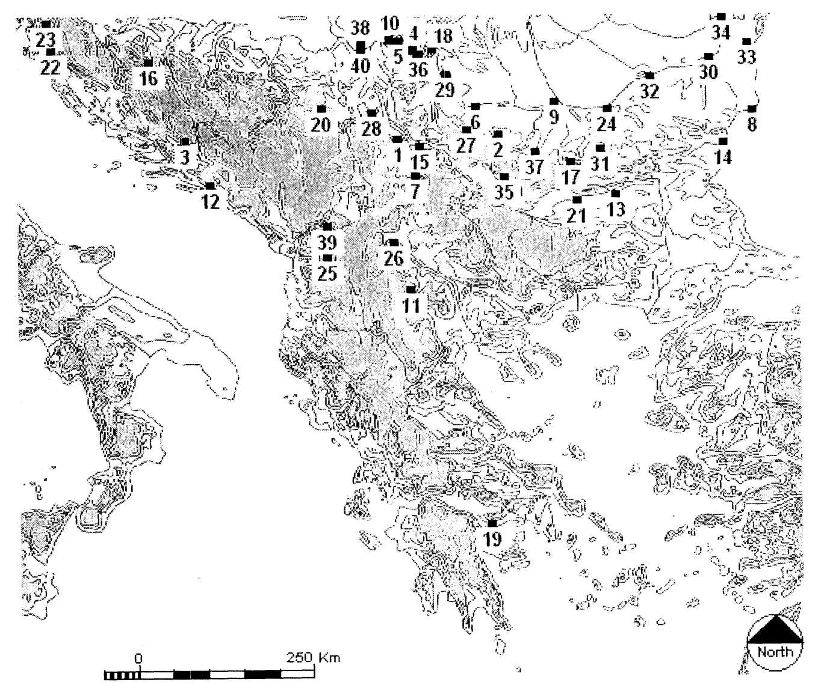
The Balkans and the Danube limes

 | New | Restored | Total
ILLYRICUM: | 92 | 207 | 394
Epirus Nova | 32 | 26 | 58
Epirus Vetus | 12 | 24 | 36
Macedonia |  |  | 46
Thessaly |  | ₇ | 7
Dardania | 8 | 61 | 69
(Dacia Mediterranea): |  | 140
near Serdica |  |  | 9
Cabetzus region | 1 | 16 | 17
near city? | 5 | 23 | 28
near Germenne | 1 | 6 | 7
near Pauta(lia) |  |  | 5
Kasseta region |  |  | 5
near Naissus | 32 | 7 | 39
near Remesiana |  |  | 30
(Dacia Ripensis): |  | 38
near Aquae | I | 37 | 38
THRACE: |  |  | 179
Europe |  |  | 2
Rhodope |  |  | 12
Thrace |  |  | 35
Haemimons |  |  | 53
Moesia Inferior |  |  | 51
μεσόγεια |  |  | 26
LIMES: |  |  | 85
(Moesia Superior) |  |  | 28
(Dacia Ripensis) |  |  | 29
(Moesia Inferior) |  |  | 20
(Scythia Minor) |  |  | 8
Dobrudja, where two Romanian archaeologists, Mihai Zahariade and Andrei Opai|, excavated a burgus. The nature of activity within this small fortification seems to have drastically changed in the mid-fifth century, when a considerable reduction in the quantity of weaponry is recorded. The fortification gradually lost its military nature and became a storehouse for the local military annona with the aim of ensuring the supplies of troops passing by⁶¹
⁶¹ Ovidiu: Bucovala and Papuc 1981 and 1986. Cape Kaliakra: Dimitrov 1985:123. Capidava: Florescu and Covacef 1988—9:203. Garvan: Barnea 1986:448 and 1984:344. Fora similar situation identified at Tropaeum Traiani, see Papuc 1977:358. That the basilica at Garvan was restored under Anastasius is indicated by bricks from the nave's pavement with stamps bearing the emperor's name. See Barnea 1958:295-6 and 1980:251. Musait: Scorpan 1974:114. Pantelimonu de Sus: Barnea and Vulpe 1968:423. Topraichioi: Zahariade and Opaij; 1986:565, 567, and 569—71.
156
Figure 2 Location map of the principal forts and fortified churches mentioned
in the text
ι - Balajnac; 2 - Berkovica; 3 - Biograci; 4 - Boljetin; 5 - Bosnian; 6 - Botevo; 7 - Bregovma; 8
- Cape Kaliakra; 9 - Celei; 10 - Cezava; 11 - Debreste; 12 - Dubrovnik; 13 - Dyadovo; 14 - Dzhanavar Tepe; 15 - Gamzigrad; 16 - Gornji Vrbljam; 17 - Gradat; 18 - Hajducka Vodenica; 19
- Isthmia; 20 - Jelica; 21 - Karasura; 22 - Kastelina; 23 - Korintija; 24 - Krivina (Iatrus); 25 - Kruja; 26 - Markovi Kuli; 27 - Mikhailovgrad (Montana); 28 - Momcilov Grad; 29 - Mora
Vagei; 30 - Musait (Sacidava); 31 - Nikiup (Nicopolis ad Istrum); 32 - Nova Cherna; 33 -
Ovidiu; 34 - Pantelimonu de Sus (Ulmetum); 35 - Pirdop; 36 - Ravna; 37 - Sadovec (Sadovsko
kale and Golemanovo kale); 38 - Sapaja; 39 - Shurdhah; 40 - Svetinja.
North of the Stara Plamna range, the most striking feature is the ubiquity of fortified hilltop sites, concentrated along river valleys and the northern slopes of the mountains, occupying strongly defensive positions perched above cliffs or on top of steep-sided hills. Few have been explored by systematic excavations, but those that have (Nova Cherna, Krivina/Iatrus, Sivri Tepe near Kochovo, Zmei kale near Kopnvec, Gradat near Batoshevo, Krumovo kale near Targovishte, Dolno Kabda, Sadovsko kale near Sadovec, Biala, and Shumen) seem to have been substantially restored at some point during the sixth century, most likely during Justinian's reign. That, in some cases, restoration may have started earlier than that is indicated by an inscription mentioning Emperor
157

The making of the Slavs
Anastasius, which was found at Vavovo kale near Gradec. These forts were built with walls of ashlar filled up with white mortar and rubble (opus implectum). Walls are massive, with towers along the circuit and double enclosures (proteichismata) sometimes added to earlier fortifications, as in Shumen. These forts are called πόλεις by Theophylact Simocatta. For example, he refers twice to latrus as a πόλι$. After being destroyed by the Huns in the mid-4oos, latrus had been abandoned for at least fifty years. When building restarted in phase D (late fifth to early sixth centufy), the ιτόλις had turned into a simple fort. The only building in stone and the largest on site is the basilica. A building with a portico (Building xxxiii), but with no apparent use as dwelling, may have had some representative role, perhaps in connection with the military commander of the garrison. In the ruins of the fourth-century horreum, a complex of eleven houses was built, with walls of stones and mud bricks. A two-storied house was located in the southeastern corner of the horreum. On top of the former prinapia, now abandoned, a workshop was erected, which had a brick-made kiln. All houses were buildings of adobe or stones bonded with clay But the use of glass vessels (Stengelgldser) seems to have continued, though it remains unclear whether they were of local production or imports. During phase E, covering most of the seventh century, houses built in stone bonded with clay produced handmade pottery and a bow brooch. More important, the faunal material from this period typically contains a large number of species, particularly dog and wild animals, which suggests an increasing reliance on hunting for meat procurement.⁶²
A similar picture can be drawn on the basis of excavations at Nikiup (Nicopolis ad Istrum). The Roman city had been abandoned before the early 400s. The early Byzantine fort built in the former city's southeastern corner encloses an area of 5.74 ha, little more than one fourth of the size of the Roman city (21.55 ha). Early Byzantine Nicopolis had no regular street grid and no agora surrounded by public buildings. A large basilica, built at the highest point on the eastern side of the enclosure, was the dominant feature within the defenses. A second, single-naved
⁶² Theophylact Simocatta vn 2.16 and vo 13.9. latrus: see Mitova-Dzhonova 1968:13 and 15 fig. 4; Wachtel 1974:140; Gomolka 1976:40; Herrmann 19793:18, 197^:114-15, I986a:io, and 1987a; Bierbrauer 1986:457; Dohle 1989:41; Billow 1990:369, 372, and 383; Dinchev I997a:so. For faunal remains, see Bartosiewicz and Choyke 1991:191. Sivri Tepe: Antonova 1970:304. Krumovo kale and Dolno Kabda: Ovcharov 1971. Biala: Dimitrov 1985:125. Vavovo kale: Velkov and Lisikov 1994:263. Shumen: Antonova 1987:55-6. For opus implectum and other building techniques, see Biernacka-Lubanska 1982; Poulter 1983:98-9. At Sadovsko kale, Ivan Velkov s excavations focused exclusively on the western half of the plateau and left most of the fort unearthed. As a consequence, the plan of the fort, as published in 1934, is wrongly viewed as a "classical" example of early Byzantine defense architecture in the Balkans. See Werner 1992:409.
The Balkans and the Danube limes
church was still in use in the last quarter of the sixth century, as evidenced by a coin struck for Emperor Tiberius II, which was found above the nave floor. Despite clear evidence that the large basilica was destroyed by fire, the absence of metal fittings and roof-tiles from the destruction levels suggests that the church had been systematically stripped of reusable material, before being abandoned. A series of buildings running from east to west seems to have served as barracks or storehouses. In the center of the fort there was a two-roomed structure, perhaps a workshop, crudely built with limestone blocks and reused architectural fragments bonded with earth and supporting mud walls. Large "open spaces" existed along the northern side of the site, on the western side and around the basilica. There is no sign of large-scale grain cultivation and there seems to have been a shift from winter-sown cereal crops to garden cultivation of millet and legumes, which could have been grown close to the city or, conceivably, in the open land which existed inside the defenses.⁶³
It has been argued that since most of the forts in Moesia Inferior were built in isolated and almost inaccessible sites, they might not have been occupied permanently. However, most of them had at least one church, sometimes with a baptistery, as in Gradat. Moreover, houses built in the stone-cum-clay technique have been found on many sites, as has evidence of agricultural (sickles, at Gradat) and industrial activities (a smithy in the pentagonal tower at Sadovsko kale). At Sadovsko kale, one of the rooms built against the fort's wall produced twenty-nine gold coins, while two skeletons were found in the neighboring room, in a non-burial context, together with five gold coins and silver jewels, including two bow brooches, all scattered on the room's floor. The rooms immediately next to the pentagonal tower have been interpreted as belonging to elite members of the fort's garrison, clearly caught by surprise and killed during an attack.⁶⁴
How did the occupation on these sites end? At Nova Cherna, numerous traces of fire catastrophe were found within the quadriburgium, but this event is dated to the first half of the sixth century Clear evidence of destruction by fire was found in several parts of the fort at Gradat, the last coins found there being issued under Justinian. At Sadovsko kale, the archaeological evidence from rooms 2 and 3 clearly indicates an attack,
⁶³ Poulter 1995:40-2, 44, 46, 166, and 181. At latrus, the soldiers'diet seems to have included oats and peas, arguably cultivated on site. See Hajnalova 1982:232. At Voivoda, near Shumen, a house built parallel to the fort's wall has been interpreted as a grinding area. The associated agricultural tools, however, are of a much later date. See Danmnov 1976:17 and 24.
⁶⁴ Gradat: Milchev and Koicheva 19783:60. Sadovsko Kale: Werner 1992:411. Other churches within forts: Milchev and Koicheva 197813:25, 27, and 31; Soustal [991:344 and 349. All were three-aisled basilicas. Houses: Milchev and Koicheva 1978.1:60; Milchev and Draganov 1992:39; Uenze 1992:125; Antonova 1987:61.

158

The making of the Slavs
which, however, does not seem to have been followed by either fire destruction or systematic plundering. The last coins found on the site are those of Maurice.⁶⁵
The situation is slightly different on the territory of the former provinces Dacia Ripensis and Moesia Superior. Some forts were restored during Anastasius' or Justin Is reign, during Justinian s reign, or as late as Justin Us reign. Sixth-century forts were at about six kilometers from each other, in a sight distance, with refugia on hilltops, no farther than 150 to 200 m away from the Danube line. Many were square or rectangular in plan. The preference for angular architecture so typical of Justinian's reign is also visible. More often than not, these forts incorporate into a larger fortification an older, fourth-century burgus. Some forts were completely destroyed by fire at some point during the last quarter of the sixth century. Others were simply abandoned.⁶⁶
At Gamzigrad, the imperial palace was abandoned as early as the fourth century. During Theodosius Is reign, a basilica was built on top of the southern wing of the palace, and a glass workshop was installed in the former bath. After being destroyed sometime during the sixth century, the basilica was restored and a baptistery added on its southern side. A small settlement with houses built in stone bonded with earth appeared around the church. During most of the sixth century, Gamzigrad may have functioned as a fortified village. The presence of a considerable number of querns and agricultural implements bespeaks its rural character. Bulgarian excavations at Mikhailovgrad (Montana) have revealed a house built near the northwestern tower. The house produced a significant quantity of amphora sherds and agricultural implements, as well as a scale. Fragments of bronze vessels may indicate a workshop. The settlement had only one single-naved church. Evidence of long-term occupation also comes from Golemanovo kale. The fort had between thirty-five and forty houses, in addition to about forty to fifty storage rooms. The most impressive feature of this site is the presence of two-storied houses with no heating facilities, such as Ι δ or the so-called "Nestor house" (named after the Romanian archaeologist Ion Nestor, who excavated it in 1937). The latter produced a hoard of seven gold coins, in addition to silver jewels (including a pectoral cross), illustrating the wealth of its
65 ]\|_{ova} Cherna: Milchev and Angelova 1970:36; Ivanov 1974:68—9; Milchev 1977:351—7. For Gradat, see Milchev and Koicheva i978a:6o—1. For Sadovsko kale, see Uenze 1992:127.
⁶⁶ Distance between forts: Jankovic 1981:208 and 211. Restoration under Anastasius or Justin I: Gabricevic 1986:72. Restoration under Justinian: Uenze 1992:97; Jovanovic 1982—3:328 and 330. Restoration under Justin II: Milosevic and Jeremic 1986:250. For examples of angular architec ture, see Kondic 1982-3.1:141; Kondic 19843:142. Incorporation of older burgi: Kondic 1984a: 144—7. Destruction by fire: Tudor 1965:124; Uenze 1992:107 (c. 580). Abandoned forts:
Jovanovic 1982—3:330; Cermanovic-Kuzmanovic and Stankovic 1986:455; Atanasova 1987:125; Atanassova-Georgieva 1974:167.
l60
The Balkans and the Danube limes
inhabitants. All houses were built in stone bonded with clay. The abundance of agricultural implements and spindle whorls has been too hastily interpreted as indication of a rural settlement, with no military function. Similar houses with glass windows and heating facilities were found on the acropolis of the site at Mokranjska stem, in the Iron Gates segment of the frontier. They are in sharp contrast with poorer dwellings in the lower part of the settlement.⁶⁷ Closer to the Danube line, smaller forts produced evidence of more modest dwellings. At Celei (Sucidava), on the left bank, rooms with brick ovens were built against the curtain. A two-roomed building was found in the middle of the fort, not far from a hypocaustum probably belonging to a larger building, now completely destroyed. A "secret fountain" outside the fort had an underground access beneath the southern wall. Small rooms built against the curtain were also found at Hajducka Vodenica, and wattle-walled houses appeared at Bosman. At Mora Vagei, there were no buildings at all, which may suggest that soldiers lived in tents. Some forts had single-naved churches, as in Celei, with burials both inside and outside the basilica. The fort at Golemanovo kale produced an unique case of a two-storied church, included in a bastion (peribolos) on the northern rampart. An older church built outside the fort continued to be used during the 500s, but its baptismal function was transferred to the intramural basilica. In other cases, the church stood between the main walls and the proteichisma. At Berkovica, the three-aisled basilica built outside the fort, immediately next to its wall, was later incorporated into a large bastion-like structure protruding from the fort's precinct. A second church was incorporated with its apse into the fort's northeast rampart. At Botevo, a small military outpost near Ratiaria, Bulgarian archaeologists discovered in 1947 a church of cruciform plan.⁶⁸
In addition, the northern Balkans provide two examples of fortified
⁶⁷ See Jankovic 1981:212. Gamzigrad: Srejovic, Lalovic, and Jankovic 1980:77; Popovic 1982:556 and 557 fig. 13; Srejovic 1986:90. Mikhailovgrad: Aleksandrov 1987:64 and 79. Because of the presence of agricultural implements, Joachim Henning (1986:107) believed the Mikhailovgrad site had no military function. For Golemanovo kale, see Uenze 1992:116-19; Werner 1992:415. Werner (1992:403) believed that the site at Golemanovo kale was not a military one because no structure was found on site that could be interpreted as liorrcum. In fact, very few, if any, horrca were erected on sixth-century military sites in the Balkans.
⁶⁸ "Secret fountain" at Celei: Tudor 1965:109 and 116—17. Another well was found at Bosnian (Kondic i982-3a:i4i and 143). Rooms built against the walls: Jovanovic 1982-3:321. Mora Vagei: Cermanovic-Kuzmanovic and Stankovic 1986:454—5. The occupation of the site is evidenced by six dolia and faunal remains, the majority of which are of pig. The fort had a small port, an indi cation that supplies for the garrison may have come via the Danube river. Another anchorage is said to have existed at the neighboring fort at Cezava (Kondic 19843:155), but does not appear on any of the published plans. For the church and the cemetery at Celei, see Tudor 1965:111; Tudor, Toropu, Tatulea, and Nica 1980. For the two-stoned church at Golemanovo kale, see Uenze 1992:52. Berkovica: Mitova-Dzhonova 1974:342-3 and 1984:340-1. Botevo: Hoddinott 1975:242.
ΙΟΙ
The making of the Slavs
churches built in the middle of nowhere, apparently without any related settlements or cemeteries. At Dzhanavar Tepe, 4 km south of Varna, in Bulgaria, a single-naved basilica was built with projecting north and south rooms inscribing both apse and narthex, aU in the form of powerful towers. The one on the northwestern side was a baptistery. Some have suggested Syrian influences, but there is no doubt as to the defensive character of the complex. A still more compelling example is the Stag's basilica at Pirdop, in western Bulgaria, with a massive rectangular wall with four angje towers enclosing the church. The precinct seems to have been built at the same time as the extant church. Despite claims to the contrary, the defensive character of the complex is betrayed not only by its walls and towers, but also by barrel vaults and domes replacing the timber roof during the last building phase. It is not clear why these two churches were fortified in this way. Taking into consideration their isolated location, however, it may be possible to associate them with churches built within city or fort ramparts or close to the strongest parts of the precincts.⁶⁹
The situation in Moesia Superior is remarkably similar. Under Justinian, no less than nine new forts were built in the Iron Gates segment of the Danube limes, three of which incorporated older burgi. The only period of restoration or building indicated by coin-dated archaeological contexts is indeed that of Justinian's reign, as clearly shown by excavations at Sapaja, Saldum, Cezava, and Svetmja. Wattle-walled houses have been found at Ravna and Svetinja, near Viminacium. In the latter case, they were all similar in size and form, with surfaces ranging from twenty to twenty-seven square meters. Loom weights found in houses 1 and 3 suggest that weaving was an important activity. With the exception of house 3, which produced only seeds of millet, most samples of grain seeds from Svetinja were mixtures of wheat, rye, barley, and millet, a clear indication of three-field rotation. Supplies of corn undoubtedly came from outside the small military settlement, probably from the neighboring city of Viminacium. During the third building phase, which is coin-dated to the end of the sixth century, a smithy was established on the other side
⁶⁹ Dzhanavar Tepe: Pillinger 1985:285—7. The church has been dated on no solid grounds to the fifth century (Hoddinott 1975:327). Other examples of cross-shaped churches in the Balkans: Carevec (Hoddinott 1975:251), Carkvishte (Hoddinott 1975:279), the basilica D in Caricin Grad (Duval 1984:419), and the H. David basilica in Thessalonica (Krautheimer 1986:239—40). As suggested by the Carevec basilica, such churches might have served as martyria. For Pirdop, see Hoddinott 1975:327; Mitova-Dzhonova 1974:56; Chaneva-Dechevska 1984:619; Pillinger 1985:284-5; Krautheimer 1986:251—2. Though the last building phase may be Justinianic, a final remodeling of the church seem to have occurred sometime during the last third of the sixth century. To my knowledge, there are no other examples of isolated churches in the Balkans, despite claims to the contrary (Mikulcic I986a:244). The only other case is located outside the area under discussion, in Istria. See Sonje 1976 and 1976—8.
102
The Balkans and the Danube limes
of the rampart. The house produced a considerable quantity of soot with iron dust and slag. Elsewhere, there is evidence of storage facilities, possibly designed for supplies of corn from other areas. At Sapaja and Cezava, despite an abundance of ceramic material testifying to the intensity of human activity, there were no buildings at all. Soldiers may have resided in tents. But the forts at Cezava, Veliki Gradac, and Boljetin were dominated by single-naved churches, the latter two with later additions of baptisteries. Fire destruction was only attested at Ravna (on the profile A-A' at the southwest wall) and dated by archaeologists to 596 on purely historical grounds. At Svetinja, the second building phase ended with heavy destruction as evidenced by a thick layer of rubble mixed with fallen parts of the upper rampart construction. This destruction has been coin-dated between 575 and 587. After restoration, the settlement in phase III was abandoned at some point after 590/1, the date of the last coin found on the site. At Saldum and Cezava, the abandonment may have taken place shortly after 592/3 and 593/4, respectively.⁷⁰
In the interior, the evidence of forts has only recently come to light. In connection with special measures taken for the protection of the mining district in the Morava valley, several torts seem to have been built at key points. At Bregovina, near Caricin Grad, the only fully excavated building is the three-aisled basilica, which incorporated one of the fort's towers. A sixth-century coin was found in the middle of the nave. Six other, only partially excavated, structures within the fort produced evidence of the stone-cum-clay technique. The fort at Balajnac, near Nis, had a large, remarkably well-preserved, cistern, which produced a coin minted for Emperor Justinian. Very little is known about other buildings in the interior of the fort or about the date of its abandonment. Several other forts have been only partially explored in the iron ore district of
⁷⁰ Fire destruction at Ravna: Kondic 1982—36:249. Abandoned sites: Popovic 1987:12—13; Petrovic 1982—3:133; Vasic 1990:907. Justinianic forts in northern Serbia: Vasic and Kondic 1986:555; Popovic 1991:14; Vasic 1994-5. Sapaja: Dimitrijevic 1982—3:47-9. Saldum: Kondic 1974:46; Petrovic 1982-3:133. Transdrobeta: Vasic 1999:35. Cezava: Kondic 1974:41; Vasic 1982-3:102 and 1990:907. Miloje Vasic s subdivision of the sixth-century phase at Cezava into two sub-phases is not supported by the published archaeological profiles. For Svetmja, see Popovic 1987:10; Milosevic 1987:57. The construction of the bulwark across the narrow strip of land between the Dunavac and the Mlava bed is coin-dated to 542/3. New houses were built under Justin II and Maurice on both sides of the rampart. Svetmja has recently been interpreted as port, and the bulwark as wharf. See Mirkovic 1999:24-5. The soldiers who manned the bulwark (believed to be Gepid mercenaries, because of the stamped pottery found on the site) most probably came from Viminacium. For wattle-walled houses, see Kondic 1982-36:249; Popovic 1987:12-13; Milosevic 1987:49. For samples of gram seeds, see Borojevic 1987:67 and 70. For the smithy, see Popovic 1987:28—31; Milosevic 1987: 47. Among artifacts found in the house, there were two folles struck for Maurice in 587/8 and 590/1, respectively, in addition to parts of two armors made of small rectangular iron plates and a fragment of a comb case sheath. For storage facilities, see Vasic and Kondic 1986:558. For fort churches, see Boskovic 1978:437; Kondic 1984a: 155; Vasic 1990:907.
163
The making of the Slavs
Tutin, in southern Serbia. The most impressive site in this region, however, is Jelica-Gradina, near Cacak. Within the area enclosed by walls, a building was found, with walls of stone bonded with clay. The building produced fragments of quern stones and ceramic and glass remains. The site had at least three churches, one of which was an extramural, cemeterial basilica. Basilica С had a cruciform baptistery with walls decorated with frescoes. Fragments of window glass also point to a decoration unusually lavish for a fort basilica. The church produced a pentanummion struck for Justinian between 526 and 537 and the excavator believes that the fort was built under Justinian, in the 530s. However, twelve burials within and outside basilica С had no associated finds. The Jelica-Gradina fort also had a martyrium, which produced a silver reliquary, now lost. Another group of burials - women, men, and children - was found inside basilica A. The associated grave-goods (a bronze buckle and a Vogelfibel) indicate a date in the 500s. A third cemetery of thirty-one burials, including a burial chamber, was found within and around the third church, most probably a basilica coemeterialis. A gold coin struck for Emperor Justin II was found near the burial chamber. It gives a terminus a quo for this cemetery. The presence of burnt layers in various parts of the site has been interpreted as an indication that habitation within the fort ended in violence, but no chronological evidence exists for this event, while the occupation of the site during the seventh century remains doubtful. Field surveys and trial excavations in the same region identified four other forts, all of which produced evidence of a sixth-century, perhaps Justinianic, occupation. The same is true for the fort at Momcilov Grad near Potocac, which produced a great number of coins issued under Justinian's reign. By contrast, the fort near Pautalia was built in the early 400s. When Procopius spoke of Justinian restoring Pautalia, he may have referred to this fort, not to the city itself.⁷¹
The date established on the basis of coin finds for the small fort at Dyadovo, in Thrace, excavated by a Dutch-Bulgarian team, is confirmed by an inscription found near Nova Zagora indicating substantial building activity during Justinian's reign. Radiocarbon dating of grain seeds from houses destroyed by fire at the end of the building phase С indicate that the neighboring fort at Karasura was rebuilt at some point after the early sixth century, thus confirming Procopius' textual evidence. Among all
⁷¹ Forts in the Morava basin: Werner 1986:561-4. Bregovina: Popovic 1989—90; Jeremic and Milinkovic 1995; Milinkovic 1999. Balajnac: Jeremic 1995. Forts in the Tutin area: Milinkovic 1982a, 1982b, and 1985. For Gradina and other forts in the area, see Milinkovic 1995 and http://arheo.f-bg.ac.yu/projekti/jelica/index.html (visit of May 29, 2000). Momcilov Grad: Brmbolic 1986. Pautalia: Goccva 1971:431. For forts in the Timok valley in eastern Serbia, see Petrovic 1994—5.
164
The Balkans and the Danube limes
churches on site, only the extramural basilica coemeterialis has been fully explored. More interesting is the evidence of intramural habitation. Two storage rooms containing no less than 167 anaphoras and 4 dolia were built against the northwest wall shortly after the early sixth century. House N 10/W 10 had two stories, and the presence of a quern suggests that its first floor may have served as a mill. The great number of weapons found in N 10/W 10 does not necessarily indicate fighting, despite clear evidence that the house ended in fire, for the house's second floor may have been used as armory. Three houses with walls of stone and adobe bonded with clay were built on top of the ruins of the storage rooms erected during the building phase D. Subdivision of the area formerly designed for storage indicates that the new buildings served as dwellings. The pottery found in these houses has no analogy in the Balkans. It has been therefore interpreted as an indication of Armenian settlers brought to Thrace during the seventh century. Moreover, house S 5/W 34, dated to the same building phase as the three houses already mentioned, produced wheel-made pottery (called "Byzantine" by the German archaeologists), arrow heads, a shield, bronze and iron brooches (including fibulae with bent stem), and a stirrup, all artifacts strikingly reminding those from the house excavated at Caricin Grad in the western portico of the colonnaded street running from the circular plaza to the upper city's south gate. Just as in Caricin Grad, there is no evidence to substantiate the idea of a Slavic settlement. On the other hand, there is clear evidence that the fort at Karasura was destroyed by fire at some point after Justinian's reign. After restoration, buildings belonging to phase Ε were also destroyed by fire at some point during the seventh century, as evidenced by burnt layers on many house floors.⁷²
Thanks to an excellent survey of the archaeological evidence in Thrace and the neighboring areas, it is possible to visualize the distribution of forts in the region south of the Stara Planina range (Figure 3). One of the most striking features of this distribution is the cluster of forts around the main mountain passes. Particular attention seems to have been paid to passes of lower altitude. Many forts were large (over 2 ha), sometimes with an extra-fortified acropolis. With only one exception, forts in the Stara Planina mountains have no churches, but many were equipped with
⁷² Karasura: Procopius, Buildings iv it; Wendel 1987:201 and 1992:201 and 290; Herrmann 1992:174-5; Dohle 1992:196; Bottger 1992:245 and 249; Dinchcv 1997^53· Extramural church: Schoneburg 1991. For other fort churches 111 Thrace, see Bonsov 1988b; Soustal 1991:238, 300, and 488. Dyadovo: Boer 1988-9:9. It is not at all certain that any Armenian settlers came to Thrace during this period. According to Sebeos (pp. 70-1 and 81), Emperor Maurice had the intention to conscript the Armenian nobility to serve in the Balkans and twice attempted to settle Armenian families in Thrace, the last time just before Pliocas' revolt. There is no indication, however, that the settlers ever arrived in Thrace.
165

The making of the Slavs
The Balkans and the Danube limes

Figure 3 The distribution of known fifth- to sixth-century forts in Thrace
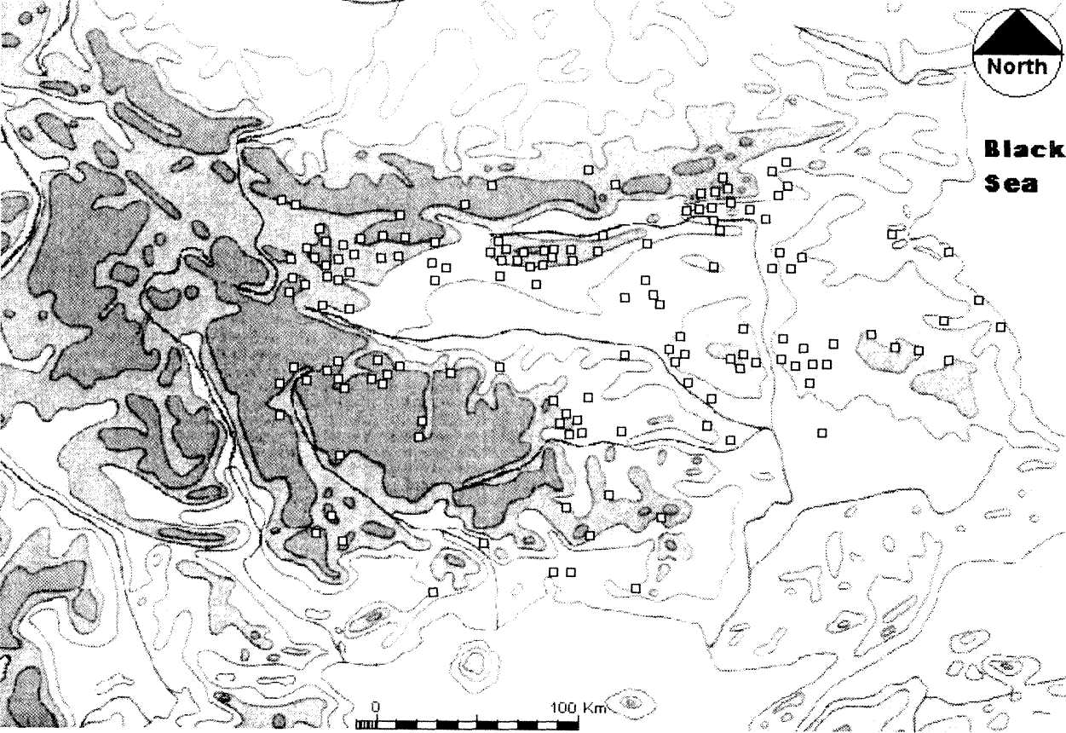
( s
Lowest contour 200 m, thereafter 500 m and over 1,000 m (data after Soustal 1991).
cisterns or wells. Despite the lack of systematic excavations and relevant finds, their dating to Justinian s reign is secured by the presence of protei-chismata, as well as of triangular, pentagonal, and horseshoe-shaped towers.⁷³
Equally interesting is the evidence from Macedonia. It is often assumed that forts in this region can easily be separated from fortified villages or refugia because of being apparently built by military experts. In many cases, interior amenities (cisterns, horrea, armamentaria) were identified. Typical for the Justinianic phase are the disappearance ofpraetoria and the building of interior structures against the ramparts. A date to Justinian's reign is also suggested by the presence of triangular and pentagonal
⁷³ Proteichismata: Ovcharov 1973; Biernacka-Lubanska 1982:148, 159, and 162; Gregory 19823:260. For proteichismata and Justinianic fortifications in Crimea, see Veimarn 1958:10. Fora case of pentangular tower in the Caucasus region, see Voronov and Bgazhba 1987:118. For the archaeological survey of Thrace, see Soustal 1991. On the Black Sea coast, two forts were identified at Sv. Nikola and Maslen nos, both on the bay of Burgas, but no excavations were carried in any of them (ibid., pp. 62-3). The main passes of lower altitude in the Stara Planina are Kotel (685 m), between the upper Ticha valley and the Luda Kamchiia, and Traianova vrata (Sued, 843 m) between the Eledzhik and the Dolna Vassilica mountains. The latter was the most important pass on the main highway across the Balkans, from Constantinople to Singidunum. Each one of these two passes was defended by ten forts, unlike passes at higher altitude (such as Troian, Zlatishki probed, and Shipka), which had fewer.
towers, and confirmed by coin finds. All Macedonian forts have churches, either three-aisled or single-naved basilicas. Despite clear evidence of heavy destruction by fire, the fort at Markovi Kuli was twice restored. In the end, it seems to have been abandoned sometime after 601/2, the date of the last coin found in the fort's aqueduct. The same is true for the fort at Debreste, though an exact date for its abandonment cannot be conjectured. In both cases, there is no indication that the abandonment was the result of any external threat.⁷⁴
Elsewhere in the Balkans, the evidence is too meager to permit any conclusions. In Albania, only three forts have been identified so far from the sixth and seventh centuries: Drisht-Shkoder, Shurdhah, and Kruja. Their date was established on the basis of the presence of triangular and horseshoe-shaped towers, a feature most typical for Justinianic military architecture. Though excavations were carried at Shurdhah, the original date initially advanced for houses found in the interior has been disputed. Nor is it clear what was the relation between the famous cemetery at Kruja and the neighboring fortress. With the exception of the large fort at Isthmia, which may have accommodated soldiers and their families, the evidence from Greece is minimal.⁷⁵
Farther to the north, forts produced evidence of occupation at the time of the Byzantine take-over in Dalmatia, during the Gothic war in Italy. Recent archaeological excavations at Dubrovnik reveal that shortly after Byzantine troops occupied the eastern Adriatic coast, a fort was built on the former island of Lave. It was immediately followed by a large
⁷⁴ For the use of leveling courses of brick (opus latcriciwi) or alternating courses of brick and stone (opus mixtum), with bricks set in a bed of red mortar, as typical for the late fifth- and sixth-century military architecture, see Ovcharov 1977:470—1 and 1982:68; Gregory I982a:2s8. Cisterns: Mikulcic and Bilbija 1981—2:213; Mikulcic I986b::i66. A smithy was identified at Ljubanci: Chausidis 1985—6:191. For other buildings in the interior, see Mikulcic and Nikuljska 1978:139. Houses built against the ramparts: Mikulcic I986b:261 and 266. Triangular and pentagonal towers: Georgiev 1985—6:203—4. At Markovi Kuli, the triangular tower is coin-dated to Justinian's reign. New work was added during Justin II's reign (two coins issued between 575 and 578 date phase и). After heavy destruction, a new restoration amplified the triangular tower into a massive, polyg onal bastion. This latter phase is coin-dated to the last regnal years of Justin II or to Tiberius ITs reign. See Mikulcic and Nikuljska 1978:139 and 141; Mikulcic and Nikuljska 1979:72. Fort churches: Mikulcic and Bilbija 1981— 1982:214; Ramhutowa 1981:45-8; Spasovska-Dimitrioska 1981—2:170—1; Mikulcic I986a:206. The three-aisled basilica at Venec had a baptistery, that of Debreste was built next to an episcopal residence.
⁷⁵ Forts in Albania: Komata 1976:182; Anamali 19933:455-7; Hoxha 1993:555-6. Shkodcr produced brick stamps with Justinian's monogram. Triangular towers also appear at Qafa. The three-aisled basilica from Zaradishte produced a relatively large number of coins minted for Justin I and Justinian, but its chronology is not clear. For Shurdhah, see also Spahiu 1976:154—5 and 158; Karaiskaj 1989:2647. For the cemetery at Kruja, see Anamali and Spahiu 1963. That families of soldiers may have resided within forts is suggested by the presence of intramural female and child burials. See Kardulias 1988:208 and 1992:284; Milinkovic 1995. Military sites in Greece: Ober 1987:226.

I66
167

The making of the Slavs
extramural, three-aisled basilica, built on the site of the modern city cathedral. This fort appears to be the largest on the Adriatic coast and in mainland Montenegro, comparable in size to such cities as Dyrrachium, Onhezmos, and Butrint. At some point after 536, but before 597, the bishop of neighboring Epidauros was transferred to the new basilica erected under the eastern ramparts of the fort. Dubrovnik thus became a bishopric and, perhaps, a lesser center of Justinian's administration of the coastal region.⁷⁶
In Slovenia, no settlements existed during the fifth and sixth centuries, other than hillforts. The abandonment of settlements in the lowlands was accompanied by drastic changes in the economic profile of those communities, with a greater emphasis on pastoralism. At Ajdovski gradec, faunal remains mainly consisted of bones of sheep and goat, followed at a distance by pig and cattle. A date established for the forts in the northwestern Balkans during Justinian's reign seems to be confirmed by finds of coins and fibulae. In most cases, the fort's interior contained relatively large, open spaces, probably under cultivation. At Tinje, houses were cut in rock, with wattle or wooden superstructure. One of them, no. 4, produced a hoard of agricultural implements, with socketed shares, a mattock, and a scythe. At Rifnik, houses were built in stone bonded with clay. One of them, built very close to the church, produced evidence of glass windows. Another house may have served as a smithy. Houses built in stone bonded with clay were also found at Ajdovski gradec. House A had four rooms and produced exceptional artifacts: a bronze bowl, stamped pottery, spatheia, a marble mortar, and a silver pin. It has been interpreted as an episcopal residence. House D had a single room with a heating system with channels under the floor of lime mortar. House Ε produced a considerable number of tools (awl, knife, whetstones, saws), which suggests that the building may have been a workshop. Handmade pottery was found in house G, built immediately close to the precinct. A multi-roomed building was also found at Gornji Vrbljani, in western Bosnia. It had an inner courtyard, an oven, and a kitchen. No other buildings were apparently built on the site. By contrast, at Korinjski hrib, in Slovenia, some of the towers of the precinct may have served as dwellings, as suggested by the existence of hearths. Another tower contained a cistern. At Rifnik and Korintija, on the island of Krk, the cisterns were cut in rock. At Ajdovski gradec, Biograci, and Kastelina, on the island of Rab, the cisterns were part of the precinct. Almost all forts have at least
⁷⁶ Stevovic 1991:142, 147, and 150; see also Cambi 1989:2400 and 2402. Even before the Gothic war, a defense line was built on the left bank of the Neretva river, with forts at Debelo brdo, Bobovac, Usora-Bosna, and Zecovi near Prijedor. At the same time mining activites resumed at Bosanski Novi. See Basler 1993:17-18.
I68
The Balkans and the Danube limes
one single-naved church located on the highest point of the settlement. But Christian congregations on the northern shore of the Adriatic, in the Alpine region farther north and in Bosnia, clung to architectural types established in the early fourth century. Box churches without apses, the altar pushed forward into the nave and a semicircular clergy bench behind the altar, have been found at Rifnik and Ajdovski gradec. It is often assumed that the occupation of the forts in the northwestern Balkans ceased sometime before or shortly after 600, as a consequence of Avar or Slavic attacks. At a closer examination of the published material there is no indication of destruction by fire, except at Gornji Vrbljani, for which, however, there is no indication of date.⁷⁷
In many cases, the exact dates for the building, restoration, destruction, or abandonment of the Balkan forts were established on the basis of isolated coins or hoards. Hoards are particularly important in this context, since they are often associated with impending disaster caused by barbarian raids. It might be worthwhile, therefore, to take a fresh look at the numismatic evidence before drawing the final conclusion of this chapter.
INFLATION IN THE BALKANS AND THE END OF THE LIMES: THE
EVIDENCE OF COIN HOARDS
Hoards are generally believed to have been deposited close to the date of the latest coin. An unusual clustering of coin hoards within a short span of time is often interpreted as indicating some severe threat to the region. Plotted on maps, hoards were often used for tracing movements of armies or peoples and areas of social and military unrest. They were thus viewed as mute testimonies to misfortunes, calamities, or tragedies. It comes as no surprise, therefore, that archaeologists made extensive use of coin hoards for tracing barbarian invasions into the Balkans, especially when coin hoards were found in or near destroyed forts.⁷⁸ Despite the extensive use of numismatic evidence for documenting Slavic invasions, very few scholars attempted to map hoards in order to show in detail how far away they lay from the conjectural routeways and focal areas of settlement.
⁷⁷ Ciglenecki 19873:107 and 1987Ы272 and 285. See also Bierbrauer 1984:53-4. For pastoralism, see Petru 1978:226. For faunal remains at Ajdovski gradec, see Knific 1994:215. Intramural open
V
spaces: Ciglenecki 1979:463 and 1987b:!: 14—15. Coins and fibulae: Bolta 1978:515; Cremosnik 1987-8:94. Tinje: Ciglenecki 1987^44. Rifnik: Bolta 1978:511. Ajdovski gradec: Knific 1994:212 and 2i6. Gornji Vrbljani: Ciglenecki 19873:107; Basler 1993:33. Korinjski hrib: Ciglenecki 19873:274 and I987b:ioi—3. Korintija: Tomicic 1986—7:151. Kastelina: Tomicic 1988—9:33. Fort churches: Tomicic 1986—7:151 and 1988-9:30-2; Faber 1986-7:123. Church architecture 111 Dalmatia, Bosnia, and Istria: Krautheimer 1986:179; Bolta 1978:515; Knific 1994:212; Bratoz 1989:2381; Basler 1993:48.
⁷⁸ Kent 1974:202; Banning 1987:7; Metcalf 1991:141. See also Curta 1996:65-78. What follows is primarily based on this study.
169

The making of the Slavs
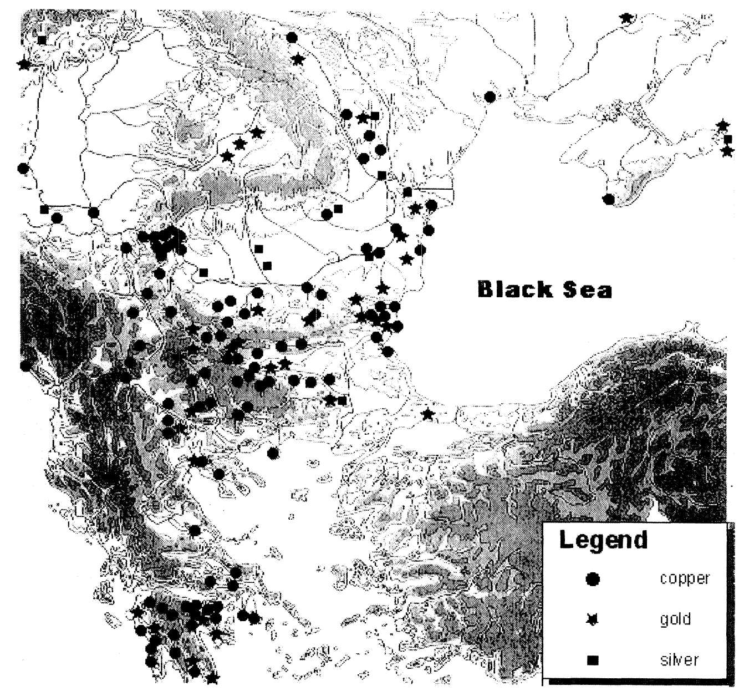
The Balkans and the Danube limes
Even fewer examined large numbers of hoards in order to assess from their size and age-structure how soon after the terminus post quem their concealment is likely to have been. Some observed that not every incursion provoked hoarding. Moreover, the evidence of sixth-century hoards suggests that coin hoarding continued in relatively quiescent periods.⁷⁹ The deposition of low denomination copper coins has been attributed to economic factors. Inflation had a particularly marked effect on the radiate, making it practically worthless. Large hoards of radiates may thus have been originally buried for safe-keeping, but not retrieved because inflation had rendered them valueless or they were already worthless and were buried as a means of disposal.⁸⁰
The early Byzantine Empire operated a closed economy, in which the monetary value of coins was officially sanctioned. It is often assumed that copper coins which passed beyond the sphere of control of the issuing authority lost their value, because coinage in that metal was almost uniformly of a fiduciary nature. Exporting copper beyond the imperial frontiers would have immediately dropped its value to that of its bullion content.⁸¹ If this is true, however, it is very difficult to explain the presence of coin hoards, primarily of copper, in the regions beyond the Danube frontier of the Empire, where historical sources locate the Sclavenes. These sources suggest that beginning with the 570s the raids of the Slavs considerably increased and changed in both direction and effects. Some argued that until 602 the most destructive invasions were in the southern region of the Balkans and that Roman sites in the north survived until Heraclius' early regnal years. Did, then, invasions of the Cutrigurs, Avars, and Slavs result in such clear-cut changes in the pattern of coin-hoarding in various provinces that we can identify particular moments when these provinces were overrun? The distribution of hoards in the Balkans would at best indicate that large tracts in the western and central parts were not touched by invasions at all (Figure 4).⁸²
As shown in Chapter 3, the diocese of Thrace was systematically raided
⁷⁹ For the use of hoards for documenting Slavic invasions, see Metcalf 1962a and 1962b; Iurukova 1969b; Popovic 1975 and 1980; Nystazopoulou-Pelekidou 1986; Madgearu 1997. Out of more than 200 hoards known so far from the Balkans, not a single one produced a terminus a quo to be associated with the serious Cutrigur raid of 558/9. Conversely, coin hoarding in the Balkans increased particularly after 565 and before 580, at a time when, according to historical sources, there was no major Slavic invasion or any other barbarian attack across the Lower Danube. See Curta 1996:80 and 103-4.
⁸⁰ Aitchison 1988:273—4; Berghaus 1987:16. For an interesting study of coin hoarding and burying in relation to economic recession, see Mikobjczyk 1982. See also Sarvas 1981. Samuel Pepys's diary (1667) is the cautionary tale most frequently cited against hastily associating hoards with invasions. See Higbed 1967; Casey 1986:53—5.
⁸¹ Hendy 1985:257; Aitchison 1988:270. Contra: Pottier 1983:225; Morrisson 1989:251. For coin cir culation in the Balkans, see Duncan 1993.
⁸² Popovic 1980:257; Metcalf 1991:140; Curta 1996:76 and 178 fig. 1. For the Sclavene raid of 548, which reached Durres (Epidamnus, Dyrrachium), see Procopius, Wars vn 29.1—3.
I7O
Figure 4 The distribution of sixth- to seventh-century Byzantine com hoards
in Southeastern Europe.
by Cutrigurs and Sclavenes in the late 400s and the early 500s, as well as by Sclavenes and Avars in the late 500s. One would expect to find a large number of hoards in an area under such a serious threat. The distribution of sixth-century hoards in the Balkans reveals, however, a striking difference between central regions, such as Serbia and Macedonia, and the eastern provinces included in the diocese of Thrace (Figure 5). With just one exception, there is no hoard in the eastern Balkans with a terminus post quem before 600. The latest coins found in Thracian hoards were either struck for Justin I or, more often, pre-550 issues of Justinian. The number of hoards drastically dropped in the following decades and hoards completely disappeared between 580 and 680.⁸³ One can easily find similar examples in Thessaly and the western provinces of the Balkans,
⁸³ Curta 1996:94-5 and 180 fig. 3. The exception is the ill-published Mezek hoard with a last com probably struck during the second half of Justinian s reign (Iurukova 1969^262).
171

The making of the Slavs
The Balkans and the Danube limes
for which clear evidence exists that they were also raided by Avars and Sclavenes. However, no hoard was found on the territory of Epirus Vetus, Prevail tana, and Epirus Nova, while Thessaly is ranked close to the eastern provinces. By contrast, the largest number of hoards is that from Greece, which was seriously threatened only after с 580.
A considerable number of sixth- and early seventh-century hoards were found in urban contexts, in Caricin Grad (Justiniana Prima), Pustogr|dsko (Stobi), Adamclisi (Tropaeum Traiani), Athens, Corinth, or Salona. Others were found in Roman camps, particularly in the Iron Gates area of the Danube frontier.⁸⁴ In cases where coins were associated with other artifacts, we can discern a certain pattern. While two hoards with the last coin issued under Justin II include cast fibulae with bent stems,⁸⁵ hoards of silver of the late 600s contain silver earrings with star-shaped pendants of a type usually found in the late 500s.⁸⁶ Archaeological observations thus suggest the existence of certain regularities in hoarding activity. A closer examination of the numismatic data may verify this hypothesis. Many hoards of copper have a terminus post quern between the reign of Anastasius and the early years of Justinian's reign, with a peak shortly before and after 530 (Figure 6). The number of hoards decreased dramatically after 535 and a new increase took place only after 570. By contrast, the seventh century witnessed a significant increase, particularly after 670, in the number of hoards of silver, silver and copper, or silver and gold.
On the basis of a detailed statistical analysis of the age-structure of Balkan hoards it is possible to explain this hoarding pattern by drawing comparisons between various regions in the Balkans.⁸⁷ Hoards from both Greece and Dobrudja with latest coins minted before 570 include fairly large numbers of minimi (i.e., lowest copper denominations) and so-called "barbarian imitations." These hoards were often interpreted as indicating continuous raids by Cutrigurs, Antes, or Sclavenes, but the examination of hoards with last coins struck after 570 suggests a different solution.⁸⁸ This latter group of hoards typically includes a much smaller number of coins, usually lesser fractions of the follis, issued in the late
⁸⁴ Cities: Popovic 1984^61—9 and 77-y; Barnea et al. 1979:22 and fig. 2; Popovic 1978:620 with n.
79; Metcalf 1962b: 138—44 and 145-6; Avramea 1983:52 and 54-6; Mirnik 1981:89; Marovic 1984.
Forts: Jovanovic 1984; Popovic 198413:23—6, 71-2, and 75-7; Minic 1984; Kondic 1984b. ^{8:1} Bracigovo: Uenze 1974:485—6; Koprivec: Milchev and Draganov 1992:39. For a recent discussion
of this group of fibulae, see Curta 1992:83—5 and Uenze 1992:154—8. ⁸⁶ Zemiansky Vrbovok: Svoboda 1953; Radomersky 1953. Silistra: Angelova and Penchev 1989.
Priseaca: Butoi 1968. For earrings with star-shaped pendants, see Com§a 1971; Aibabin 1973;
Cilinska 1975. ⁸⁷ Curta 1996:84—97. 8.4 "Barbarian imitations": Iurukova 1969a; Gaj-Popovic 1973; Zhekov 1987. For the interpretation
of pre-570 hoards as signalizing barbarian raids, see Preda and Nubar 1973:81; Popovic 1978:610;
Poenaru-Bordea and Oche§anu 1980:387.
I72
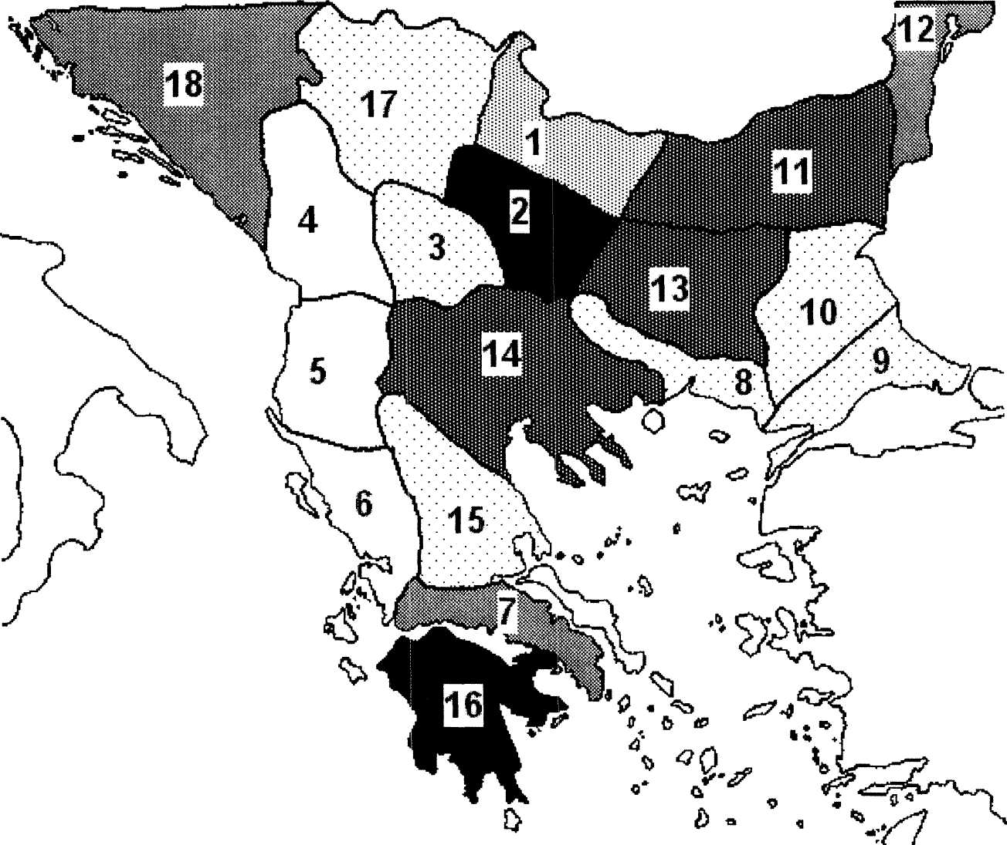
Figure 5 The distribution of sixth- and seventh-century Byzantine coin
hoards in the Balkans, plotted by provinces
Blackened areas — over twenty hoards; white areas — no hoards. The descending scale of grays indicates the frequency of hoard finds. Provinces: 1 — Dacia Ripensis; 2 - Dacia Mediterranea; 3 -Dardania; 4 - Praevalitana; 5 — Epirus Nova; 6 — Epirus Vetus; 7 — Achaia (without Peloponnesus);
8 — Rhodope; 9 — Europe; 10 — Haemimons; 1 г — Moesia Inferior; τ 2 — Scythia Minor; 13 — Thrace; 14 — Macedonia; 15 - Thessaly; 16 - Achaia (Peloponnesus); 17 - Moesia Superior; 18 -
Dalmatia.
400s and early 500s. Since accumulation had often begun in the early 500s and continued until the reigns of Justin II or Tiberius II, the owners of these hoards seem to have deliberately avoided lower denominations, no doubt because of the growing inflation. Indeed, by the time hoards concluded in the 570s and 580s, 1/4, 1/8, and 1/40 fractions of the follis were already valueless and probably out of circulation.⁸⁹ If so, then hoards
⁸⁹ The last nummia were struck under Emperor Maurice, but both the nummion and the penta-nummion had become rare duringjustinian s reign. See Morrisson 1989:250. The regional stress in the copper coinage supply may have caused small-scale production of leaden imitations ot low denominations. See Culica 1976—80; Morrisson 1981; Weiser 1985.
173

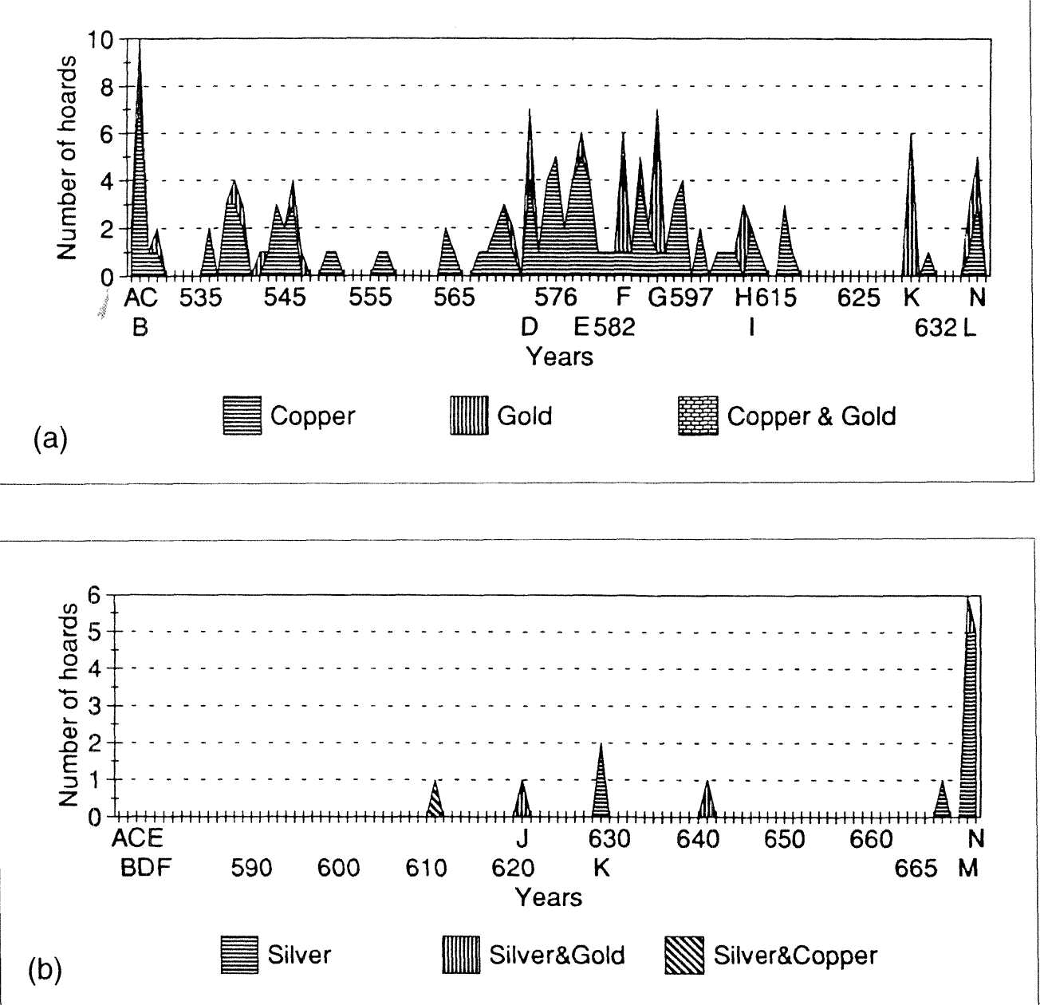
The making of the Slavs
Figure 6 The mean number of sixth- to seventh-century Byzantine coin
hoards found in Eastern Europe
including very low denominations, with latest coins struck shortly before 570, as well as a large number of saving hoards with minimi from Greece dated after 570, may have never been retrieved by their owners not necessarily because of external threats, but because they had become valueless.⁹⁰ After 540, there is a general decline in the number of coins and no coins minted between 545 and 565 made their way to the regions beyond the Danube frontier. In Greece, on the other hand, hoards with latest coins minted before 570 display a significant decrease in both the number and the value of coins. In 554, coin circulation seems to have completely
⁹⁰ Inflation during Justinian s reign was encouraged by the financial ability of John the Cappadocian, who levied a supplement to the land tax, called the "air tax" which added 3,000 lb of gold to the annual revenue, in order to balance the budget grievously threatened by the Persian wars. See Jones 1964:284.
The Balkans and the Danube limes
ceased. By contrast, hoards dated after 570 indicate a continuous circulation between 540 and 560. Despite minor variations at the regional level, the trend is visible throughout the entire Balkan peninsula. By 540, a dearth of copper seems to have become most serious in the northern Balkans, but the evidence of hoards shows that Greece and Scythia Minor also felt the impact of the crisis.
What caused this sudden change from inflation to lack of copper currency? The crisis coincides with the unpopular reform of 542, when Peter Barzymes, Justinian's comes sacrarum largitionum, decreased the number of folles to 180 per solidus. In addition, in 545, Peter Barzymes was compelled by the failure of the Egyptian harvest to make extensive compulsory purchases of wheat in Thrace, Bithynia, and Phrygia. Dismissed in 546, he came back in 554/5 and held office until 562. Although the financial situation was very difficult, he was able to supply Narses with sufficient funds for paying off the arrears which had accumulated in Italy and for raising the considerable army with which Justinian eventually defeated the Ostrogoths. In addition, between 545 and 562 Peter raised 7,500 pounds of gold which were instrumental in buying the final peace with Persia.⁹¹ The general decrease in coin circulation in the Balkans and the proportional increase of low or very low denominations may have something to do with these strains. The drastic decrease in the number of coins after 542/3 may have also been associated with the plague and the subsequent famine in Constantinople.⁹² The lack of any coin finds dated to 554/5 may also be connected with the project of another reform, that of 5 5 3, which aimed at decreasing the weight of the half-follis. The project had to be abandoned after street riots broke out in Constantinople.⁹³ The evidence of hoards, however, suggests an alternative interpretation.
In the central Balkans, in Dobrudja, and north of the Danube frontier, the number of hoards with latest coins struck under Emperor Justinian is very small. The first half of Justinian's reign, however, witnessed the largest number of Thracian hoards, all found in or near small-sized forts along the roads from Philippopolis to Diocletianopolis and Beroe. This has traditionally been interpreted as indicating Slavic raids, which reached a peak around 550. Indeed, Procopius' evidence suggests that the raids of both Cutrigurs (in 551) and Sclavenes (in 549, 551, and, possibly, 545) focused on the diocese of Thrace (see Chapter 3). However, his account highlighted only those Sclavenes who approached the walls of
⁹¹ Procopius, Secret History 25.12. Monetary reform of 542: Whitting 1973:10ό; Gnerson 1982:46—47. For Peter Barzymes'career, see Jones 1964:295-6; Delmaire 1989:269.
⁹² For the plague, see Durliat 1989. For its effect on mint output, see Pottier 1983:241.
⁹³ See Pottier 1983:241; Morrisson 1986:1 15.

174
175

The making of the Slavs
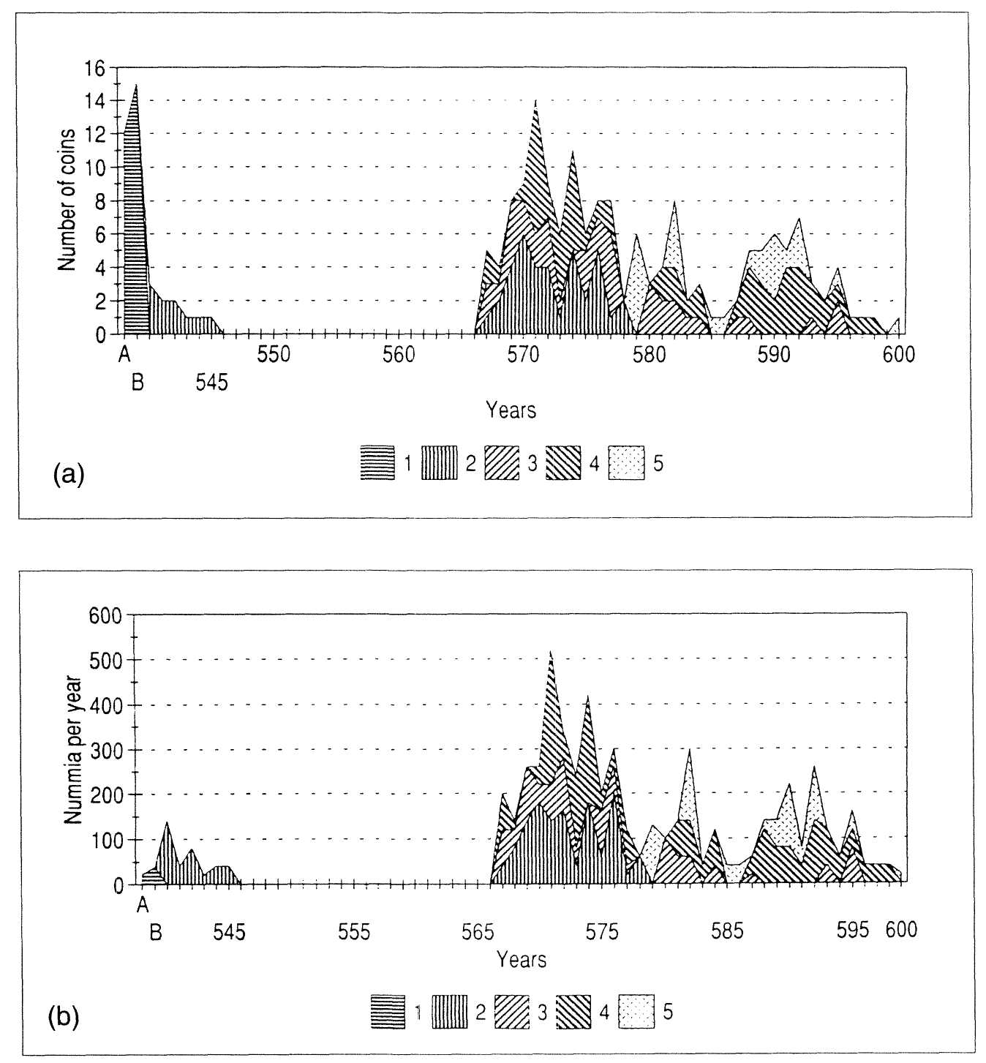
The Balkans and the Danube limes
Constantinople and completely ignored concurrent developments in Illyricum. On the other hand, there are no hoards from the last fifteen years of Justinian's reign (550—65), a period in which the eastern Balkans were ravaged by the invading Cutrigurs, although Slavic raids seem to have completely ceased.⁹⁴
The dwindling of the hoarding activity between 545 and 565 coincides in time with the implementation of Justinian's defense system in the Balkans. On the basis of Procopius' evidence, the completion of this building program can be dated shortly before 558. A connection between Justinian's building program and contemporary hoards is substantiated by their archaeological association with small-size forts. Justinian's gigantic project in the Balkans and its execution must have strained the local coin circulation. The increasing number of payments and other monetary transactions brought by this economic conjuncture had serious consequences especially on small savings, such as found in hoards of radiate. This may also explain the sharp decline in accumulation, as fewer coins were now withdrawn from circulation. Throughout the Balkans, hoarding developments match the picture given by stray finds. In both cases, the number of coins in the late 540s and in the 550s drastically dropped, although to different ratios in Greece, Macedonia, Serbia, and Dobrudja. North of the Danube frontier, circulation of coins practically ceased between 545 and 560, a clear indication that relations between the two banks of the river were interrupted as a consequence of Justinian's building program (Figures 7—8).⁹⁵ This conclusion is supported by finds of gold coins north of the Danube. Thirteen specimens are known so far from the first half of Justinian s reign. By contrast, there are only seven gold coins from the rest of Justinian's reign, as well as from Justin II's and Tiberius II's reigns (Figures 9—12).⁹⁶
Despite the occasional presence of gold coins, no hoards of gold were found in the regions adjacent to the Danube frontier. Hoards of early sixth-century solidi were found, however, at a considerable distance from the Danube frontier, in the steppes north of the Black Sea and on the Baltic Sea shore. Many include large numbers of light-weight solidi, which may have been specifically minted for paying mercenaries
⁹⁴ Curta 1996:90—1 and 93—7. For the association between Thracian and Macedonian hoards and incursions of Sclavenes and Cutrigurs, see Iurukova 196913:257 and 259; Popovic 1978:262; Poenaru-Bordea 1976.
^{9r>} Stray finds of coins of Anastasius and Justin I in present-day Romania are relatively numerous, but the largest number of coins are those of Justinian. See Butnariu 1983—1985. Out of 96 coins of Justinian known from barbarictitn (Eastern Europe), 54 are Romanian finds. Forty specimens were published with exact dates. Only eight of them were minted after 550.
⁹⁶ Gold coins in barbaricum: Butnariu 1983—5; Huszar 1955; Kropotkin 1962 and 1965; Gassowska 1979; Kos 1986; Fiala 1989; Stoliarik 1992.
I76
Figure 7 The mean number of coins (a) and numrnia per year (b) in hoards
found in Romania 1-Cudalbi; 2-Gropeni; 3-Unirea; 4-Horge§ti; 5-Movileni.
recruited in barbaricum.⁹⁷ Late sixth-century hoards of gold found south of the Danube frontier, in the Balkans, have a different composition. They typically include between five and nine solidi each, with all coins struck in Constantinople within a short span of time. It has been suggested that such hoards represent payments to the army known as dona-tiva. Under Tiberius II, the accessional donativum was indeed 9 solidi and
97 Kropotkin 1962:231-2 and 253; Frolova and Nikolaeva 1978; Laser 1982:106-го. Sec also Fagerlie 1967; Gaul 1984. For the interpretation of light-weight solidi, see Harm 1989:165-7; Smedley 1988:129. See also Hahn 1981:97.
177

Figure 8 The frequency (a) and the mean number of coins per year (b) issued
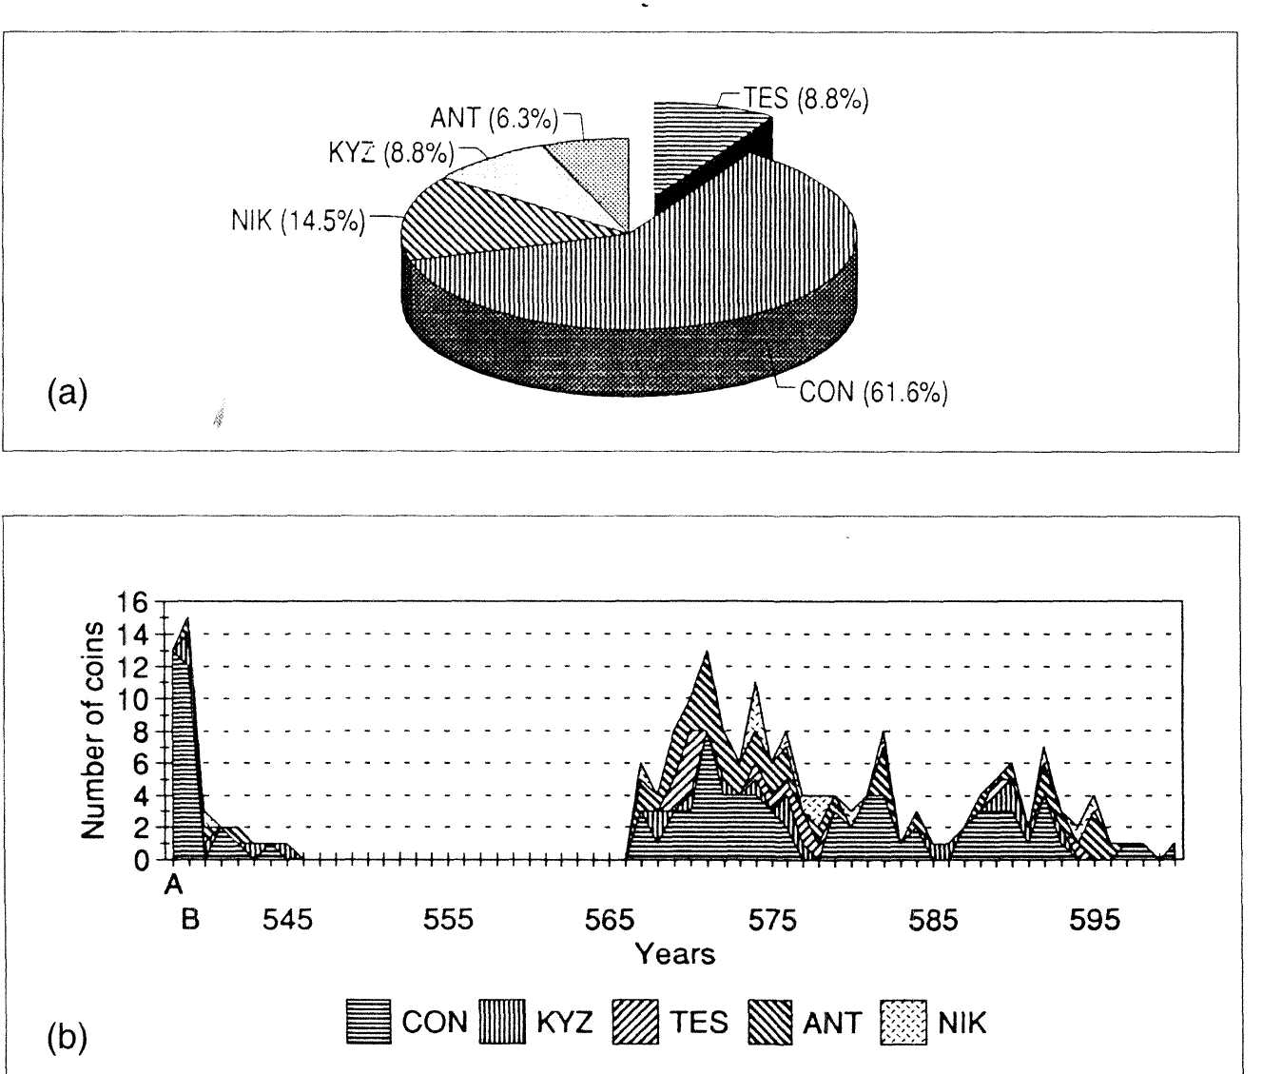
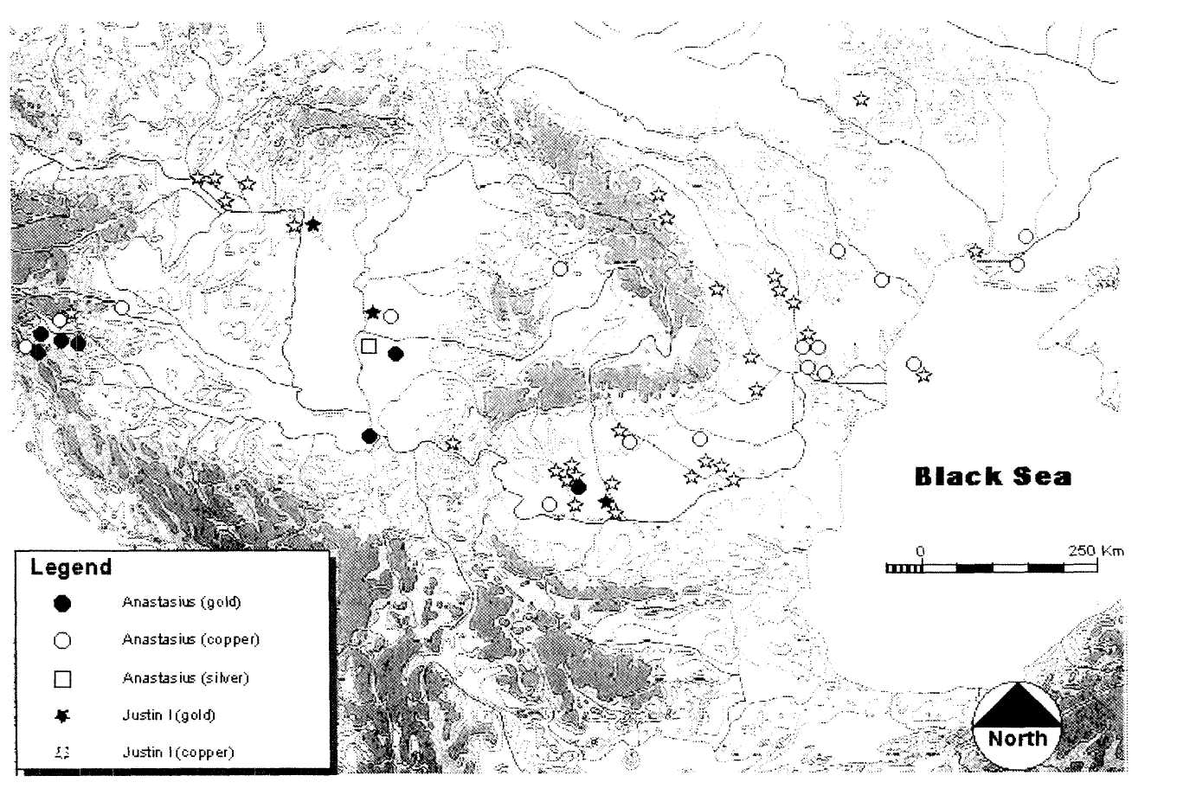
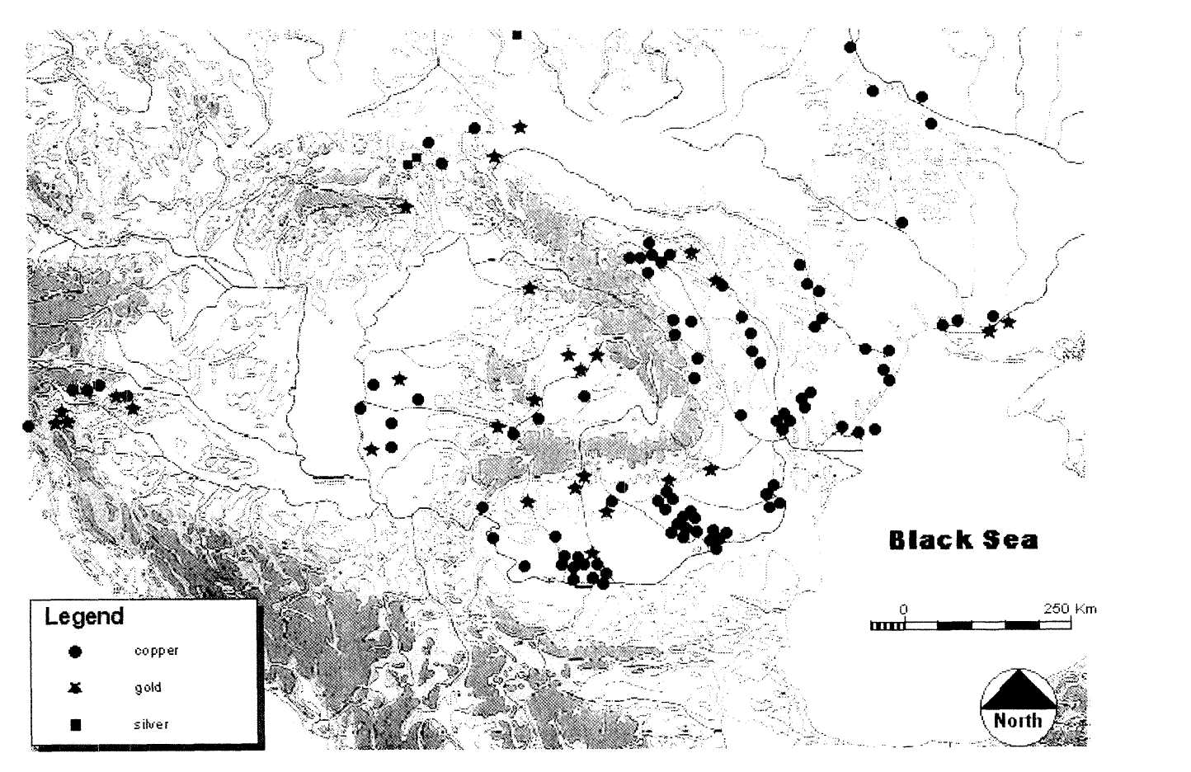
The Balkans and the Danube limes
The making of the Slavs
in mints represented in hoards found in Romania
the quinquennial one 5 solidi. Donativa were still paid in 578 and the practice of ceremonial payments to the army may have survived as late as 641.⁹⁸ In addition, the distribution of late sixth-century hoards of solidi within the Balkans coincides with the shift of military operations from the eastern to the western Balkans, which took place in the late 570s and early 580s in connection with the siege of Sirmium by the Avars and the Sclavene raids into Greece. Hoards of five to nine solidi may therefore be seen as an example of the correlation between mint output and hoarding, on one hand, and military preparations, on the other. Such hoards indicate the presence of the Roman army, not Avar or Slavic attacks. Their concealment is not necessarily the result of barbarian raids, because their owners may have kept their savings in cash in a hiding place
⁹⁸ Curta 1996:86 and 103; Hendy 1985:188 and 646-7. According to Wolfgang Hahn (1981:96-7), the 23-carat solidi introduced by Maurice were specifically struck for his quinquennial donativum
of 587.
Figure 9 Distribution of stray finds of coins of Anastasius and Justin I north of
the Danube frontier
Figure 10 Distribution of stray finds of coins of Justinian north of the Danube
frontier

I78
179

Figure и Distribution of stray finds of coins of Justin II, Tiberius II, and
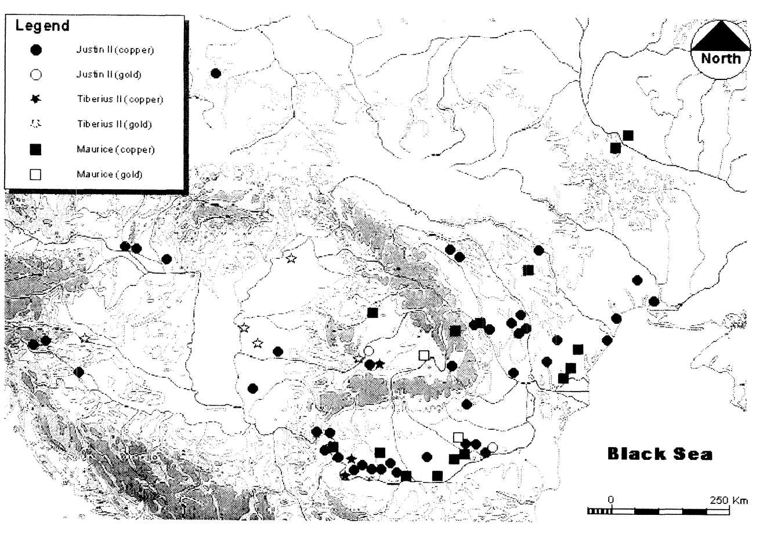
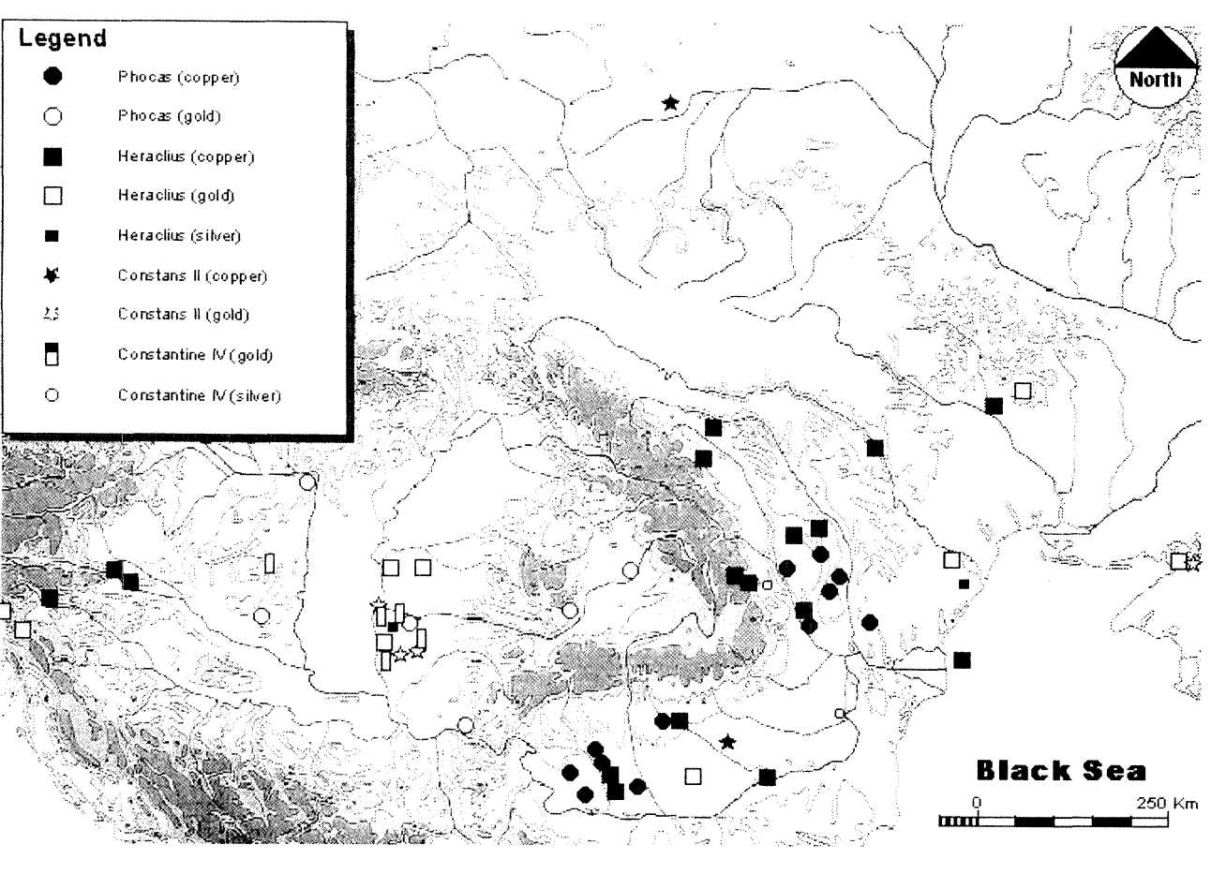
The making of the Slaps
Maurice north of the Danube frontier
Figure 12 Distribution of stray finds of coins of Phocas, Heraclius, Constans II, and Constantine IV north of the Danube frontier
The Balkans and the Danube limes
custodiae causa, not ob metum barbarorum." In contrast with the abundance of low value coinage, finds of late sixth-century gold coins are extremely rare in the regions beyond the Danube frontier. This may indicate that few such savings fell into the hands of Sclavene or Avar marauders. The chronology of gold hoards, on the other hand, is different from that of hoards of radiate. While the number of hoards of copper considerably diminished after с 6oo, small quantities of gold, possibly donativa, were still hoarded in the early seventh century.¹⁰⁰
During the early 6oos, both copper and gold continued to reach the regions north of the Danube. By 620, however, the distribution of the new silver coinage, the hexagram, provides a true measure of disruption. Only two hexagrams are known so far from the Balkans. By contrast, a large number of silver coins were found north of the Danube (Figures 4 and 12). The majority were struck for Constans II and Constantine IV. Many hoard specimens are freshly minted and die-linked, which may indicate that they did not change hands much after leaving the mint. Hoards of hexagrams have been interpreted as bribes or gifts sent directly from Constantinople to some barbarian, most likely Bulgar, chieftains. Viewed against the background of general decline, if not total cessation, of coin circulation in the Balkans, these shipments of silver to the regions north of the Danube are in sharp contrast to the small accumulations of copper in sixth-century hoards on both sides of the Danube frontier of the Empire.¹⁰¹ They delineate a different distribution network for the Byzantine coinage, itself the result of changing military and political circumstances.¹⁰²
CON CLUSION
Justinian, or, more probably, one of his Vaubans named Viktorinos, designed the defense system of the Balkans as a network of three interrelated fortification lines. This plan is spelled out by Procopius, and
⁹⁹ For the association between mint output and military operations, see Metcalf 1976:92. For hoards of gold and the presence of the military, see also Poenaru-Bordea and Oche§anu 1983—5:180; Iurukova 199213:287. See also Okamura 1990:51.
¹⁰⁰ Gerasimov 1959:263; Iurukova 1980; Avramea 1983:58 and 65; Marovic 1984:302. For an unusu ally rich hoard, see also Iurukova 1992a; Fiedler 1994a: 31 with n. 2.
¹⁰¹ Curta 1996:109—16. The two hexagrams found south of the Danube are those from the Valea Teilor hoard. See Oberlander-Tarnoveanu 1980:163—4. For the hexagram, see Yannopoulos 1978; see also Hahn 1978—9. For hexagrams found north of the Danube, see Radomersky 1953; Fiala 1986; Mitrea 1975; Bonev 1985; Somogyi 1997.
102 "pjjjg |_{s} f_{ur}ther substantiated by the two ceremonial issues from a late seventh-century hoard and by Emperor Constantine IV's seal, all found in Siliistra (Bulgaria). See Angelova and Penchev 1989:40; Barnea 1981. For the Silistra "coins" as ceremonial tokens for the anniversary ot either Rome (April 21) or Constantinople (May 11), see Hahn 1975:156.

180

The making of the Slavs
archaeological investigations proved the existence of three successive lines of fortifications along the Danube, the Stara Planina range, and the high ridges of Istranca Daglar. The system may have been implemented shortly after the devastating Cutrigur invasion of 539/40. The major part of this grandiose building program was already finished in 554, when Procopius ended Book iv of his Buildings. This program was later extended to the northwestern Balkans, following the defeat of the Ostrogoths and the conquest o| Dalmatia. In the central Balkans, Justinian laid a stronger emphasis on the second line of defense, for the largest number of forts were found around the main mountain passes across the Stara Planina. Many forts in the northern and central Balkans were quite small. Among seventy forts found in Bulgaria until 1977, more than half were less than 1 ha, and among those, the majority had no more than 0.5 ha.¹⁰³ A tabulation of some of the most important forts mentioned in the archaeological survey, for which exact data on the occupied area is available, confirms this conclusion (Table 7). Moreover, a closer examination of the tabulated forts shows that most of those built along the Danube frontier, in either Moesia Superior or Dacia Ripensis, were remarkably small. By contrast, forts built in Macedonia, in Scythia Minor, or Achaia tend to be large, over 1 ha. How could this situation be explained?
One way to answer this question is to tackle the problem of the troops used to man these forts. On the basis of archaeological research at Isthmia, Nick Kardulias has recently argued that estimates of the military population of sixth-century forts should be based on a coefficient of 1.8 to 2.7 square meters per man, which corresponds to calculations based on the archaeological evidence from the Late Roman forts at Lejjun, on the Arabian frontier, and at Thamughadi, in North Africa, as well as to the sleeping space in modern, standard US-army 25-man barracks for enlisted men. Figures obtained by using this coefficient show that most small forts did not hold more than a numerus (or tagma), the basic tactical unit of the early Byzantine army, with numbers varying from 100 to 500 men. Garrisons at large forts, such as Krivina (Iatrus), Jelica, Isthmia, or Nikiup (Nicopolis), may have held maximum forces ranging between 2,000 and 4,000. By contrast, adding up the lowest estimated numbers of soldiers for all garrisons of forts with known area, which were found in the Iron Gates segment of the Danube frontier, we obtain a total force of slightly more than one legion with an operational strength of 5,000 men (Figure 13).¹⁰⁴
¹⁰³ Ovcharov 1982:22. For Justinian's plan, see Procopius Buildings iv i.
¹⁰⁴ Kardulias 1988:207, 1992:282-3, and 1993. A srxth-century military treatise (De Re Stmtegica, p. 9) recommends that "the men in the garrison should not have their wives and children with them." However, "if a fort is extremely strong, so that there is no danger of its being besieged, and we can keep it provisioned without any problems, then there is no reason why the men cannot have their families reside with them." Indeed, the only evidence for the presence of women and children in sixth-century forts comes from large ones, such as Isthmia and Jelica.
l82
The Balkans and the Danube limes Table 7 Sixth-century Balkan forts: area and estimated number of soldiers

 |  | Area | Estimated number
Fort | Province | (in hectares) | of soldiers
I Nikiup | Moesia Inferior | 5-74 | 3,589 to 3,651
i Venec | Macedonia | 3.00 | 1,876 to 1,908
Pcinja | Macedonia | 3.00 | 1,876 to 1,908
Krivina | Moesia Inferior | 2.80 | 1,751 to 1,781
Debreste | Macedonia | 2.80 | 1,751 to 1,781
¹ Isthmia | Achaia | 2.71 | 1,694 to 1,724
Balchik | Scythia Minor | 2.60 | 1,626 to 1,654
Dolojman | Scythia Minor | 2.50 | 1,563 to 1,590
Pantelimon | Scythia Minor | 2.20 | 1,375 to 1,399
Enisala | Scythia Minor | 2.00 | 1,250 to 1,272
! Karatas | Dacia Ripensis | 1.87 | 1,169 to 1,189
Vavovo | Moesia Inferior | 1.80 | 1,125 to 1,145
Korinjski | Dalmatia | 1.80 | 1,125 to 1,145
; Kaliakra | Scythia Minor | 1.70 | 1,063 to 1,081
| Korintija | Dalmatia | 1.70 | 1,063 to 1,081
Momcilov g. | Dacia Mediterranea | 1.50 | 93^ to 954
Saldum | Moesia Superior | 1.36 | 850 to 865
: Kastelina | Dalmatia | 1.30 | 813 to 827
Kula | Dacia Ripensis | 1.25 | 781 to 795
j Dvoriste | Macedonia | 1.00 | 625 to 636
¹ Sapaja | Moesia Superior | 0.86 | 538 to 547
Nova Cherna | Moesia Inferior | 0.81 | 506 to 515
Vrbljani | Dalmatia | 0.66 | 413 to 420
Sadovec | Dacia Ripensis | 0.65 | 406 to 413
j Sivri Tepe | Moesia Inferior | 0.50 | 312 to 318
Zelenikovo | Macedonia | 0.50 | 312 to 318
Cetacea | Dacia Ripensis | 0.47 | 294 to 299
Ovidiu | Scythia Minor | 0-37 | 231 to 235
Ljubicevac | Dacia Ripensis | 0.36 | 225 to 229
Dyadovo | Thrace | 0.36 | 225 to 229
! D. Butorke | Dacia Ripensis | 0-33 | 206 to 209
Ljubanci | Macedonia | 0.30 | 188 to 191
i Glamija | Dacia Ripensis | 0.28 | 169 to 172
| Milutinovac | Dacia Ripensis | 0.27 | 168 to 171
Ravna | Moesia Superior | 0.24 | 150 to 153
Bosman | Moesia Superior | 0.20 | 125 to 127
Mora Vagei | Dacia Ripensis | 0.03 | 19
183
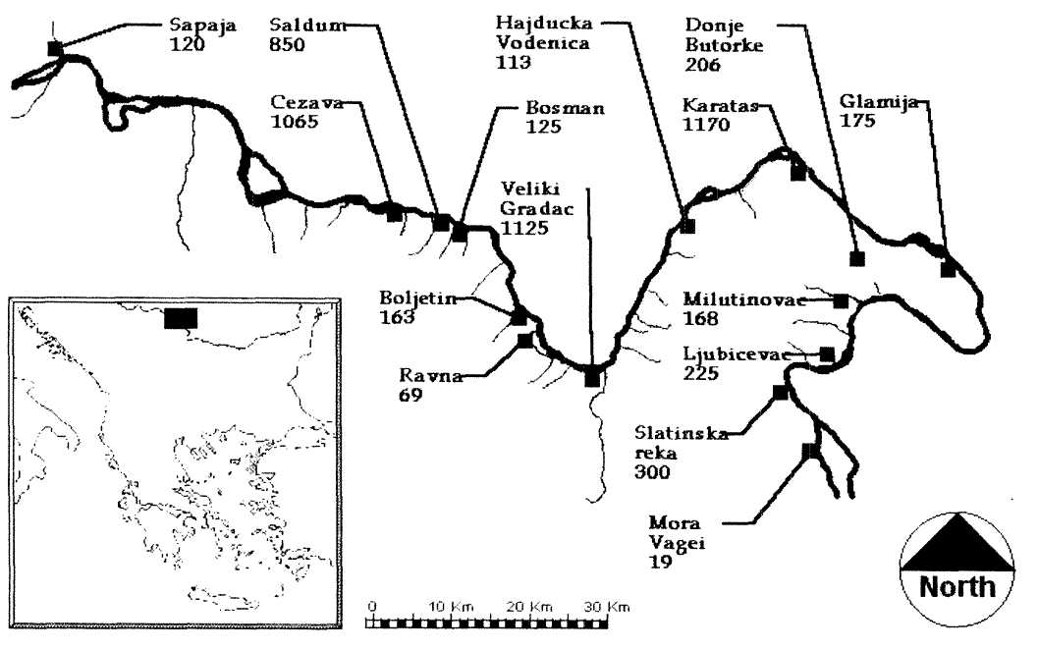
The making of the Slavs
Figure 13 Sixth-century forts in the Iron Gates segment of the Danube limes,
with estimated numbers of soldiers
It has been argued that Justinian depended on local farmers, serving as a kind of peasant militia, to defend his walls and forts in the Balkan peninsula.¹⁰⁵ Both the absence of rural settlements and the great number of forts, especially in the northern Balkans, show this conclusion to be wrong. It would not have made much sense for the state to undertake such expensive building projects, only to leave defense of these fortifications in the hands of local militias. Whether or not the troops which manned the forts remained there for a longer term cannot be decided on the basis of the archaeological evidence alone. But the general picture obtained from this evidence is one of rather permanent garrisons, at least in medium to large forts, with houses, amenities, and churches.
The evident association of smaller forts with the regions in the northern Balkans does not indicate that the defenders were fewer. Justinian's building program was designed to increase the potential of the existing troops by dividing and subdividing them into smaller units capable of manning the newly built or restored forts. Frontier areas, such as the mining district at the border between Dacia Ripensis and Moesia Superior, received special treatment with barrier walls and towers built across the outlets of the tributaries into the Danube.¹⁰⁶ An important role was that of the Danube fleet. Theophylact Simocatta shows that in the
¹⁰⁵ Rosser 1985:253.
106 \K/_{erner} 1986:562. Elsewhere in the Balkans, barrier walls seem to have been either earlier con structions (the Hexamilion) or designed to protect water supplies (the Long Walls). See Gregory I982b:2i; Harrison 1974:247; Crow 1995:117. For the Long Walls as predating Anastasius' reign, see Стоке 1982 and Whkby 1985b.
184
The Balkans and the Danube limes
late sixth century, Securisca was still an important center for producing boats and rafts for the army. Archaeological excavations indicate that the location of forts on the right bank of the Danube was influenced by the location of major ports of the Danube fleet. The Danube fleet was under the command of the quaestor exercitus, the office created by Justinian in 536 by combining two Balkan provinces, Scythia Minor and Moesia Inferior, and two provinces overseas, Caria and Cyprus, into a single administrative unit in which the fleet played an obviously crucial role. Moreover, since the quaestor exercitus was not only the most important military commander of the Thracian diocese, but also the most important administrative office in that region, some historians suggested that the quaestura Iustiniana exercitus was an antecedent of the first theme, the Karabisianoi.¹⁰⁷
In contrast to other regions, where Justinian's program simply consisted of restoring older constructions, the building activity in the northern Balkans seems to have been taken more seriously. Local quarries, such as those of oolitic limestone in the Svishtov-Ruse area, supplying all sites in the Iantra valley, provided most of the building materials. Who took the responsibility for all these forts? Frank Wozniak suggested that local aristocrats and their personal armies took the provincial defense into their own hands. If true, this hypothesis would still have to account for the problem of how forts were supplied with ammunition, weapons, and food. Themistius' evidence from the fourth century suggests an important role of the central government and the imperial administration. There are some indications that the system was still in use during the sixth century.¹⁰⁸
Ever since Α. Η. Μ. Jones interpreted the quaestura exercitus as an administrative reform designed to ensure a continuous food supply for troops stationed on the Thracian border, scholars insisted that the attributions of the quaestor were primarily financial. He was directly responsible for the annona of the army in Moesia Inferior and Scythia Minor. In addition, lead seals found in the region point to communication of some regularity between the two Balkan provinces included in the quaestura exercitus and the central government. Thirteen imperial seals, nine of
¹⁰⁷ Theophylact Simocatta vin 6.7. The major ports of the Danube fleet were Ratiana, (Se)cunsca, and Transmarisca. See Mitova-Dzhonova 1986:506. For the Karabisianoi, see Szadeczky-Kardoss 1985:61 and 63.
108 Themistius, Oratio 10.136, trans. P. Heather and J. Matthews (Liverpool, 199r), 44; Velkov 1987:147. For an earlier example of central distribution, see Whittaker 1994:103 and 105. For a detaued discussion of annona in the early Byzantine period, see Durliat 1990:37—282. For local aristocrats and sixth-century forts, see Wozniak 1982:204 and 1987:265. For marble quarries in Macedonia, see Keramidchiev 1981—2:123. For stone-cutting workshops in Thrace, see Vaklinova 1984:647—8.
18s
The making of the Slaps
which are from Justinian, demonstrate that officials in Scythia Minor received letters and written orders from the emperor.¹⁰⁹
Even more interesting is the evidence of amphoras. Egyptian papyri show that the daily food ratio for a soldier consisted of three pounds of bread, two pounds of meat, two sextant of wine and 1/8 sextarii of olive oil. At least three elements of this ratio were commodities usually transported in amphoras. The capacity of these vessels varied minimally, as suggested by a few measurements taken, and never exceeded forty to fifty liters, the majority ranging between fifteen and twenty-five liters. There are two basit types according to the shape: squat or globular, and oblong or elongated. The first type, subdivided into Late Roman 2 (LR 2), Kuzmanov XIX = Scorpan XIII, and Kuzmanov III = Scorpan VI, is well represented in sixth-century Balkan forts. LR 2 amphoras were produced in the Aegean and were used for transporting either wine (as indicated by grape seeds found in some cargo amphoras on the Yassi Ada shipwreck) or olive oil. Such amphoras were quite common on sixth-century sites in Greece (e.g., Argos), as well as in northern and central Balkan forts. The same is true for Kuzmanov III = Scorpan VI, a type well represented at Ratiaria and Cape Kaliakra. As for the Kuzmanov XIX = Scorpan XIII amphoras, presumably used for transporting wine, they were found in great quantities at Krivina (Iatrus) and Voivoda. No globular amphoras were found in the Balkans in seventh-century contexts.¹¹⁰
Elongated amphoras of a type known as Late Roman 1 (LR 1) were also a familiar presence. Produced in Cilicia, near Antioch, in Cyprus, as
¹⁰⁹ Imperial seals: Barnea 1984:95; Schultz 1978:100; Culica 1975:246; Barnea 1982:202; Gerasimova-Tomova 1992:70; Barnea 1969:29—30. A seal of Justinian of unknown provenance, now in the National Museum at Sofia, may have been found in Bulgaria. See Mushmov 1934. By contrast, only one imperial seal is known from the interior (Gaj-Popovic 1980:165). Similarly, only one seal of Justinian was found in Crimea. See Sokolova 1991:204. The sigillographic evi dence from the Balkans includes an abundance of official seals: prefects, eparchs, consuls, chartu- larii, magistri, and a secret is. They must have belonged to the local administration. Three seals belong to stratelates, one of whom may have been the last king of the Gepids, Cunimund. By contrast, the sigillographic evidence from Crimea produced no seals of prefects, eparchs, consuls, or military officials. Attributions of the quaestor exercitus: Jones 1964:280; Torbatov 1997:78 and 80.
¹¹⁰ Daily food ratios: Bottger 1990:926; Torbatov 1997:82 with n. 4. For early Byzantine amphoras, see Hautumm 1981:38; Bottger 1988:73-4; Bakirtzis 19893:73; Van Doorninck 1989:248 and 252; Conrad 1999. LR 2 amphoras reached Ireland and England and made their way into Avar burials and local settlements north of the Danube frontier. See Hautumm 1981:43—4; lakobson 1979:14; Cantea 1959:22; Mitrea, Eminovici, and Momanu 1986—7:224. This distribution sug gests that LR 2 amphoras carried some precious substance, arguably a liquid, not just plain grain supplies. Balkan finds of LR 2: Abadie-Reynal 1989^53; Kuzmanov 1974:313, 1978:21, and 1987:115; Jeremic and Milinkovic 1995:224 fig. 31; Uenze 1992:302; Mackensen 1992:252; Popovic 1987:13. For Kuzmanov XIX=Scorpan XIII amphoras, see Bottger 1990:926; Kuzmanov 1985:25.
186
The Balkans and the Danube limes
well as in Rhodes, they were used for transporting wine, oil, or grain. They were the commonest of all amphoras at Argos, in Greece, Constantinople, and on many military sites in the Balkans. They were also found in great quantities in Crimea and on the eastern Black Sea coast. The Yassi Ada shipwreck produced a large number of LR ι amphoras, though in relatively fewer quantities than the LR 2 type. Unlike this latter type, LR 1 amphoras are also known from early seventh-century contexts. A closely similar type, Kuzmanov XV = Scorpan XII is one of the three types found at Krivina (Iatrus), but it is also known from early Byzantine forts on the eastern Black Sea coast and in Crimea. A second variant of the elongated type is known under the rather improper name of spatheion. Spatheia were most probably produced in the east Mediterranean area and may have been used for carrying olive oil, though other commodities, such as garum or honey, may not be excluded. Such amphoras were relatively rare at Argos and 111 Constantinople. The Yassi Ada shipwreck produced only two specimens. But they were very common in the northern Balkans, and the only type of early Byzantine amphoras found on hilltop sites in Slovenia.¹¹¹
By contrast, types produced in Palestine (Late Roman 4 to 6), which were common in the western Mediterranean area and in Gaul, where they certainly transported wine, are comparatively much rarer. Only a few fragments were found in Constantinople, at Histria, Novae, and at Cape Kaliakra. Large quantities come from Argos and from some other sites in Greece, where LR 1 and LR 2 do not occur too frequently. Catherine Abadie-Reynal first attempted to explain this difference in distribution patterns by pointing to different distribution networks. She argued that Palestinian amphoras, particularly the so-called "Gaza amphora" (LR 4), seem to indicate "free-market commerce," for they crossed the Mediterranean and reached Gaul in significant quantities. Their relatively lower frequency in the Aegean area and total absence in the Balkans (except a few trade centers on the coast) suggest that the Balkans were an area of state-run distribution. The frequency curves for LR 1, LR 2, and spatheion-type amphoras seem therefore to support the hypothesis of annona-type distributions to the army This is also suggested
¹¹¹ LR 1 amphoras: Mackensen 1992:252; Hautumm 1981:64; Hayes 1992:64; Jovanovic 1982-3:325; Popovic 1987:13; Opait; [984:320; Kuzmanov 1974:3 Г2 and 1978:22; lakobson 1979:14; Van Doorninck 1989:247; Alien 1996. For Kuzmanov XV=Scorpan XII amphoras, see Bottger 1990:926; lakobson 1979:12. Bottger (1988:74) suggested that the Kuzmanov XV amphora was produced in the Balkans, but no evidence exists to support this idea. For spatheia, see Mackensen 1992:252; Bottger 1990:926; Borisov 1985:42; Jovanovic 1982—3:325; Mackensen 1987:258; Knific 1994:220. By contrast, in Gaul, particularly at Marseille, spatheia appear in great quantities in fifth-century deposits, but are very rare in the 500s and early 600s. See Boniray and Pieri 1995:97.
187
The making of the Slavs
by the constant association of these amphoras with military sites, as well as by their relatively homogeneous typology.¹¹²
That the sixth-century limes still relied on the central distribution of grain is shown by legislative measures taken by emperors from Anastasius to Justin II. AH attempted to provide a solution to the irremediable problem of making a much impoverished and depopulated region of the Empire capable of producing enough food for the troops corning to its defense. Approaches to this problem ranged from compulsory collection of the annona to tax exemptions, but in all cases at stake were food supplies for troops stationed in Thrace or Moesia Inferior. Some have even and rightly assumed that the very creation of the quaestura exercttus in 536 was a solution to the problem of helping Scythia Minor and Moesia Inferior feed their troops with supplies from the rich overseas provinces. That none of these measures proved to be successful is indirectly shown by the Strategikon. Its author, an experienced military officer, not only knew that the Sclavenes buried "their most valuable possessions" in secret places, but also recommended that "provisions found in the surrounding countryside should not simply be wasted," but shipped on pack animals and boats to "our own country." The evidence of the Strategikon is archaeologically confirmed by the changing consumption patterns. In addition to shipments of annona, the soldiers of the fort at Iatrus relied heavily on hunting for meat procurement. Garden cultivation of millet and legumes at Iatrus and Nicopolis, as well as the occasional presence of agricultural implements elsewhere, suggest that the annona was not sufficient for the subsistence of the frontier troops. On the other hand, that Roman soldiers may have relied on food captured from the enemy is also a good indication of the ongoing crisis.¹¹³
A project of gigantic proportions and overall excellent execution, Justinian's system failed to provide the expected solutions because its maintenance would have required efforts far beyond the potential of the Roman state, particularly of the Balkan provinces. Clearly what seems to
¹¹² See Abadie-Reynal 1989b: 159. For finds in Gaul, see Bonifay, Villedieu, Leguilloux, and Raynaud 1989:31. For Novae, see Kienina 1999:87. For finds in Histria, see Pippidi, Bordenache, and Eftimie 1961:241. The cargo on the Yassi Ada shipwreck has been associated with food sup plies for the army, perhaps in connection with the quaestura exercitus. It is possible that the ship sunken off the southwest coast of Turkey shortly after 625 transported annona distributions to the Byzantine army in the East. See Aifen 1996:213.
¹¹³ Strategikon xi 4.8 and 32. Sec Velkov 1962:58-9; Torbatov 1997:80. Roman armies and populace were twice supplied with food by the Avars, first after the fall of Sirmium, as the conquering Avars supplied the desperately starving besieged with "bread and wine" (John of Ephesus v.32); and then during a five-day truce for the celebration of Easter, in 598, "when famine was press ing hard on the Romans" and the qagan "supplied the starving Romans with wagons of provi sions" (Theophylact Simocatta vn 13.3—4). By contrast, the Avars, unlike Germanic federates, never received supplies of grain from the Romans. See Pohl 1991^599.
I88
The Balkans and the Danube limes
have happened after Justinian's death, if not earlier, is that the emperor's building program, whose implementation coincides with the last phase of a sharp decline of the rural population, proved to be an unbearable burden for the provincial administration. When the central distribution of annona completely ceased, maintaining the troops on the frontier became impossible. During Maurice's reign, the Roman army on the Danube frontier twice mutinied, and the second rebellion brought about the emperor's rapid fall. In both cases, at stake was the deterioration of the living standards and the social status of the field army as a consequence of Maurice's intended reforms.
But when did the system eventually collapse? The communis opinio is that as soon as Phocas' rebellion broke out, the limes crumbled and the Slavic tide invaded the Balkans. This idea, however, does not stand against the archaeological evidence. The year 602 has no archaeological significance for the early Byzantine settlements in the northern Balkans. Most cities and forts along the Danube frontier had already suffered heavy destruction by fire at some point between Justinian's and Maurice's reigns, at least twenty years before Phocas' rebellion. In many cases, destruction was followed by rebuilding. We have seen that the number of forts apparently abandoned without any signs of violence by far exceeds that of forts presumably sacked and destroyed by barbarians. Moreover, recent research shows that Phocas' purge of the Danubian army did not prevent it from returning to the Danubian front after overthrowing Maurice, in order to continue operations against the Avars and the Slavs. It remained there until Phocas concluded a treaty with the qagan in 605, in order to transfer the army to the Persian front. In 620, Heraclius definitely moved all troops from Europe to the eastern front. The general withdrawal of troops from the Balkan front thus coincides in time with the definite cessation of grain supplies (annona) from Egypt, now occupied by the Persians. The effects of the latter on grain supplies for Thessalonica are well, if indirectly, documented by the Miracles of St Demetrius. The Arab conquest of Syria and the subsequent developments prevented the return of the army to Thrace. The Thracian troops would be relocated in western Anatolia and Thrace remained without any troops until 680 or 690, when the Thracian theme first emerged. By that time, Justinian I's system of defense was already history.¹¹⁴
¹¹⁴ Sebeos, p. 80. See Olster 1993:69. For the archaeological significance of ad 602, see Shuvalov 1989. For the creation of the Thracian theme, see Lihe 1977:27.
189

Chapter 5
BARBARIANS ON THE SIXTH-CENTURY DANUBE FRONTIER: AN ARCHAEOLOGICAL
SURVEY
Following the collapse of the Hunnic polity in the mid-fifth century, and the military and political recovery of the Empire in the late fifth and early sixth centuries, the northern frontier along the Danube became a key element of early Byzantine foreign affairs. The fifth, sixth, and seventh centuries were also a period of dramatic changes among the Empire's northern neighbors. For the making of the Slavic ethnie, these changes were particularly crucial. Justinian's defensive program on the Danube frontier triggered the social and political effects that led to the process of ethnic formation described in the last chapter. Equally important was the Empire's relationship with the neighbors of the Slavs, the Gepids, the Lombards, the Cutrigurs, and the Avars. The boom which has taken place in medieval archaeology over the last few decades has made this relationship far more visible than was possible on the basis of written sources alone. The purpose of this chapter is to examine the results of archaeological investigations and the problems raised by their interpretation. Emphasis will be laid upon the use of material culture for building group identity or creating symbols of power. I will first examine the evidence from the sixth-century Carpathian basin and neighboring regions, followed by a brief survey of Avar archaeology. The last section of this chapter is devoted to the archaeology of the steppe north of the Black Sea and to problems of chronology and interpretation of hoards of silver and bronze, which are relevant for the archaeological assemblages discussed in the next chapter.
Barbarians on the frontier
Emperor Marcian, and the Gepids were now paid 100 lb of gold solidi annually In 471, they occupied Pannonia Secunda (present-day Srem and Slavonia), but were attacked in 504 by an Ostrogothic army led by Count Pitzas. The Gepids attempted to regain Sirmium, but Vitigis ousted them in 528. As the Gothic war started in Italy, however, they eventually occupied Sirmium and Bassiana. They allied themselves with the Franks and began raiding into the Balkans. In response, Emperor Justinian decided to give the Lombards the annual subsidies until then paid to the Gepids. The Gepids were defeated in 547 by an allied Lombard—Byzantine—Herul force, and again, in 551 or 552, by Lombards alone. They were led by petty kings ruling over the eastern part of the Carpathian basin. In the late 480s, Thrapstila was "king" of Sirmium, followed at his death by his son, Thrasaric. Cunimund, who ruled between 560 and 567, also resided in Sirmium, together with the Arian bishop of the Gepids. In Sirmium, Cunimund minted silver imitations of Byzantine and Ostrogothic coins.¹
Following their victory over the Herules in с 507, the Lombards moved south of the Danube's middle course into Pannonia. At some point after 526, they seem to have established themselves permanently in that region. They were most likely federates, since they appear as defending the Danube frontier, much like Suebians before them. In addition, Justinian allowed them to expand between the Sava and the Drava rivers, which brought them very close to Sirmium and to other Gepid settlements. Wacho, the king of the Lombards, had close ties to the Merovingian rulers in Reims. His eldest daughter, Wisigarda, married Theudebert in с 530, while his younger daughter, Walderada, became the wife of Theudebert s son, Theudebald (547—55). In addition, the collapse of the Thuringiaii "kingdom," following Theiidebert's victory of 534 or 535, brought large numbers of Thuringians within the area controlled by Lombards. Auduin, who ruled from 547/8 to 560/5, married Rodelinda, the daughter of Herminafred, the last Thuringian king.²
The first to speak of "Gepid culture" in relation to sixth-century artifacts found in the Hungarian plain (east of the Tisza river) was Jozsef Hampel, the founder of medieval archaeology in Hungary. The first cemetery was excavated in the early 1900s by Gabor Csallany at

THE CARPATHIAN BASIN
Attila's death and the rapid demise of the Huns opened the way for the rise of new political forces in the Middle Danube region. The Gepids were among the first to take advantage of the power vacuum. Their king, Ardaric, who ruled between 451 and 455, became the new ally of
190
¹ Procopius, Wars vn 33.8—n; Secret History 18.16— 1 у. See also Bona 1956:235 and 1976:16 and 71; Pohl 1980:289; Christou 1991:56. For the succession of Gepid kings, see Kiss 1989—90. During their raid of 539, the Gepids of Thrasaric killed magister inilitnm Calluc (Jordanes, Romano 387). To Jordanes, the Lombards were the allies of the emperor against the Gepids (Romana 386). The chro nology of the Lombard—Gepid wars has been disputed. Most scholars, however, adopted 547 for the first confrontation, 549 for the second, and 551 for the third war. See Christou 1991:84, 91, and 95; Pohl 1997:90.
² Christou 1991:59 and 62; Bona 1990b: 14—1 5. For Frankish—Lombard relations, see also Werner 1962:136.
191

The making of the Slavs
Berekhat, near Szentes. By 1925, Karolyi Eperjesy had unearthed the cemetery at Csanad-Bokeny, the first to be coin-dated to the late fifth century. Shortly after World War II, Kurt Horedt began working at Moresti, in Transylvania, the first fully excavated, sixth-century, settlement in the Carpathian basin. The "Gepid culture," however, came to be more often associated with burial assemblages. In his still unrivaled monograph of 1961, Dezso Csallany listed 275 cemeteries with more than 1,900 burials and an immense quantity of artifacts. Kurt Horedt first emphasized the association of the "Gepid culture" with contemporary assemblages in Germany and France and called it the easternmost Reihengmber group.³
By contrast, the evidence of sixth-century burials in Transdanubia (i.e., the region west of the Middle Danube and presumably inhabited by Lombards) is comparatively meager. Only seventeen cemeteries are known so far in western Hungary with about 400 burials dated to the period of the Lombard presence in Pannonia. Ever since Joachim Werner subdivided the archaeological material attributed to the Lombards into three chronological phases, artifact-categories from Pannonia are viewed as different from those of Italy and the region north of the Danube river. Recent studies, however, have produced a far more complex picture. Instead of a uniform, unidirectional, migration movement, archaeologists now emphasize ties maintained between regions north and south of the Middle Danube. After с 450, a new burial pattern made its appearance in Bohemia, Moravia, and Slovakia. Warriors were buried with large numbers of weapons (swords, spears, arrow heads, shield bosses, and axes). Close contacts were maintained with Merovingian Gaul, as indicated by the glass beaker found at Zohor, and with the Scandinavian world, as exemplified by the cross-brooch found at Orasice. A significant change in fashion is also visible in female burials. Besides a pair of brooches at shoulders, women wore one or two additional fibulae attached to leather straps hanging from the belt and adorned with amber or glass beads. That occupation of the area north of the Danube continued even after the Lombards established themselves in Pannonia is shown by finds of stamped pottery in Moravia. On the other hand, strong ties were maintained with the regions further to the north. This results, for example, from the unusual association at Kajdacs of thirty-eight inhumations with ten contemporary cremation burials. Further confirmation comes from finds of handmade pottery similar to that produced in central
³ Hampel 1905:776; Bona 1979a: 10; Csallany 1961:17; Horedt 1979a. See also Horedt 1977. The term Reihengraberkreis was coined in 1858 by Ludwig Lindenschmidt and was used to describe funerary assemblages of the Merovingian period. The German archaeologist Joachim Werner first attempted to build a chronology for this archaeological horizon. See Werner 1935.
Barbarians on the frontier
Bohemia. Some archaeologists laid a particular emphasis upon a variety of small, handmade pots, which were found only in children's burials. Such pots were hastily classified as Slavic, Prague-type pottery, in an attempt to provide an archaeological illustration to Procopius' story of Hildigis and his retinue of Sclavene warriors (see Chapter 3). Similar pots, however, appear in contemporary children burials east of the Tisza river, in "Gepidia." This further indicates that deposition of handmade pots should be interpreted in terms of age status, not ethnicity. Istvan Bona rightly rejected the interpretation of handmade pots in connection with the episode of Hildigis, by pointing to substantial chronological differences.⁴
Cemeteries in "Lombardia" appear along the right bank of the Danube, between Vienna and Budapest, often near already abandoned Roman forts, but no associated settlements have been found. Contacts with the western Frankish world increased during this period, as indicated by the growing number of Frankish—Alamamiic brooches, which are otherwise absent from both Bohemian—Moravian and later Italian assemblages. The same is true for finds of swords with damascened blades (such as that from Tamasi), which point to production centers in the Rhine valley.⁵ Unlike the Frankish Reihengraberkreis, cemeteries in western Hungary produced a relatively large quantity of millefiori beads. Such beads were produced in Italy or in some other place in the eastern Mediterranean. By contrast, amber beads almost disappear from funerary assemblages, though connections with Scandinavia certainly continued, as evidenced by the introduction of the so-called "animal Style I" for the decoration of local types of brooches or by finds of bracteates (e.g., burial 21 at Varpalota). Scandinavian connections, perhaps mediated via "Lombardia," are also visible in funerary assemblages within the Empire's frontiers. A pair of Scandinavian brooches was found in association with a freshly minted
⁴ See Bona 1979^393— 4 and 19793:24; Menghin 1982:59—60; Christie 1995:37. Phasing of the archaeological evidence: Werner 1962; Tejral 1990:231. North Danubian phase: Tejral 1975. Contacts with Merovingian Gaul and Scandinavia: Pieta 1987:394-5; Zeman 1987:521. Female dress: Bona 1976:41; Zeman 1987:521. The stamped pottery was produced only in Pannonia and only after с 530 (Werner 1962:54). Kajdacs: Bona 1979^395; Menghin 1982:60. Handmade pottery: Werner 1962:60; Bona 1979b:399—400.
⁵ Lombard occupation of abandoned Roman sites: Bona 1976:33. Sixth-century settlements in Bohemia and Moravia: Vojtechovska and Pleinerova 1997; Cizmar 1997. Replicas of two brooches from Varpalota and Hegyko were found at Haulchin (Belgium) and Wiesbaden (Germany). See Werner 1962:62; Kiihn 1974:1076—86 and 1094—106. Conversely, tongs-shaped fibulae, which are typical for funerary assemblages in Bohemia and Moravia, occasionally appear in the West (Kiihn 1974:827—40). For damascened sword blades, see Bona 1978:112. The most powerful example of Lombard—Frankish contacts is that from Mosonszentjanos (northwestern Hungary). One of two burials found there produced a Frankish bell-beaker of Rhenish origin and a wooden bucket with plate escutcheon mounts with anthropomorphic heads, which are also allied to an extensive group in the Rhenish area. See Bona 1976:72—4; Menghin 1982:66—7.
193
The making of the Slavs
solidus of Justinian (dated after 538), in a female burial in Gracanica (Kosovo, Yugoslavia). Their closest analogy is the fibula from Skodborgus (Denmark), which was found together with B- and D-bracteates, dated to the early sixth century⁶
Archaeologists traditionally divide "Gepidia" into three areas: the Tisza plain, north Serbia, and Transylvania. Large sixth-century settlements excavated in Transylvania include sunken buildings (Grubenhduser) with a superstructure supported by five, six, or, sometimes, even more posts, but without any heating facility. Such buildings were common in contemporary settlements of Central and Western Europe. The earliest, but also richest, burials, dated to the second half bf the fifth century also come from Transylvania. High-status burials, with many types of often costly grave-goods, may indicate the presence of a power center, perhaps the most important in the area during the half-century following the demise of Attila's Hunnic Empire.⁷
By 500, however, the distribution of wealth changed dramatically Rich and isolated graves were replaced by relatively large cemeteries, and costly objects of gold by other, comparatively simpler, status markers. Unlike fifth-century funerary assemblages, such markers often appear in women's graves. Among the most important were silver eagle-headed buckles, lavishly decorated with niello and cabochons and equally luxurious silver or gilded silver brooches of the Aquileia class. Both artifact-types also occur in contemporary funerary assemblages in Crimea, which
⁶ MiUcfiori beads: Tomka 1980:22; Koch 1974; Fiedler 1992:81. Amber beads: Bona 1956:213; Werner 1962:82. Bracteates: Haseloff 1981:702; Werner 1962:80; Bona 1976:01. 80. Gracanica: Popovic and Cerskov 1956:319-20; Vinski 1968:106 and pis. 11—in; Haseloff 1981:238—41 and pi. 32/1. Werner assigned the pair of fibulae to a Kentish variant of square-headed brooches, but no such specimen is known from Anglo-Saxon England. See Werner 1970:77; Hines 1997. That con tacts with Scandinavia may have been mediated via "Lombardia" is shown by the large, single, fibula from Gracanica, with its footplate inspired by brooches of the Cividale, Ravenna, and Castel Trosino classes (Kiihn 1974:1187-91, 1217-24, and 1239-48). In addition, the Gracanica burial produced a buckle and two belt straps for which the closest analogies are those from the second burial at Mosonszentjanos. 1 wish to thank Dr Mihailo Milinkovic (University of Belgrade) for his kind assistance in reconstructing the exact position of the grave-goods found at Gracanica and for sharing with me his excellent knowledge of sixth-century archaeological assemblages in Yugoslav^.
⁷ Bona 1976:29-30; Cseh 1986:205. Settlements in Transylvania: Horedt 1979a; n. a. 1955a; Vlassa et al. 1966; Gaiu 1994; Barzu 1994-5; Zaharia 1994—5. There are no fully excavated, sixth-century settlements in the Tisza region, only isolated buildings. See Cseh 1997. Grubenhduser similar to those from Transylvania were found in Germany (Barhorst, Gladbach, Weimar, and Irl), England (West Stow), and Belgium (Brebieres). See Kiss 1992:59. For late fifth-century, high-status burials, see Harhoiu 1982:587. The Hunnic gold, or at least a good part of it, most likely fell into the hands oi the anti-Hunnic coalition of 454. Knowing that the Gepid king Ardaric was the leader of this coalition, it is tempting to associate the "princely graves" at Apahida 1 and и (with objects weigh ing more than 1 kg and 2.4 kg gold, respectively) with the late fifth-century Gepid royal seat. See Kiss 1987b: 58 and 61.
194
Barbarians on the frontier
points to long-distance contacts with "Gepidia." A small number of sixth-century Byzantine coins suggests that, in material culture terms, relations with the Empire had comparatively less importance.⁸
By contrast, contacts with Scandinavia were much stronger. Nils Aberg suggested that a true commercial network existed between sixth-century Gotland and Italy, in which "Gepidia," particularly after the conquest of Sirmium, played a major role. Two eagle-headed buckles were found at Tylkowo, a sixth-century cemetery in Mazuria, while Joachim Werner rightly pointed to "imports" from "Gepidia" found in the warrior burial at Taurapilis (Lithuania). An equal-armed brooch found in grave no. 84 at Szentes-Nagyhegy, in Hungary, is a typical specimen of the animal Style 1 (phase B) in east Sweden, which dates from the early sixth century To the same direction points the buckle accidentally found at Gyula, near the present-day Hungarian—Romanian border, which was certainly produced in Scandinavia in a style strikingly similar to local fibulae decorated in animal Style I. Finally, the square-headed brooch with foot-plate bar, which was found in burial no. 124 at Szolnok-Szandaszollos, is a unique continental specimen of a purely Scandinavian series of the early 500s. Such contacts were probably the result of a variety of factors, ranging from gift-exchange and exogamy to traveling craftsmen. It is much more difficult to identify trade connections. In any case, once they reached "Gepidia," few Scandinavian and Baltic goods were further redistributed into neighboring regions.⁹
This is most evident from the examination of sixth-century amber finds within the Carpathian basin. Unlike contemporary funerary assemblages in western Pannonia, burials in eastern Hungary and
⁸ According to Istvan Bona (1976:72), the mam cause for the radical changes taking place around ad 500 was that "the majority of Gepids had lost their clan rights as many were hit by poverty, wealth and power being concentrated in the hands of a small group of nobles relying on their small armed retinues." With no serious, quantitative, study of "Gepid" funerary assemblages, although plausible, Bona's interpretation is no more than pure speculation. It is true, however, that in Transylvania changing burial patterns were accompanied by the rise of hillforts, a phenomenon probably linked to dramatic social changes. See Horedt 1957, 1964, and 1969; Harhoiu 1982:590. No such forts were found in the Tisza region, which produced, however, the richest and largest sixth-century cemeteries. Eagle-headed buckles: Rush 1959; Bona 1976:13—15. Brooches of the Aquileia class: Kiihn 1965:95—101; Harhoiu 1982:589 and 1990:187. Contacts with Crimea: Ambroz 1968:14 and 17; Aibabin 1990:32—5. Sixth-century Byzantine coins in "Gepidia": Bona etal. 1993:77.
⁹ Trade network: Aberg 1953:90 and 100—1; Hines 1984:277. Tylkowo: Rusu 1959:12. Taurapilis: Werner 1977. Szentes-Nagyhegy: Csallany 1961:59—62 and pis. xxxix/5 and xli/i; Aberg 1953:102; Haseloff 1981:187—8. The animal Style 1 decoration of this fibula is very similar to that of "Lombard" fibulae in western Hungary (e.g., burial no. 8 from Bezenye). Gyula: Csallany 1961:113 and pi. схси/2; Haseloff 1981:702. Szolnok-Szandaszollos: Csallany 1961:211 and pi. ccxlvi/i; Haseloff 1981:701; Hines 1984:271-2 and 1997:28 and pi. 102a.
195

The making of the Slavs
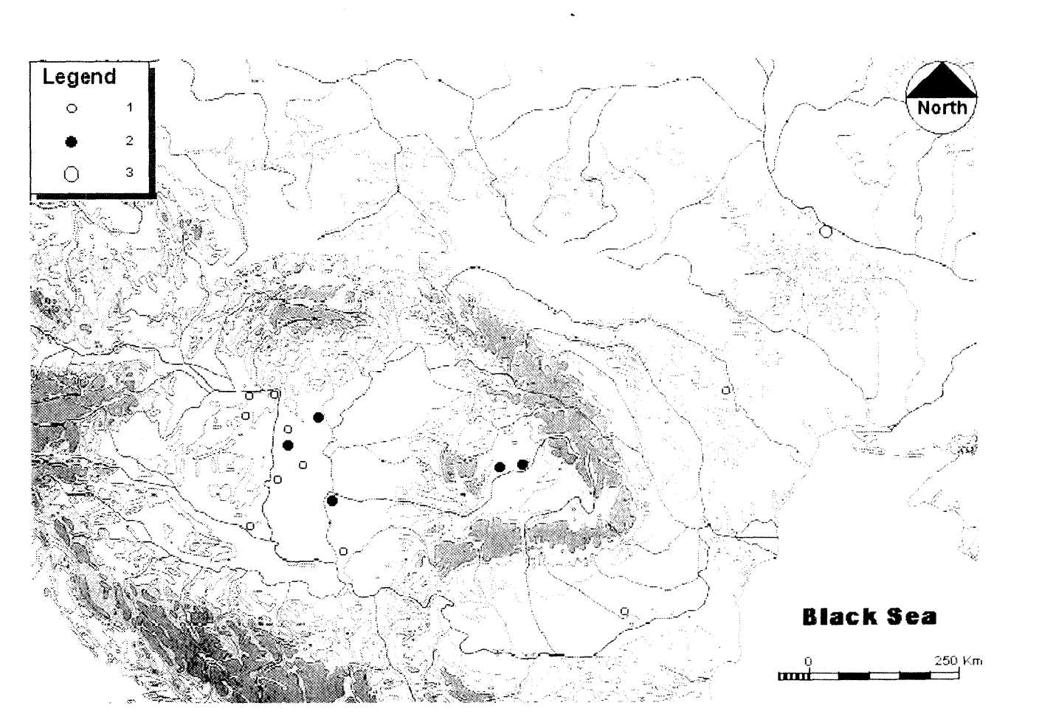
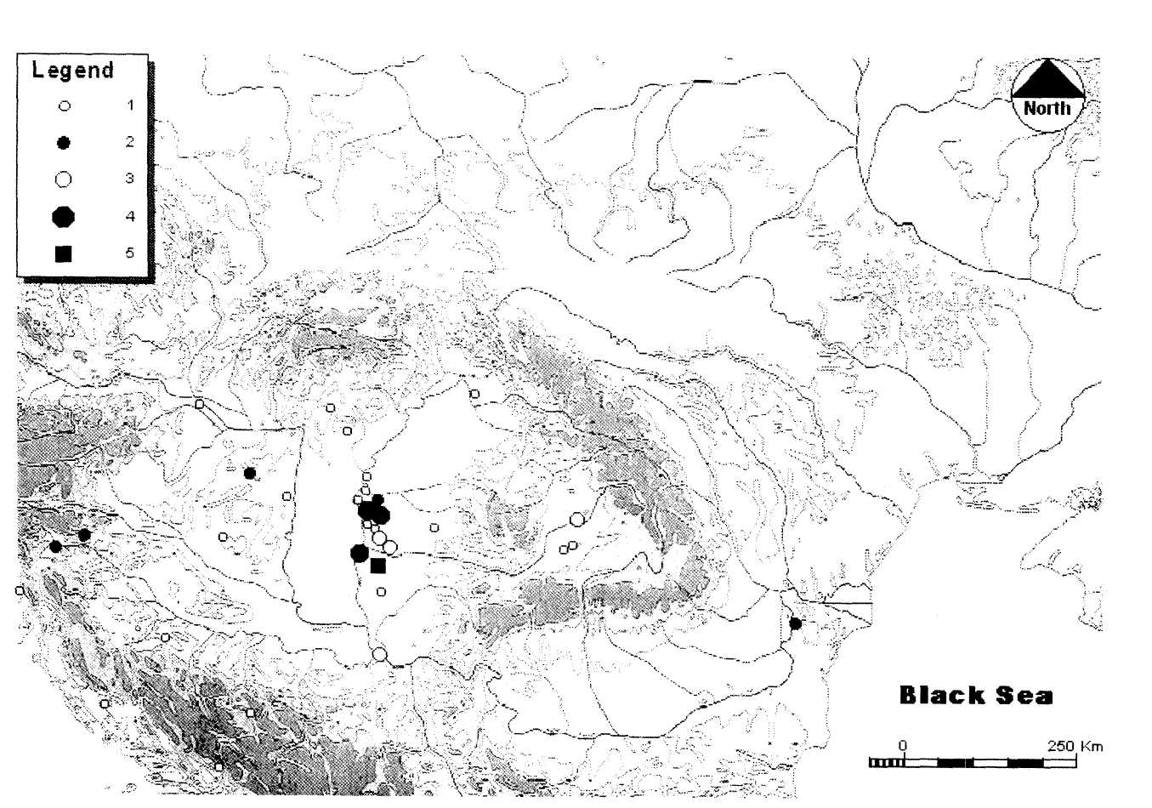
Barbarians on the frontier

Figure 14 Distribution of amber beads in late fifth- or sixth-century burial assemblages within the Carpathian basin and neighboring areas
1 - 1 specimen; 2 - between 2 and 10 specimens; 3 - between 10 and 20 specimens; 4 - between
30 and 40 specimens; 5 — over 100 specimens
Transylvania produced a large number of amber beads, often in more than one specimen and in combination with glass or chalk beads. The largest quantity in a single cemetery (138 in total) is from Kiszombor, but neighboring cemeteries (Szentes-Nagyhegy, Berekhat, Szentes-Kokenyzug, Szoreg) also produced large numbers of amber beads. A distribution map of all known finds (Figure 14) shows a concentration in "Gepidia," especially in the region on the left bank of the Tisza, between the Koros/Cri§ and the Maros/Mures, rivers. Despite the lack of any characterization studies, it is possible that these beads were made of succin ambtr, which is found on the shores of the Baltic Sea. That amber traveled along the Vistula trade route is demonstrated by amber deposits, such as that found at Basonia, but none could be dated later than с 450. The distribution map shows that if amber beads were imported into "Gepidia" from the Baltic coast, comparatively few were allowed to pass further, which may indicate that they were used, between с 500 and с 565, as markers of group identity in "Gepidia." This is also suggested by the distribution of amber beads dated to the
Figure 15 Distribution of amber beads in seventh-century assemblages withm
the Carpathian basin and neighboring areas
For symbols, see Figure [4
Early Avar period (c. 570 to с 670), which sharply contrasts with the previous, more localized distribution (Figure 15).¹⁰
As shown in Chapter 1, emblemic style often marks and maintains boundaries and transmits a clear message to a defined target population. It becomes highly visible particularly in times of sociopolitical stress and between-group competition and hostility. Archaeological finds in Hungary and the neighboring regions, which could be dated to the late fifth century or to the first two-thirds of the sixth century, concentrate either on the right bank of the Danube or on the left bank of the Tisza river (Figure 16).^{n} There are few known finds in the land between the two rivers and no sites of a fortified nature. This area was interpreted as
¹⁰ Amber beads in Pannonia: Csallany 1961:272, Provenance analysis: Petrequin et al. 1987:2180-2. For contacts between Merovingian Gaul and the Baltic coast, see also Kazanski 1991b. Almost 50 percent of the beads found in cemeteries in the northern Caucasus region and in Crimea were made of amber from the Kurzem coast. See Krumphanzlova 1992:361; Deopik 1961:204 table 1. Deposits of amber: Wielowiejski 1987:77-9 and 83. Early Avar amber beads: Toth and Horvath 1992:205—6. Amber beads found in Early Avar assemblages were interpreted as markers of the identity of Gepid communities under Avar rule. See Kiss 1996:197.
¹¹ Data after Menghin 1982 and Bona et al. 1993.

196
197

The making of the Slavs
Barbarians on the frontier

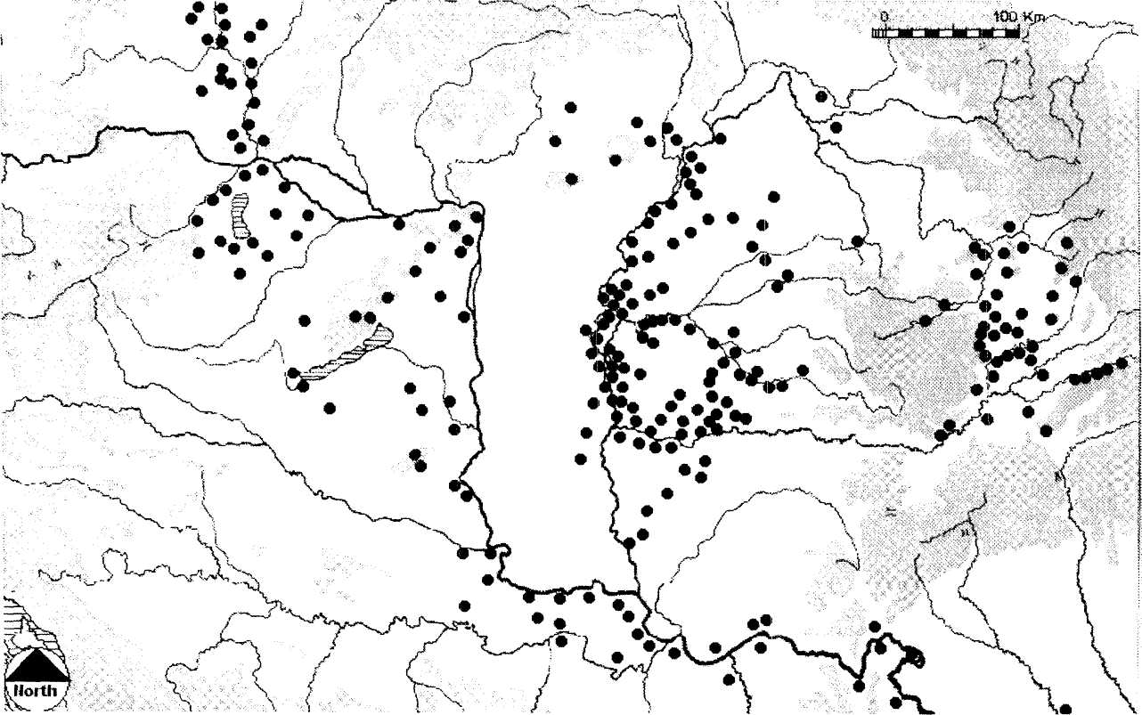
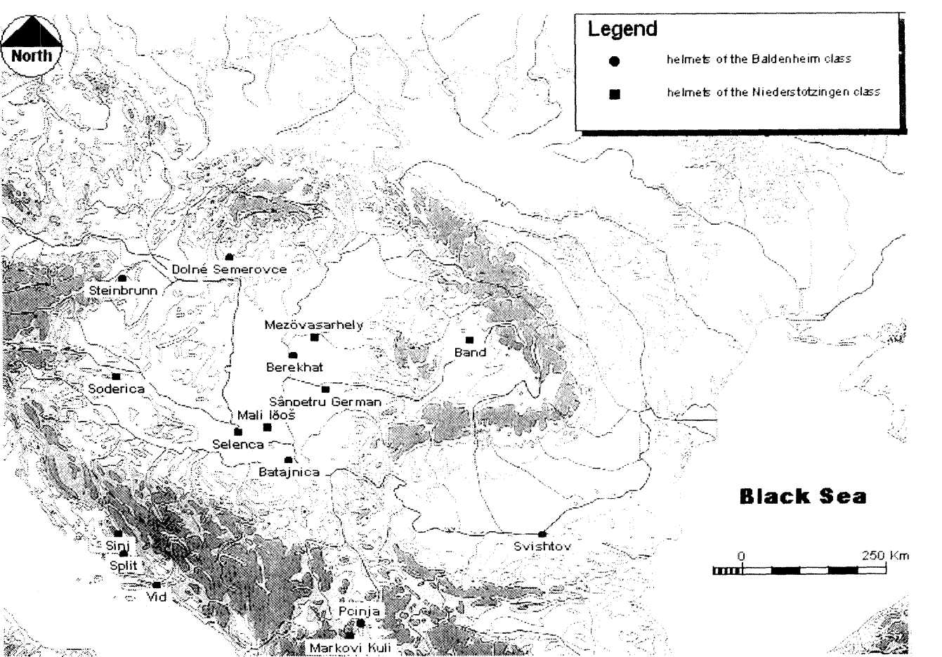
Figure 16 Distribution of late fifth- and sixth-century finds within the
Carpathian basin

a "no man's land" separating the Lombards from the Gepids. There was undoubtedly significant interaction across this buffer zone. The construction of male identity in both "Lombardia" and "Gepidia" operated with the same artifact-categories, which is most visible from the dress of the deceased at burial or from the provision of military gear. With few exceptions (such as the damascened blades from Tamasi), there is no difference between swords found in warrior graves in western Pannonia and "Gepidia," despite Jordanes' claim that the ensis was a typically Gepid weapon. In both cases, these were double-edged weapons, ranging from 80 to 100 centimeters in length. In both areas, as elsewhere in Europe, shield deposition signalized male adulthood. Both west of the Danube and east of the Tisza river the prevalent type of shield boss was indeed not different from contemporary Anglo-Saxon or west Merovingian specimens with convex cone, straight wall, and five flange rivets.¹² Helmets of the Baldenheim class, which were also used by Roman
¹² For the "no man's land" between Lombards and Gepids, see Werner 1962:116; Christie 1995:55. Wacho, the Lombard king, married Austrigusa, the daughter of the Gepid king (Paul the Deacon, Historia Langobardomni 121). The episode of Hildigis also points to interaction between Lombards and Gepids. For the ensis as a Gepid weapon par excellence, see Jordanes, Getica 50; Csallany 1961:96 fig. 1; Cseh 19903:30; Kiss 1992:52. For the distribution of graves with swords in pre-Avar "Gepidia," see Kiss 1992:96 fig, 1. Shields and shield deposition: Hiibener 1989:94; Dickinson and Harke 1992:13-17 and 69. It is true, however, that well-datable burial contexts in western Pannonia show that by the mid-sixth century there was a change in shape of shield bosses from
I98
Figure 17 Distribution of helmets within the Carpathian basin and
neighboring areas
army officers, were found in both "Lombardia" (Dolne Semerovce and Steinbrunn) and "Gepidia" (Batajnica and Berekhat) (Figure 17). Such rare and expensive artifacts, which clearly signalize high social status, are easy to distinguish from slightly later helmets of the Niederstotzingen class, for which parallels could be found as far as Bokchondong in South Korea.¹³
Interaction between "Lombardia" and "Gepidia" is even more visible, when we examine finds of stamped pottery. There are about forty
sugar-loaf to convex-coned, presumably under the influence of Gepid and Byzantine weapons (Werner 1962:80). Both forms of shield bosses were still in use during the Early Avar period; see Kiss 1992:52.
¹³ Baldenheim helmets: Vinski I957:pls. i-vn/7 and lyK^rpls. 1/1, vn/2-3, x/2, and ix/i; Csallany I96i:pls. li/8, lxxxv/з, and Lix/5; Kiss 1983; Maneva 1987; Pieta 1987:394; Mikulcic and Nikuljska 1979:69 fig. 4; Georgiev 1985—6:210 fig. 6/3; Press et al. 1973:137 figs. 1-2; Bona 1976:50 fig. 11. See also Bohner 1993:206. The Ostrogothic kings Tbtila and Theodahad were represented on their own, respective, coinage as wearing Baldenheim-type helmets. Similar helmets appear in very rich burials in Western Europe. For the rich decoration of the Bitola helmet, which imitates coin-studded jewelry, see Marinescu 1996:294. Niederstotzingen helmets: Kovacs 1913:281 fig. 13; Maneva 1987:102; Cseh 199011:30; Dorner 1960:%. 3/r; Vinski i982:pl. XV. Such helmets originated in the Far East. See Werner 1988. Their appearance in eastern and central Europe, as well as in Italy, is attributed to the Avars. See Vinski 1982:14; Maneva 1987:102; Swietosl-awski 1993:284; Kryganov 1990:76.
199

The making of the Slavs
stamped vessels found in "Gepidia" and some thirty pots from "Lombardia." Pots with stamped decoration were certainly produced locally, as evidenced by the kiln and the associated potsherds found at Torokszentmiklos, in eastern Hungary. Such pottery was only rarely found in settlements, which may indicate its exclusively funerary use. All known finds of stamped pottery come from male burials. No die-study exists of stamped vessels from cemeteries in western Pannonia and "Gepidia", to be compared with C. J. Arnold's analysis of stamped urns from Anglo-Saxon cemeteries. The methodology used by Attila Kiss for identifying sixth-century stamps that were also used during the Early Avar period is based on the macroscopic comparison of the stamps presented in the form of a presence/absence diagram. According to Kiss, there are five stamps which appear on both "Gepid" and "Lombard" vessels and four stamps which appear on "Gepid," but not on "Lombard," pottery. In reality, though most likely cut in different dies and with different frequency, almost all stamps were used in both areas. In the absence of die-studies, however, it is difficult to decide whether or not and to what extent dies moved from one site to the other, following family or kin connections. In any case, judging from the evidence available from published photographs and/or drawings, it seems there was no specific clustering. Stamp patterns, if not dies, were used on both sides of the "no man's land" between the Danube and the Tisza.¹⁴
Clear material culture distinctions were maintained, however, in a wide range of artifact-categories found in women's graves. As in many other cases in sixth-century Europe, female apparel may have been used as internal and external badge as well as a reminder of ethnic identity. While cemeteries in western Pannonia produced no specimens of any kind, various types of earrings, especially those with polyhedral cube, were particularly frequent in "Gepidia."¹⁵ Unlike graves in "Lombardia,"
¹⁴ The presence of an antler die within the early Byzantine fort at Momcilov Grad (Brmbolic I986:fig. 37) indicates that decorated pottery was also produced within the Empire's frontiers. For the production of stamped pottery in "Gepidia," see Cseh 1990b. The kiln at Torokszentmiklos produced decorated pots which are die-linked to stamped vessels of unknown provenance, now in the National Museum in Budapest (Cseh 1990^236). Settlement finds of stamped pottery: Horedt I979b:pl. 37/1; Popovic 1987:22 fig. 17/7, 9—12; Barzu 1994—5:288 fig. 14/8, 12, and 19. Burial finds: Simoni 1977—8:231; Knific 1994; Kiss 1984:135; Bona 1990b. See also Kiss 1992:55 and 77—9. Die-link studies: Arnold 1983 and 1988. The lattice circle, which is viewed as a typically Lombard stamp, occurs frequently on handmade, sixth-century pottery in southeast and southwest Germany (Werner 1962:60). Two stamps, the lattice lozenge and the simple lattice rectangle, are particularly frequent on pottery found in Italy. Stamped pottery also appears in early Avar ceramic assemblages, but there are no die-linked specimens. See Vida 1990—1:133, 1995:104, and 1999:37 with n. 16.
^{ь} Female apparel as marker of ethnic identity: Sasse 1990:48; StrauB 1992:70; Dickinson 1993:39; Hines 1994:52. See also Pancake 1991:46. For the absence of earrings in Transdanubia, see Sagi 1964:396. Earrings with polyhedral cube: Horedt 1979b; Slabe 1986:201; Bierbrauer 1987:150; Cseh I99oa:29—30; Uenze 1992:163. For other types of earrings, see Kiss 1992:52—3 and 1996:309.
200
Barbarians on the frontier
where single-layered combs were preferred, women and children in "Gepidia" were buried with double-layered ones in their hair.¹⁶ Unlike Lombard women's graves, Gepid ones had no straps with fastened jewels, though they occasionally produced reliquaries attached to the belt. In "Lombardia," after с 530, there were no burials, either of children or of women, with artificially deformed skulls. By contrast, artificial cranial deformation, a practice introduced by the Huns in the early 400s, was maintained in "Gepidia" during most of the sixth century.¹⁷
No other artifact-category, however, is more relevant in relation to the construction of ethnic boundaries than brooches. The distribution of all types of bow fibulae which were in use during the first two-thirds of the sixth century (Figure 18) shows a sharp contrast between the area west of the Danube and the region east of the Tisza river.^{IH} A particularly popular class of brooches in "Gepidia" was the Gurzuf type, which also occurs in Crimea and Mazuria, an indication of long-distance contacts established with "Gepidia."¹⁹ However, the most popular fibulae were those of the Hahnheim class, many of which have parallels in Germany or France. There are two variants of this class, apparently of local production and use.²⁰ A related, also very popular, type of brooch was that of the Krainburg class.²¹ Brooches of this class appear in Crimea, Mazuria, Germany, and France. Specimens with a slightly different decoration
¹⁶ See Bona 1956:213 and 1976:43. Such combs were produced locally. See Dumitrasxu 1982.
¹⁷ Reliquaries: Csallany I96i:pl. xxxix/4. Lack of skull deformation 111 "Lombardia": Zeman 1987:524. Skull deformation in "Gepidia": Cseh 19903:60. On skull deformation and ideals of female beauty, see the interesting remarks of Mikic 1992—3:197—8. Artificial cranial deformation is also attested in contemporary cemeteries in the western Balkan area. See Pilanc 1975; Slabe 1978; Vuga 1980. For "Hunnic" artificial cranial deformation, see Werner 1956. For artificial cranial deformation in Merovingian Gaul, see Crubezy 1990. The practice is also attested in Crimea, where it is associated with both female and male burials. See Kropotkin 1959:190. For a cross-cultural perspective on artificial cranial deformation and its relation to social status, see Garrett 1988.
¹⁸ Data compiled from Csallany 1961; Kiihn 1974; Werner 1962; and Bona 1990b. In what follows,
1 left aside cast fibulae with bent stems and crossbow brooches, which were particularly frequent in "Gepidia." The same is true for fifth-century brooch types, such as Alkofen or Krefeld (Kiihn 1974:571-5 and 587-95)·
¹⁹ Kiihn 1974:728—42. Assigned brooches: Csanad-Bokeny, Kiszombor (grave 88), Moresti, Novi Banovci, Pecica, Szentes-Rakoczi utca, Szentes-Kokenyzug (graves 49 and 66), Berekhat (graves
2 and 43), Szentes-Nagyhegy (grave 22), and Sanmcolau Mare. Specimens produced in Crimea may have imitated "imports" from "Gepidia" (Aibabin 1990:20—1).
²⁰ Kiihn 1974:799—811. Assigned brooches: Hodmezovasarhely-Gorzsa (grave 94), Magyartes, Szentes-Kokenyzug (grave 56), Berekhat (grave 274), Tarnamera, andjankovo (grave 13). Despite Kiihn's claims to the contrary, it is possible that this class of fibulae originated in the West, some time before or after 500, and was later "imported" to "Gepidia." For local variants, see Horedt 1979a: 183. Some authors compared one of these variants with the so-called "Slavic" brooches of Werner's class II, a comparison rejected by Werner himself. See n.a. 1954:210; Horedt 1977:258; Werner 1950:167.
²¹ Kiihn 1974:758—66. Assigned brooches: Beregovo, Csongrad-Kettoshalmi, Dunafoldvar, Kistelek, Oradea, Szentes-Nagyhegy (grave 77), Szentes-Kokenyzug (graves 29 and 50), Tiszarorl (grave 1), and Tiszaladany.
201

Figure 18 Distribution of sixth-century fibulae within
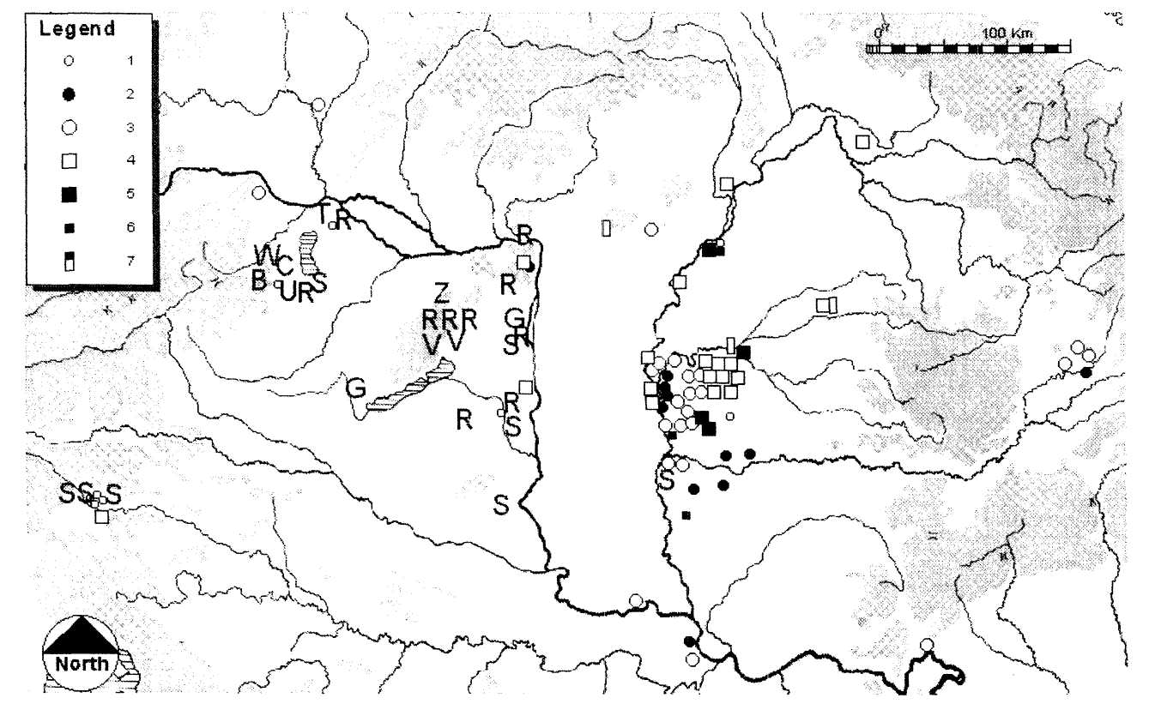
The making of the Slavs
the Carpathian basin
ι — disc-brooches; 2 — Gurzuf class; 3 — Hahnheim class and variants; 4 — Krainburg class; 5 —
Reggio Emilia class; 6 - Szentes-Berekhat class; 7 - Wittislingen class; В - Burghagel class; С -
Cividale class; G — Goethe class; R — Ravenna class; S — S-shaped brooches; Τ — Castel Trosino
class; V — Trivieres class; U — Ulm class; W - Wiesbaden class; Ζ — Zangetifibeln
were also found in Italy, where they were interpreted as "imports" from "Gepidia."²² Conversely, fibulae of the Reggio Emilia class may have been Ostrogothic "imports" into "Gepidia."²³ Two specimens of the Suuk Su group, that of Kiszombor (grave 146) and that of Magyartes, have analogies in Spain. Two other classes, Pfullingen and Wittislingen, originated in the West.²⁴ By contrast, S-shaped fibulae and disc-brooches are very rare in the area east of the Tisza river.²⁵
The range of brooch classes in "Lombardia" is also very wide. A
²² Kiihn 1974:758-66. For Italian specimens, see Bierbrauer 1975:284 and pi. xxin/2 and
1978:221-2 and pi. xcni/7.3. ^{ъ} Kiihn 1974:718—26. Assigned brooches: Szentes-Nagyhegy (grave 8), Berekhat (grave 105 and
stray find), and Tiszaflired.
²⁴ Kiilm 1974:510-46 (Suuk Su), 639-48 (Pfullingen), and 891-4 (Wittislingen). Only one speci men of the Pfullingen class is known, that of grave 247 at Kiszombor. Wittislingen brooches: Gyongyos, Oradea, Szarvas, Oszony. The only known analogy for the fibulae from Berekhat (grave 202), Tiszaflired (grave 1), and Bocar (grave 4) is the specimen found at Mainz (Kiihn 1974:288 no. 190). They all form Kiilm's class Szentes-Berekhat (Kiihn 1974:1275-8). Three other brooches (Mores,ti, Novi Banovci, and Szentes-Kokenyzug, grave 29), which belong to Kuhn's class Taman (Kiihn 1974:766-79), have no analogies outside "Gepidia."
²⁵ S-shaped fibula: Szoreg (grave XI). Disc-brooches: Tiszaflired (grave 1) and Hodmezovasarhely (grave 77).
202
Barbarians on the frontier
brooch of Kuhn s Burghagel class was found at Hegyko (grave 21). Its closest analogy is a fibula from Besaii£on.²⁶ Frankish analogies may also be cited for two specimens of the Trivieres class, found at Varpalota (grave 5) and Jutas. This is also true for the fibula of Kuhn's Ulm class found at Fertoszentmiklos, for the Zangenfibel found at Varpalota (grave 13), and for the fibula of Kuhn's Wiesbaden class found at Hegyko (grave 4). The only specimen of the Gurzuf class, which was so popular in contemporary "Gepidia," was found at Szentendre. From the same cemetery (grave 33) comes the only specimen of the Hahnheim class found west of the Danube river. By contrast, the number of S-shaped and discbrooches is comparatively larger. The distribution of fibulae west of the Danube river is also characterized by a relatively large number of brooches without any analogies outside "Lombardia," except Italy. Kuhn's Goethe, Cividale, Ravenna, and Castel Trosino classes are cases in point.²⁷
The distribution of all these types speaks for itself. Completely different, but coexisting, types of brooches were in use and fashion on each side of the "no man's land" between the Danube and the Tisza river. We can clearly speak of two different "styles" of brooch-use and assume that they convey information about relative identity of the brooch owners. The patterns and contrasts created did not produce, however, ethnically specific artifact-categories. Very few, if any, brooch classes were creations ex nihilo and many were either "imports" or produced as replicas of "imported" specimens. In other words, no particular class could be a priori diagnosed as either "Gepid" or "Lombard." The ethnic boundary emerged from the manipulation of specific types, without assigning an "ethnic value" to any of them. More important, this coincides in time with increasing rivalry between the two groups, following the Lombard settlement of the land between the Sava and the Drava rivers, not far from Sirmium, now in Gepid hands. The Lombard—Gepid wars of the mid-sixth century may have contributed to the consolidation of emblemic styles on the Lombard—Gepid frontier. According to Theophylact Simocatta, the final confrontation between Alboin and Cunimund was
²⁶ Brooches in "Lombardia": Tejral 1990. Burghagel class: Kiihn 1974:965—70.
²⁷ Kiihn 1974:689—94 (Ulm class), 827-40 (Ζαιιχαιβbelli), 996—1006 (Goethe class), 1076-86 (Wiesbaden class), and 1094—106 (Trivieres class), 1 187—91 (Cividale class), 1217—24 (Ravenna class), and 1239—48 (Castel Trosino class). Two specimens of the Hahnheim class were found in Mistfin and Vienna (see Werner 1962:68). S-shaped fibulae: Kajdacs (grave 2), Racalmas (graves 16 and 20), Fertoszentmiklos (grave 9), Mohacs (grave 5), Kranj (several specimens). Disc- brooches: Hegyko (graves 18 and 21), Bezenye (grave 8), Kajdacs (grave 2), Kranj (graves 193/1907, 43, 58, and 66). Goethe fibulae: Keszthely (grave B) and Racalmas (grave 2). Cividale class: Hegyko (grave 18). Ravenna brooches: Bezenye (grave 20), Varpalota (graves 1,17, and 19), Kapolnasnyek, Szentendre (graves 29 and 56), Kajdacs (grave 2), Tamasi (grave 6), Racalmas (grave 16), and Fertoszentmiklos (grave 9). Castel Trosino class: Bezenye (grave 8).
203
The making of the Slavs
caused by Rosimunda, the daughter of the Gepid king, who was kidnapped by Alboin. This may suggest that aristocratic women played a major role in the display of emblemic styles.²⁸
THE AVARS
Few events in the medieval history of East Central Europe were given more importance by historians than the annihilation of the Gepid and, later, Lombard "kingdoms" and the conquest of the Carpathian basin by the Avars. To many, the year 568 is the beginning of the Middle Ages, an East European equivalent of 476. Archaeologists working within a culture-historical framework maintain that ad 568 represents an important chronological marker and cultural watershed.²⁹
Jozsef Hampel was the first to acknowledge the existence of two chronological horizons in the archaeological material attributed to the Avars. Andras Alfpldi first pointed to the importance of Byzantine coins found in burials for the phasing of the "Avar culture." Despite recent caveats, some fifty Byzantine coins found as either funerary offerings or ornamental objects in rich male burials still underpin the entire chronological system of Avar archaeology.³⁰ There are more than 50,000 burials dated to the period between с 570 (the foundation of the Avar qaganate) and с 8oo (the collapse of the Avar qaganate following Charlemagne's victories). On the basis of her analysis of the Alattyan cemetery, Ilona Kovrig first divided this period into three phases, namely Early (568-650/60), Middle (650/60-700), and Late Avar (700-92). Only the first phase can be coin-dated, but Kovrig believed that some Early Avar assemblages, especially those associated with coins minted for Justinian, Justin II, or Tiberius II, were earlier than the first half of the seventh century. This claim, however, proved to be groundless, given the underlying problems of the chronological association of coins and artifact! and of their respective use-life.³¹
²⁸ Theophylact Simocatta vi 10.8.
²⁹ Pohl 1988:52-7. In Istvan Bona's words (1976:105), the year 568 was the end of "almost 600 years' rule by successive Germanic tribes in the Carpathian basin."
^{J)} See Hampel 1905; Alfoldi 1934. For the use of Byzantine coins for the chronology of Avar assemblages, see Bona 19903:113. Separating the Early Avar material from the Middle Avar one, however, is a very difficult, if not impossible, task. Coins are not always good guides to chronological studies. For example, a bracelet with trumpet-shaped ends was found at Szentendre in association with a coin minted for Emperor Phocas (607—10). Its closest paraUel is that from the Zemiansky Vrbovok hoard, which also produced miliaresia struck for Emperor Constantine IV (668—9). See Balint 1993:201. For the Szentendre burial, see also Garam 1992:138—9.
³¹ Kovrig 1963. See also Bona 1971:291; Sos 1973:86. The existence of an Early Avar phase had already been postulated by Dezso Csallany, who was also the first to assign artifact-categories to
204
Barbarians on the frontier
The number of Byzantine coins produced so far by Early Avar assemblages, on the other hand, is remarkably small. As a consequence of various treaties with the Empire, Byzantine payments to the Avars between 568 and 626 totalled at least 6 million solidi. It is very likely that a good part of this incredible wealth was later redistributed within the Avar qaganate as gifts. It is possible that the majority of these coins were melted to provide raw material for gold jewelry, for the exact weight of the largest earrings with pyramid-shaped pendants, which are so typical for Early Avar assemblages, is equivalent to either eight or ten light solidi. Since the use of gold, instead of the usual silver, is restricted to a few exceptionally rich burials, it is possible that supplies of Byzantine gold became the monopoly of a small elite headed by the qagan. If this is true, it may be more productive to treat Early Avar assemblages as indicative of social stratification, than to continue to draw lists of chronologically sensitive artifact-categories.³²
Some authors ascribe archaeological assemblages to the Early Avar period on the basis of their alleged analogies from Central Asia or the Middle East, but rarely can contemporary parallels for Early Avar artifact-categories be found outside the Carpathian basin.³³ Equally unique are burials with both human and horse skeletons. Swords with P- or 3-shaped sheath attachments are typical for the earliest assemblages attributed to Avar warriors, but all of them predate their frequently cited East
this archaeological phase. See Csallany 1946—8. Middle Avar assemblages produced Avar imitations of non-identifiable Byzantine coins. See Bona 1980:34. For Early Avar assemblages with coins of Justinian, Justin II, and Tiberius II, see Garam 1990:138—9. For a critique of Kovng's chronology based on coins, see Balint 1989:149 and 1993:246. The Kimagota burial, which produced a light-weight solidus of Justinian, is now dated to the first third of the seventh century. See Garam 1995:127.
³² Pohl I99ib:598. For a list of treaties and payments of gold to the Avars, see Pohl 1988:502. Unlike Goths, Lombards, or Gepids, the Avars never received payments in food. Like coins, finds of Byzantine jewels are equally rare in Avar assemblages. For the weight equivalence between Avar earrings and solidi, see Bona 1990a: 117. For gold as a monopoly of the Avar elite, see Garam 1990:258. For Avar assemblages as indicative of social stratification, see Szentpeteri 1993a and 1993b.
³³ Balint 1989:149 and 1993:214; Garam 1990:253. A clear Central Asian origin may be claimed only for bone artifacts, such as needle cases, buckles, awls, or belt pendants. See Sekeres 1957; Bona 1980:52 and 54. Of "Asian" origin may also be finds of single earrings with male skeletons, the deposition of the belt (without buckle), sword, and quiver on the right side of the skeleton, with the bow on top of the coffin. See Balint 1993:217—18 and 237; Tom к а 1995:83. The only parallels for the deposition of armor slats are those from the Altai region and the Tuva basin (Bona 1980:45). By contrast, there is no "Asian" element in the decoration of belt-buckles and plates. Silver rosette-mounts, which appear frequently in Early Avar assemblages, have no analogies outside the Carpathian basin, except two rich burials in Ukraine (Malo Pereshchepino and Glodosy). See Balint 1993:234; Sos and Salamon 1995:33. In addition, the use of earrings by adult males most likely imitated Sassanian practices (Bona 1980:39). Attempts to identify Central Asian Avars by means of physical anthropology bore no fruits. See Toth 1967.
The making of the Slavs
European or Central Asian analogies.³⁴ It is also difficult to demonstrate a Central Asian origin for the wheel-made grey ware, which was produced only during the Early Avar period in southwest Hungary.³⁵
Both bow-shaped stirrups and stirrups with elongated attachment loops, which are viewed as typical for Early Avar assemblages and the earliest European stirrups, were found in the Kudyrge cemetery in Tuva (west of Lake Baikal, near the Chinese—Russian—Mongolian frontier). Turkic archaeology, however, is notoriously lacking any firmly established chronological system. As a consequence, there is no possibility of deciding whether or not such stirrups were brought by the Avar horsemen from Central Asia or "invented" by them in the Carpathian basin. The majority of Early Avar burials were found either in isolation or in small groups of graves. In the absence of large cemeteries, which would permit an analysis of frequency, distribution, and toposeriation of artifact-categories, the relative chronology of the Early Avar period remains problematic.³⁶
Another major difficulty is the dating of Middle Avar assemblages. On the exclusive basis of burial evidence and without sufficient settlement finds for comparison, it is almost impossible to discriminate between (late) Early and Middle Avar artifact-categories, although it is clear that the second half of the seventh century witnessed some dramatic cultural change. The Middle Avar phase was first identified within the Kiskore-Halasto cemetery, but its best-known monuments are the rich burials of the so-called Totipuszta—Dunapentele—[gar group. Dated by means of coins minted for Emperors Constans II and Constantine IV, these burials have close analogies in extremely rich funerary assemblages from
³⁴ For burials with human and horse skeletons, see Bona 1979c: 18-19. For swords with P- or 3- shaped sheath attachments, see Balint 1993:219; Ambroz 1986. The date of the Avar specimens is given by the warrior burial found at Szegvar-Sapoldal, in which a double-edged sword with P- shaped sheath attachments was associated with an imitation of a solidus struck for Emperor Maurice. Another, similar specimen was found in burial 2 at Kiszombor O, in association with a solidus struck for Emperor Phocas. The latest P-shaped sheath attachments known so far are those from the horseman burial at Ivancsa, dated to the late seventh century, but such artifacts were already rare by ad 630 (Garam 1992:157). Swords with 3-shaped sheath attachments, such as found in Early Avar assemblages, have no parallel outside the Carpathian basin, except the rich burial at Malo Pereshchepino.
³⁵ Vida 1990—91:133 and 1999:42—63. Istvan Bona claimed a Central Asian origin for this ceramic category, but other authors pointed to possible parallels in sixth-century ceramic assemblages in Romania, of the so-called Ipote§ti-Cande§ti culture. See Vekony 1973. For ceramic categories with clear Central Asian analogies, see Vida 1992.
36 х_{ГШ}у Avar stirrups first occurred in Merovingian burials in southern and western Germany during the second third of the seventh century. Replicas of Avar stirrups with elongated attach ment loops were produced there as early as the second half of the seventh -century. See Bott 1976:227. For Turkic archaeology, see Balint 1989:242-3 and 249. Large Avar cemeteries only appear after с 650 (Bona 1971:292). For large cemeteries with Early Avar material, see Salamon and Erdelyi 1971; Sos and Salamon 1995; Kiss 1996; Bardos 1995. Toposeriation: Djindjian 1985.
2O6
Barbarians on the frontier
Ukraine, which will be discussed in the following section of this chapter (Voznesenka, Malo Pereshchepino, Glodosy, and Zachepilovki).³⁷
These astonishing parallels at such a great distance were interpreted as evidence for the migration into the Avar qaganate, by the late seventh century, of a Bulgar group fleeing the civil war inside the western Turkic qaganate. But there are also signs of remarkable continuity between the Early and the Middle Avar assemblages, particularly in western Hungary. Beginning with the last decades of the Early Avar period, belt buckles and plates were decorated with an original variant of the animal Style π, characterized by the frequent occurrence of the dentil pattern. Single-edged sabres, of a type commonly dated to the Middle Avar period, were found in at least three Early Avar contexts, that of the Sanpetru German burial (dated by means of a perforated coin struck for Heraclius and Heraclius Constantine), that of burial 259 from Kolked-Feketekapu, and that of grave χ from Tarnamera-Urak diillo. Combat axes, though typical for the Middle, but especially for the Late Avar period, are also known from Early Avar contexts and from seventh-century assemblages in Italy and Albania.³⁸
The understanding of Avar history and archaeology is crucial for the problem of Slavic ethnicity, particularly because, as shown in Chapter 3, in the aftermath of the Avar conquest, numerous groups of Sclavenes became subjects of the qagan. The subject of Avar—Slavic relations is extremely controversial. The debate has often been embittered by nationalistic claims, but there is also little understanding of how the Early Avar society and qaganate operated. As far as written sources allow us to tell, the territorial division following the conquest of the Carpathian basin resembles a Turkic scheme (of Chinese inspiration) based on el ("the peace zone"), including all territories under the qagan s direct rule, and
yagi, the territory of the enemy, who refuses to obey the qagan's orders.
к
³⁷ The first to postulate the existence of the chronological phase now known as Middle Avar was the Hungarian archaeologist Gyula Laszlo (1955). For the culture change of the mid-seventh century, see Balint 1993:201. The most important marker of this change is the shift from swords to sabres and combat axes, an indication of changing warfare practices. In addition, the Middle Avar period coincides with the introduction of a new decoration style primarily based on the interlaced pattern. See Balint 1989:156—60; Garam 1992:158—9. For Middle Avar sabres and their Sassanian parallels, see also Balint 1978:184. For the Totipuszta—Dunapentele—Igar group, see Garam 1976:129 and 140; Fiilop 1988 and 1990; Miiller 1989. Avar settlements: Bona 1968. The first (Late) Avar sunken building was'excavated in 1962 by Otto Trogmayer at Bokros (Bona 1971:313). The monograph of the site at Dunaujvaros remains the only comprehensive study of (Early and Middle) Avar settlements. See Bona 1973.
³⁸ Sanpetru German: Dorner i960; Kolked-Feketekapu: Kiss 1996:230 and 232; Tarnamera-Urak diillo: Szabo 1965:42 and 69 pi. vin/i—3. See also Balint 1992:339. For the theory of the Bulgar migration, see Balint 1989:169. For the transition from double-edged swords to sabres, see Simon 1991 and 1991— 2. Combat axes: Kiss 1996:238 and 318. Avar variant of animal Style II: Nagy 1988 and 1995.
207
The making of the Slavs
The Avars viewed the Danube river as the frontier between ydgi and el. Qagan Bayan considered the Sclavenes in Walachia to be part of the el. Ethnic cleavage within the el may not be easily identifiable, particularly because the Avars themselves were subdivided into clans and tribes. The archaeological evidence substantiates this complex picture. Recent studies show that within the Carpathian basin, various artifact-categories, particularly dress accessories, have a restricted, localized, distribution, and, in fact, there are few items which could be considered "Avar" on the basis of their wide distribution.³⁹
THE STEPPE NORTH OF THE BLACK SEA
There was no heir to the Hunnic "Empire" north of the Black Sea. Beginning with the late 500s, Cutrigurs, Utigurs, Saragurs, and Onogurs appear to have shared both the control over the steppe and the interest of historical sources. The first to mention the Cutrigurs were Procopius and Agathias. Both referred to them as "Huns." A German historian of the Romantic era, however, claimed that the Cutrigurs and the Utigurs were Bulgars. To many, his claim is still indisputable truth, despite the fact that no source referring to Bulgars mentions the Cutrigurs and vice versa. The Bulgars appear in written sources as early as the mid-fourth century, but only in the region north of the Caucasus mountain range.⁴⁰
By contrast, the "Hunnic" Cutrigurs were constantly located in the area close to Crimea and to the northern shore of the Black Sea. They probably controlled the entire steppe corridor up to the Danube river. Since Menander the Guardsman is the last source to mention the Cutrigurs, they most likely did not survive politically in the aftermath of the Avar invasion. During the last years of Justinian's reign, the control of
^{jl)} Bracelets with trumpet-shaped ends of the so-called Szentendre type are a case in point. The majority of specimens known so far come from Transdanubia (Sos and Salamon 1995:41). The same is true about buckles of Ibler's classes Pecs and Nagyharsany. See Ibler 1992:138 and 143. For Avar—Slavic relations, see Avenarius 1973 and 1987; Fritze 1980; Tyszkiewicz 1989. Yagl and el: Gockenjan 1993. Avar clans and tribes, see Strategikon xi 2.34—5. Non-Avar groups within the Avar qaganate: Pohl 1988:225—36. On the basis of their archaeological distribution, scholars postulated the existence of a buffer zone between Middle Avar cemeteries in south and southeast Slovakia and presumably Slavic settlements with Prague-type pottery to the north. These cemeteries were interpreted as Avar outposts in Transdanubia against Samo and his "kingdom." See Zabojnik 1988:401—2.
⁴⁰ Zeuss 1837:713-14; Romashov 1992—4:218. John of Antioch refers to Bulgars in relation to events taking place in 480 in the Lower Danube region, while other sources mention the first Bulgar raid across the Danube in 499. They subsequently appear as the allies of the Gepids. Dezso Simonyi argued, therefore, that these were not Cutrigurs, but a separate group of Bulgars who came to Pannonia with the Huns and remained there until the arrival of the Avars. See Simonyi 1964. This theory was very popular in the 1960s and 1970s and had a considerable influence upon interpretations of the Early Avar archaeological evidence. See Csallany 1963; Fettich 1972; Beshevliev 1981:85—6. Following Istvan Bona's devastating critique, this interpretation is now abandoned. See Bona 1981.
2O8
Barbarians on the frontier
the steppe was disputed between Utigurs and Cutrigurs, but the rise of the Gok Turk Empire brought the Utigurs, the Onogurs, and other groups under the domination of the western qaganate. At the same time, the Cutrigurs became subjects of Bayan, the qagan of the Avars. The two "Empires" most likely collided on the Don river. As the civil war broke within the western Gok Turk qaganate after the death, in 630, of the yabghu qagan T'ung, two confederations were competing for power and control over the steppe north of the Caucasus range: the Bulgars, under the leadership of a heir of the Dulo, the leading clan of the left division of the western qaganate, and the Khazars, led by a member of the charismatic clan Ashina of the Turkish qaganate, associated with the right division. The Bulgar qaganate established shortly after 630 by Koubratos, who concluded a treaty with Emperor Heraclius, probably reached the Dnieper river to the west, which is viewed as an indication that, in the first half of the seventh century, the steppes between the Dnieper and the Danube rivers were still controlled by the Avars.⁴¹
As in many other cases, the archaeological evidence does not fit the picture drawn by historians on the basis of written sources. The steppe north of the Black Sea has not produced so far any materials from the late fifth century. Finds of the following period (sixth to seventh century) fall into one of Ambroz's groups IV, V, and VI. Group IV, which Ambroz viewed as representing the "lower class," the "commoners" of the steppe society, consists of burials with no weapons, but with perforated buckles, mounts, and strapends, all datable to the late sixth and early seventh centuries (Veliki Tokmak, Akkerman, Bilozerka). By contrast, group V includes only extraordinarily rich burials, such as Malo Pereshchepino, Kelegeia, and Glodosy. In group VI, Ambroz included burials such as Sivashs'ke, Kostogryzovo, Kovalevka, and Iablonia, in which a human skeleton (often a male) was commonly associated with that of a horse or with parts of a horse skeleton (skull and legs).⁴²
⁴¹ Szadeczky-Kardoss 1986a:! 53-62. Koubratos' Bulgaria: Plctneva 1980:27-9; Bozhilov and Dimitrov 1995. Cutrigurs north of the Black Sea: Golden 1980:261; Balint 1989:14. Last mention of the Cutrigurs: Menander the Guardsman, fr. 12.6. As the Tang dynasty came to power with Turkic assistance, almost all sources for the history of the Gok Turk qaganate are Chinese. They have been collected by Edouard Chavannes (1969, first published in 1903). The death of the yabghu qagan T'ung coincides with the collapse of the eastern qaganate. For the ensuing civil war, see also Golden 1980:37-42 and 1982:40-1 and 50—4; Balint 1989:239-40; Whittow 1996:222.
⁴² Ambroz 1981; Orlov 1985; Baran and Kozlovskii 1991:235. The continuity of the steppe "Hunnic culture" of the early fifth century well into the sixth century has recently been advocated by A. V. Bogachev (1996). The evidence cited, however, is far from conclusive. Most sixth- to eighth- century funerary assemblages in the steppe north of the Black Sea were found in the area between the Danube and Dnieper rivers. There are comparatively fewer finds in Left Bank Ukraine and virtually no finds between the Don and the Volga rivers. See Dimitrov 1987:63; Balint 1989:102. For a rare instance of perforated belt mounts in Left Bank Ukraine, see Lipking 1974:145-7. For the steppe east of the Don river, see Bezuglov 1985.
209
The making of the Slavs
Ambroz's tripartite scheme, which was designed to provide an easy model for understanding the society of the steppe nomads, does not seem, however, to stand against the existing evidence. First, many burials of Ambroz's fourth group are female graves (Khristoforovka, Malaia Ternovka, Akkerman, Veliki Tokmak), which can easily explain the absence of weapons. Second, burials of groups VI and V do not coincide in time. Besides an extensive array of gold and silver grave-goods, extremely rich burials, such as Kelegeia, Malo Pereshchepino, and Zachepilovki, also produced Byzantine gold coins, often in relatively great numbers. In all three cases, the last coins were minted for Emperor Constans II (641-68).⁴³
The dating of group VI is more difficult, for there are no coin finds, with the exception of Iosipivka, which produced a perforated coin of Heraclius and Heraclius Constantine (613—41). All other graves can be dated only on the basis of perforated belt mounts and straps. Such dress accessories signalize the use of a belt with multiple, secondary, straps, which was first used in Sassanian Persia, as indicated by the Taq-i Bustan reliefs dated to Khusro II's reign (590—628). The belt with multiple straps did not originate in the steppe milieu, for the earliest assemblages with belt mounts from the early sixth century were found in Transcaucasia. The number of graves with belt mounts and strapends increased suddenly in the mid~5oos in both Transcaucasia and Crimea.⁴⁴ Perforated specimens, commonly known as "Martynovka mounts" became popular in the steppes north and northeast of the Black Sea only in the second half of the sixth century and the early seventh century.⁴⁵
⁴³ Malo Pereshchepino: Werner 1984a. Kelegeia: Balint 1989:95. Glodosy: Smilenko 1965. Zachepilovki: Smilenko 1968. Voznesenka: Grinchenko 1950; Balint 1989:92—4. The interpreta tion of the Malo Pereshchepino assemblage as burial has been disputed, for no human bones were found on site. See Kazanski and Sodmi 1987:72; Schulze-Dorrlamm 1987b. Joachim Werner argued in favor of a funerary assemblage, pointing to fragments of gold sheet bearing traces of wood, which he interpreted as casket mounts. Knowing that the assemblage was accidentally found in 1912 and no systematic excavations were ever carried out on the site, there is no way to decide whether or not Malo Pereshchepino was a specific, ritual, site of a kind illustrated by the Voznesenka assemblage. By contrast, the site at Glodosy produced cremated fragments of a male skeleton (twenty to forty years old). See Smilenko 1965:7—10. Joachim Werner (19843:17) also argued that all sixty-eight coins found at Malo Pereshchepino belonged to a "ceremonial or mar riage belt," for they were each perforated and decorated with a cabochon applied on the obverse. See also Balint 1985:139—40. For the coins found at Kelegeia, see Kropotkin 1962:37.
⁴⁴ Werner 1974:132; Somogyi 1987:138; Balint 1992:327 and 1993:220; Fiedler I994a:35 and 46. Judging from the iconography of the Taq-i Bustan reliefs, the number of secondary straps indi cated social rank, for the use of as many as ten or twelve straps was restricted to the king, while lesser nobles wore only three to six straps. Belts as symbols of social status appear in contempo rary Byzantium. See Martini and Steckner 1993:134-6. For examples of buckles used in associa tion with belts with multiple straps, see Schulze-Dorrlamm I987a:8o2 and 803 fig. 63; Balint 1992:324 and 438 pi. 2/1.
^{4э} Nandor Fettich was the first to link the Martynovka hoard to assemblages with perforated belt mounts. He also coined the phrase "Martynovka mounts." At Mokraia balka, in Transcaucasia, perforated belt mounts appear in the second interment phase of the cemetery, dated with coins
210
Barbarians on the frontier
Nevertheless, the use of a buckled belt became so strongly associated with the horsemen of the steppe that an early seventh-century Egyptian papyrus referred to such dress accessories as "Bulgar belts." The distribution of perforated belt mounts and strapends confirms this association (Figure 19). Belts with "Martynovka mounts" were in use in the Balkan provinces of the Empire during the sixth century, as demonstrated by their presence in both forts and burial assemblages excavated south of the Danube river. They were in use in "Gepidia" even before the arrival of the Avars, as shown by burial no. 29 at Szentes-Nagyhegy, in which a "Martynovka mount" was found in association with a Sucidava belt-buckle, a dress accessory most typical for early Byzantine forts of the Justinianic age. In Avar assemblages dated shortly after с. боо, "Martynovka mounts" are a familiar presence.⁴⁶
Assemblages with perforated belt mounts and strapends are therefore earlier than rich burials such as Malo Pereshchepino, Zachepilovki, or Glodosy, which include only mounts and strapends with granulated ornament. The best analogies for these burials are both late Early Avar assemblages, such as Bocsa and Kunbabony (dated to the second third of the seventh century), or Middle Avar assemblages of the so-called Totipuszta—Dunapentele—Igar group, some of which produced coins minted for the emperors Constans II and Constantine IV. They are also paralleled by the earliest archaeological evidence attributed to the Bulgars in Bulgaria, namely that from burial no. 5 from Madara. Gold belt mounts and strapends with granulated ornament found in this burial are considered as the latest of their kind.⁴⁷
The different date and interpretation of these two groups of burials in the steppes north of the Black Sea becomes even more evident when we introduce another class of evidence, that of hoards of silver and bronze
of the Sassanian king Kavad I (488—531). See Afanas'ev 1979:47. Perforated mounts were also found in neighboring forts built under Emperor Justinian. See Afanas'ev 1975:53 and 60. in Crimea, perforated belt mounts were in use in the mid-sixth century, as suggested by their association with coins of Justinian. See Repnikov 1906:1 5—16; Afanas'ev 1979:47. The analysis of the Suuk Su cemetery indicates that access to belts with perforated mounts was restricted to adults, both female and male. See Uenze 1992:170. For perforated mounts at Skalistoe, see Veimarn and Aibabin 1993:12—3.
⁴⁶ For "Bulgar belts" in the papyrus Erzherzog Rainer 9010, see Wessely 1889:242; Setton 1950:524; Balint 1992:415. Buckled belts have often been associated with trousers or tights, a garment believed to have been introduced by barbarian soldiers of the Roman army. See Russell 1982:146. However, as the Taq-i Bustan reliefs suggest belts with multiple straps were worn with tunics. See Martini and Steckner 1993:133. In other cases, perforated belt mounts (such as Somogyi s class A 9) may have been used to attach shoe straps. See Balint 1992:357. Perforated belt mounts in forts: Opait 1990:46 fig. 18/53-7; Uenze 1992: pi. 1 1/1—5, 8-10, 14-17. "Martynovka mounts" in burial assemblages: Petre 1987^1. 130 fig. 207 d-e; Alexandrescu and Vilceanu 1962:402 fig. 5/1; Vaklinova 1989:136 fig. 2. Szentes-Nagyhegy: Csallany 1961:50—1 and pi. xxv/i4.
⁴⁷ Bocsa and Kunbabony: Toth and Horvath 1992. Totipuszta—Dunapentele—Igar group: Garam 1976:140 and 1995:129. Madara: Fiedler 1992:143—4 and 1994:1:47; Garam 1988:162 and 167. For analogies in Transcaucasia, see Atavin and Paromov 1991.
211

Figure 19 Distribution of perforated, Martynovka-type
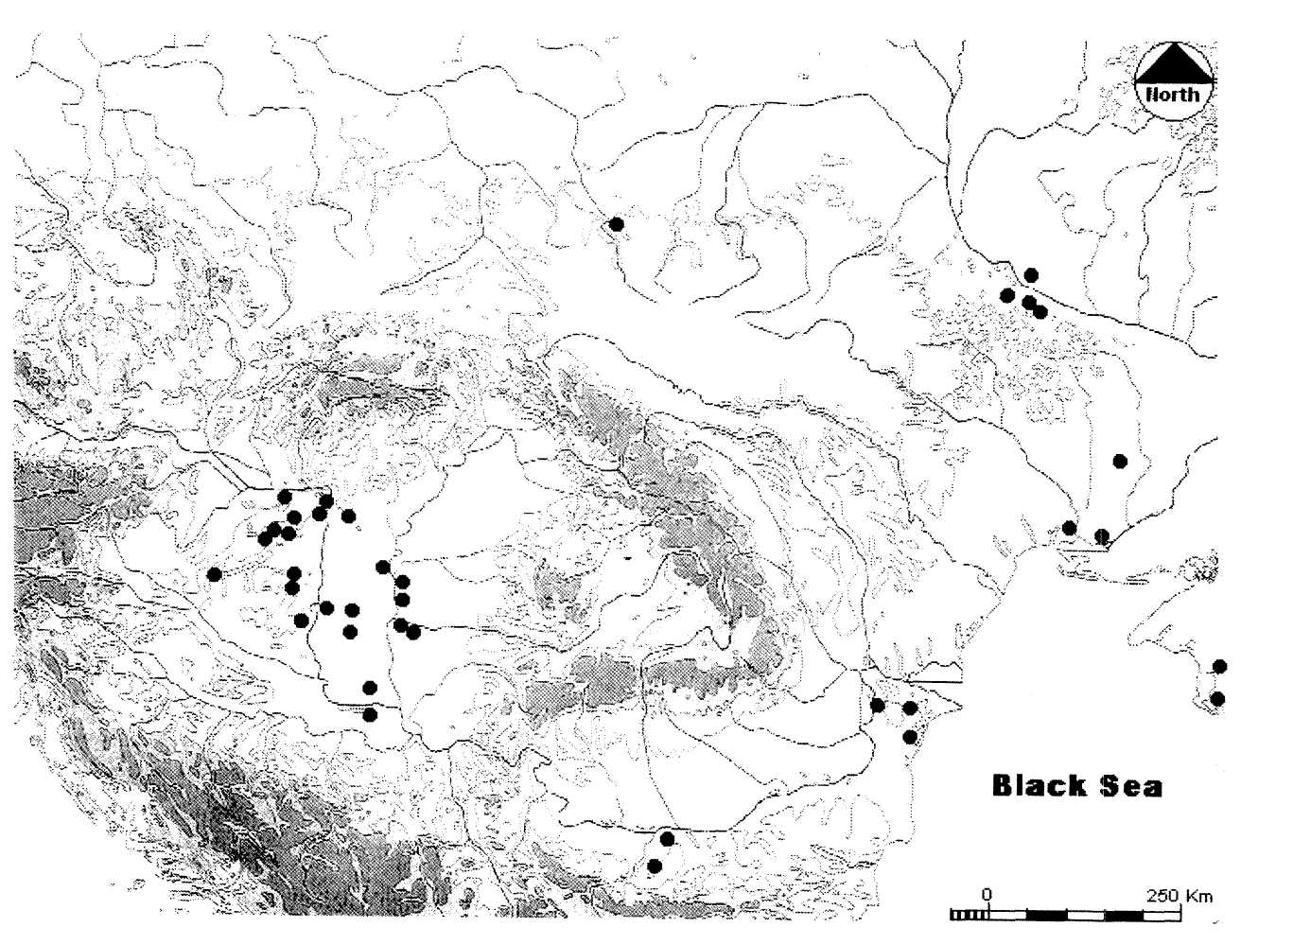
The making of the Slavs
belt straps
(Figures 20-3). A. A. Spicyn called them "Antian antiquities,"because he believed their distribution matched Procopius and Jordanes' description of the Antes. His idea had a remarkable influence on the development of Soviet archaeology, particularly after World War II. Many embraced G. Ε Korzukhina s very influential suggestion that both the distribution and the composition of hoards of silver and bronze from the forest-steppe belt were different from those of rich burials of the steppe area. No hoards were found in the steppe area and none included either weapons or horse gear. By contrast, no burial produced such artifacts as bow fibulae or earrings with star-shaped pendant. This contrast has been interpreted as an indication of two different ethnic groups: the nomads (burials) and the Slavic Antes (the hoards). The distribution in the area north of the Black Sea of sixth- and seventh-century burials and hoards of silver and bronze, respectively, are indeed in sharp contrast (Figure 24).⁴⁸
A cluster analysis of eighteen hoards of silver and bronze and five burials by means of chi-square distance, which accounts for differences in
^{4b} Spicyn 1928; Korzukhina 1955:69 and 71-2. Spicyn attributed to the Antes not only hoards, but also burials with bow fibulae. For an example of burial with bow fibulae in Left Bank Ukraine, see Aksenov and Babenko 1998:113. By contrast, M. I. Artamonov (1969) attributed both hoards and burials to the (Cutngur) nomads. For a critique of Artamonov s theories, see Tret'iakov 1971.
212
Barbarians on the frontier
total quantity of types in the assemblage, gives, however, a picture radically different from that suggested by Korzukhina (Figure 25).⁴⁹ Rich burials belong to the same cluster as hoards of silver and bronze, such as Kharyvki and Zemiansky Vrbovok. With a correspondence analysis, a technique recently introduced to archaeology, the relationships between ihoards, between artifact-categories, and between artifact-categories and hoards may be all analyzed together and represented in the same scatter-gram or series of scattergrams produced by the plotting of pairs of orthogonal axes. What catches the eye at first on the scattergram showing the relationships between assemblages is the clear segregation between hoards and burials (Figure 26). An examination of the second scattergram, which represents relationships between artifact-categories found in both hoards and burials, indicates this split to be a chronological one (Figure 27). Burials are characterized by the presence of swords with typical cross-bars, similar to those depicted on seventh- and eighth-century Soghdian silverware or in fresco scenes at Afrasiab and Pendzhikent. Earrings with bead-pendants, such as found at Malo Pereshchepino, Glodosy, and Zachepilovki, are typically associated with Middle Avar assemblages. A specimen of this category was found at Ozora-Totipuszta in association with a solidus minted for Emperor Constantine IV⁵⁰
By contrast, hoards are characterized by the presence of repousse bronze pendants, an artifact-category frequently encountered in Early Avar assemblages, but not later. Such pendants were only found with female burials. They might have belonged to corolla-type head-dresses
⁴⁹ Iakhniki: Braichevskii 19523:45—6. Khacki: Bobrmskii 1901:147—8 and pi. xiv. Kharyvki: Berezovec 1952. Koloskovo: Liapushkin 1961:186—7 and 185 fig. 87. Kozievka: Rybakov 1953:66—7. Krylos: Kropotkin 1970 and 1971. Malii Rzhavec: Rybakov 1953:74-6 and 75 fig. 16. Martynovka: Prikhodniuk et al. 1991; Pekarskaja and Kidd 1994. Nova Odessa: Rybakov 1953:67 and 69 fig. 13. Pastyrs'ke: Braichevskii 1952b. Poltava: Braichevskii 19533:46—7. Sudzha: Rybakov 1949. Veliki Kuchurov (Kuczurmare): Noll 1974; Gschwantler 1993. Velikie Budki: Romanova 1983:311; Goriunova 1987:85—7. Vyl'khovchik: Prikhodniuk 1980:129 and 99 fig. 61. Zalesie: Ugrin 1987. Zemiansky Vrbovok: Svoboda 1953. I left aside two hoards, which included only one or two artifact-categories: Grigoryvka, with only five earrings with star-shaped pendant; and Halic, with a necklace and two earrings with star-shaped pendant. See Prikhodniuk 1980:131; Garam 1980:172 and fig. 7. Not considered was the hoard from Tepe, for which I have been unable to find complete information. See, however, Thomas 1988:143. My analysis also excludes hoards of Sassanian silver, such as Khoniakovo, Pavlovka, and Sloboda Limarovka, for which see Bienkowski 1929 and Balint 1989:106 and 108—9. Despite lack of irrefutable evidence, I assumed that the finds from Martynovka and Kharyvki were hoards, not burials. See Kidd and Pekarskaya
1995·
^{э0} Swords with cross-bars: Ambroz 1986:63; L'vova and Semcnov 1985:83. For earrings with bead-pendant, see Garam 1992:150. The correspondence analysis belongs to a group of data reduction methods, which became popular in the archaeological literature in the late 1980s. The method was first developed in the 1960s in France by j. P. Benzecn and his team of the laboratory for the Mathematical Statistics at the University of Paris VI. The first to adopt the correspondence analysis were Scandinavian archaeologists. See Bolviken et al. 1982. Its adoption by American and British archaeologists came comparatively later. For the algebra, see Shennan 1990:283—6; Ringrose 1992. For various statistical methods and their use in archaeology, see also Djindjian 1990.
213

The making of the Slavs
Barbarians on the frontier

Figure 20 An early seventh-century hoard of silver and
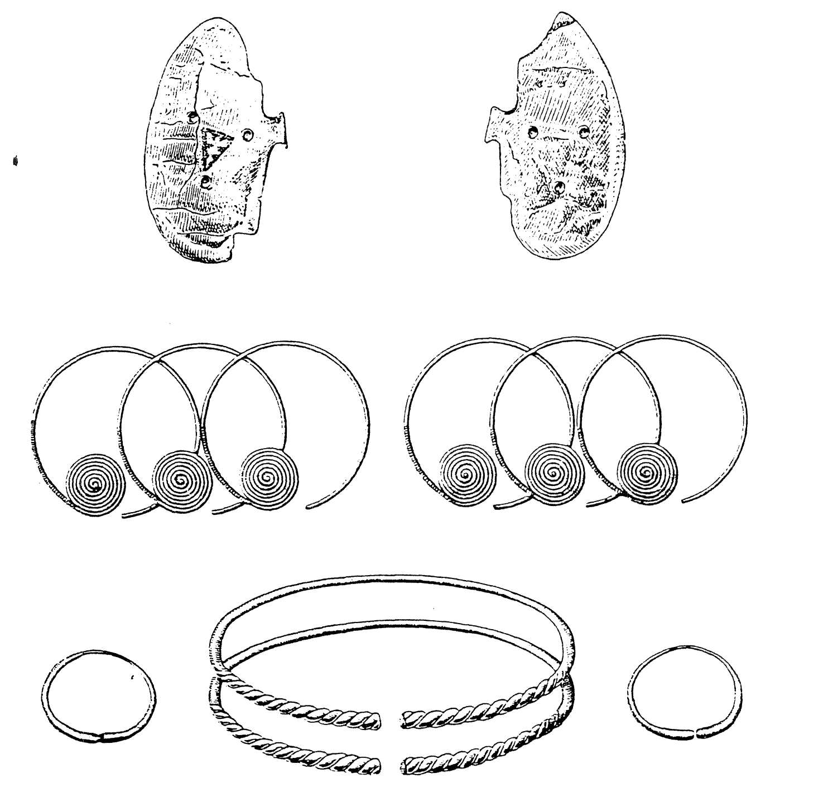
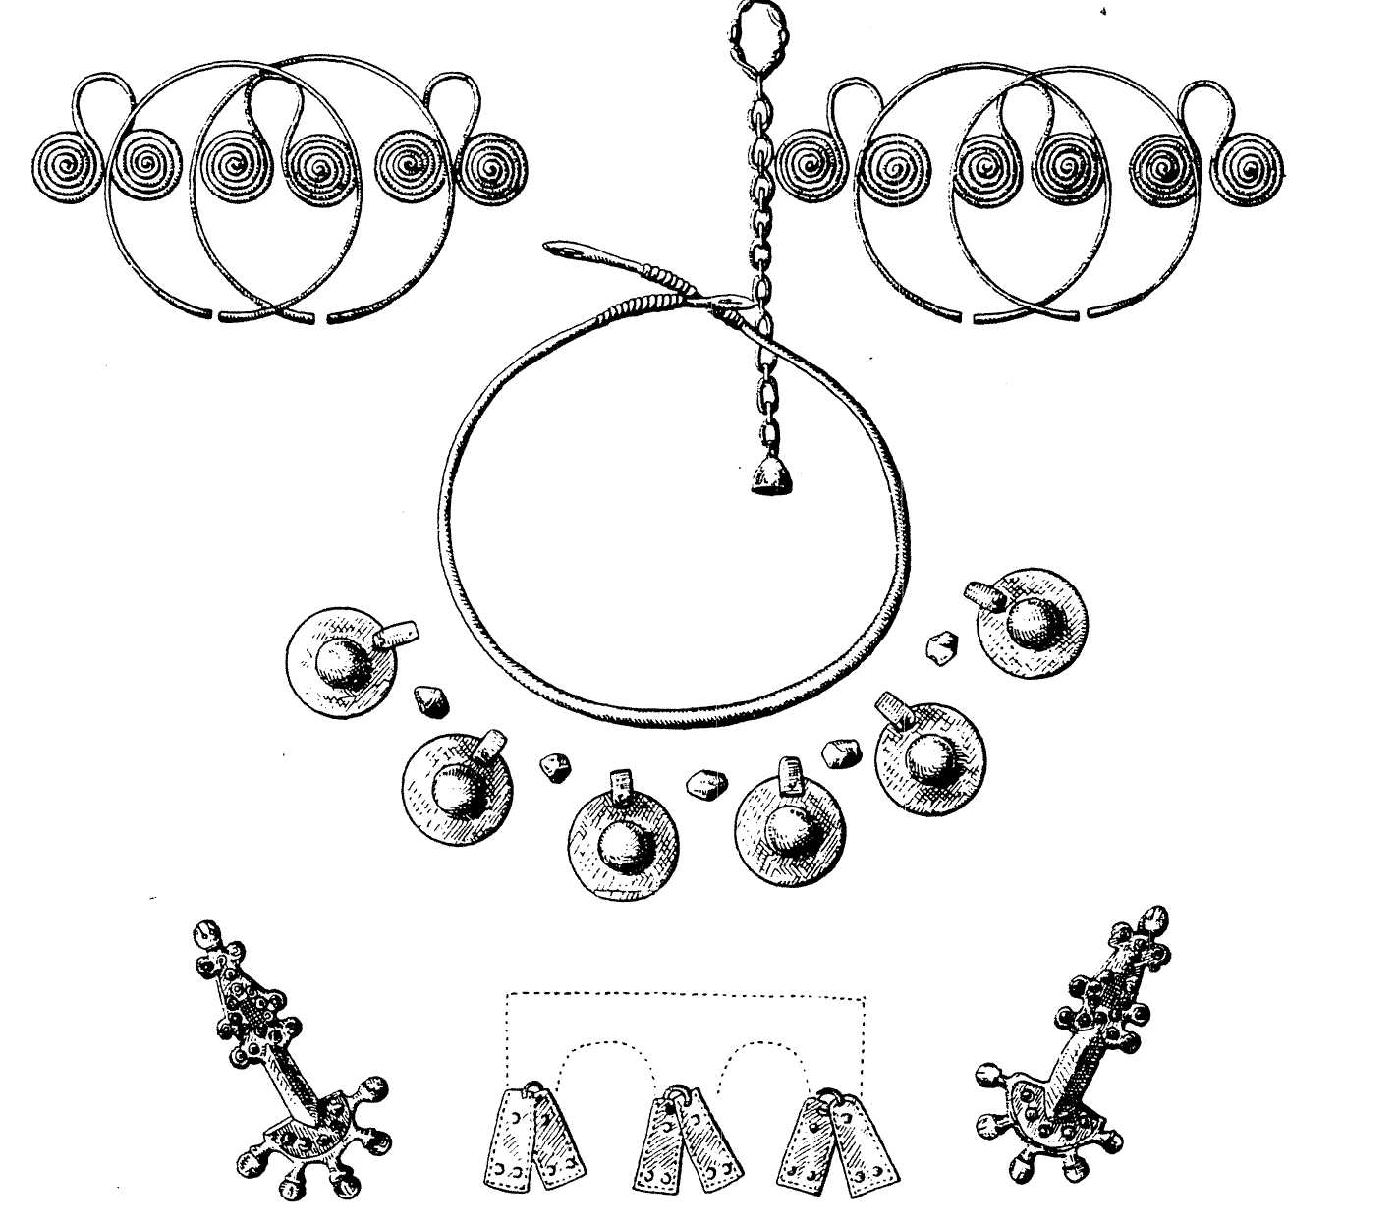
bronze from Sudzha
Source: Rybakov 1953: 64 fig. 11.
or head-bands or might have trimmed veils or lappets hanging from the head-dress. Hoards produced other artifact-categories typically associated with Early Avar assemblages, such as "Martynovka mounts" and "Slavic" bow fibulae. The latter will be discussed in detail in the following chapter. Brooches with bent stems, such as those found at Koloskovo, Nova Odessa, Gaponovo, or Kozievka, have good parallels in seventh-century funerary assemblages in Albania.⁵¹
^{M} Repousse bronze pendants: Szatmari 1980:100-1; Com§a 1984:70; Kiss 1996:201; Fiedler 1996:206-8. The closest paraUel for the silver bow brooch with peacocks from Martynovka is that found in an Early Avar female burial at Kolked (Kiss 1996:201). For fibulae in seventh-century assemblages in Albania (the so-called "Koman culture"), see Goriunov and Kazanskii 1978:26; Vinski 1971:388; Uenze 1992:153-4.
Figure 21 An early seventh-century hoard of silver and bronze from Malii
Rzhavec
Source: Rybakov 1953: 75 fig. 16.
Burials such as Glodosy, Voznesenka, Kelegeia, and Malo Pereshchepino also produced Sassanian silverware. Hoards often display sets of Byzantine stamped silverware manufactured as largitio objects for imperial distribution. Four control stamps on the base of the Martynovka cup are from the reign of Justin II, possibly from 577, when Theodore Petrus was the comes sacrarum largitionum. The closest analogy for the large goblet is the chalice found at Kaper Koraon, stamped in 605—10. Five stamps on the base of the large silver bucket (situla) from Veliki Kuchurov are from 613—29/30. Like most other groups of silver plate in "barbarian"

214
215

The making of the Slaps
Barbarians on the frontier

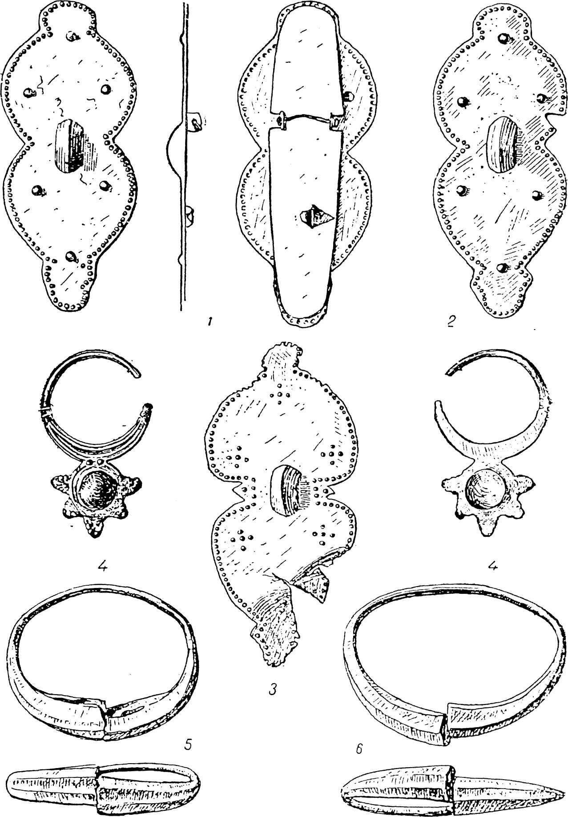
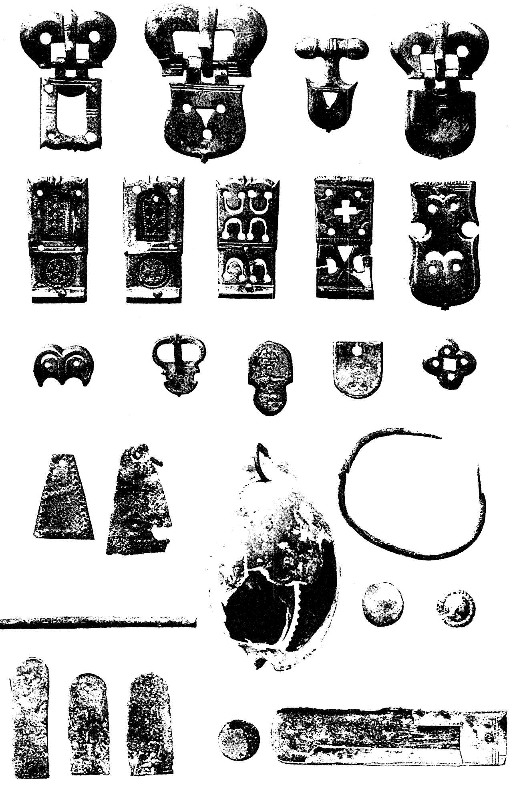
Figure 23 A seventh-century hoard of silver from Pastyrs'ke
Source: Braichcvs'kii lys^b: pi. 1.

Figure 22 An early seventh-century hoard of silver and bronze from Khacki
Source: Bobrinskii 1901: p. xix 2l6
217

The making of the Slavs
Barbarians on the frontier

Figure 24 Distribution of sixth- to seventh-century burials and hoards in the
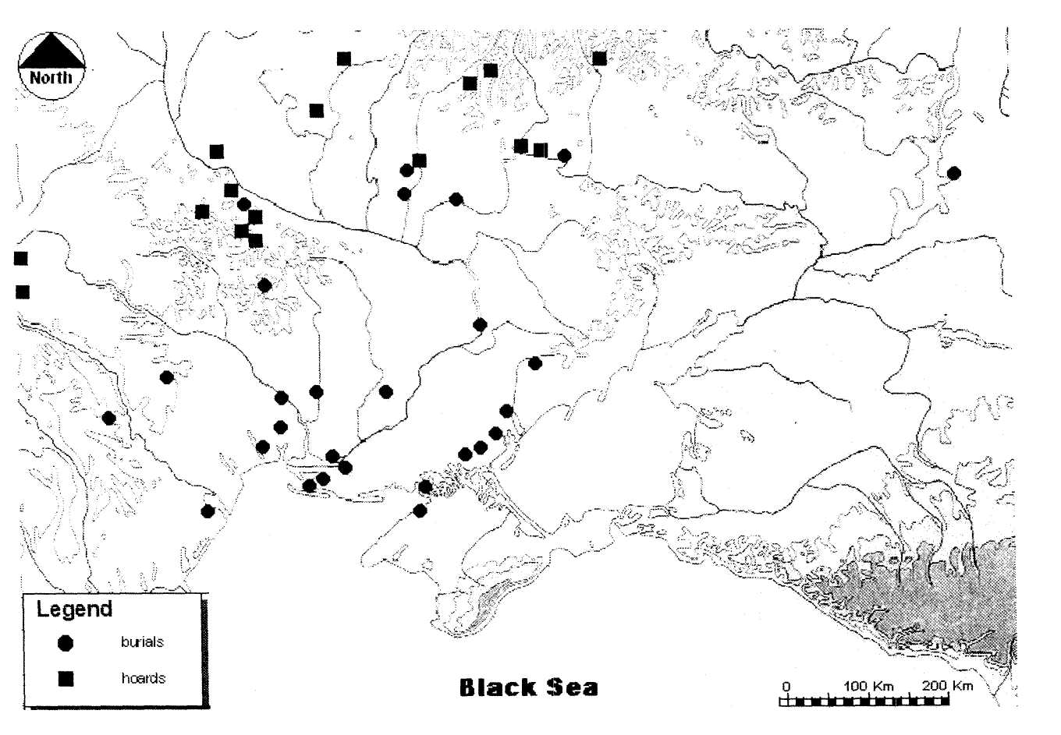
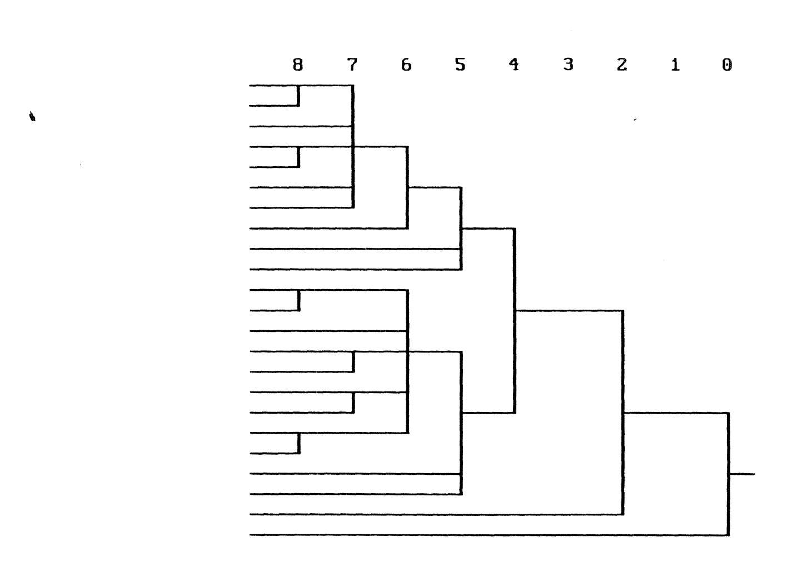
area north of the Black Sea
Europe, such as Sutton Hoo or finds from the Kama region, hoards display almost complete functional sets, with large plates, drinking vessels (goblets, cups, or bowls), and washing vessels (buckets, ewers, or basin). Since stamps not only guaranteed silver purity, but also authorized release of state silver, hoards with stamped Byzantine silverware are good indicators of the distribution of people important enough to own them. As diplomatic gifts or some other form of imperial largesse, Byzantine silver indicates that hoards with "Martynovka mounts" were not equivalent to "burials of commoners, "but truly symbolized the highest social status.⁵² However, not all hoards of silver and bronze were contemporary. A seriation of seventeen hoards reveals two groups, with the Martynovka hoard at an intermediary position (Figure 28). Applying a correspondence analysis to the same data, it becomes clear that we are actually dealing with three different groups (Figure 29). The second scattergram representing relationships between artifact-categories indicates three
⁵² Painter 1988:104; Mango 1992:214-15 and 1995:80-1. A goblet similar to that from Martynovka was found in a sixth-century fort near Haskovo (Bulgaria). See Gerasimova-Tomova 1987. For the Veliki Kuchurov simia, see Gschwantler 1993:177 and 178 fig. 6. There is no known analogy for the control stamp on the Krylos silver bowl (Kropotkin 1971:68). For the silver spoon from Martynovka, see Hauser 1992:56. Such artifacts signalize social status, not Christian beliefs, since they were certainly not baptismal spoons. See Simoni 1988:82; Hauser 1992:81. Contra: Petrikovits 1966:181; Danila 1986:91.
2l8
Similarity Coefficient: Jaccard Number of neighbours considered: 8
Mumber of shared near neighbours
Kozieuka
Koloskouo
Noua Odessa
Sudzha
Gaponouo
Uelikie Budki
Khack i
Iakhniki
Pastyrs"¹ ke
Hartynouka
Poltaua
Krylos
Kharyuki
Zemiansky Urbouok
Zalesie
Maiо Pereshchepino
Glodosy
Zachepilouki
Iasinouo
Mali! Rzhauec
Dymouka
Uyl'khouchik
Ue1i к i Kuchuroи
D
Figure 25 Cluster analysis of eighteen hoards of silver and bronze and five burials found in the area north of the Black Sea, in relation to the artifact-categories found in them
different chronological phases (Figure 30). Veliki e Budki, Kozievka, Koloskovo, Nova Odessa, Gaponovo, Sudzha, Khacki, Iakhniki, and Malii Rzhavec are all earlier than Martynovka, Pastyrs'ke, Poltava, and Kharyvki, which, in turn, are earlier than Krylos, Zalesie, Veliki Kuchurov, and Zemiansky Vrbovok. Earlier hoards are characterized by repousse bronze pendants, "Slavic" bow fibulae, "Martynovka mounts," lead mounts, and brooches with bent stems, while later hoards include earrings with bead or star-shaped pendants. The association of earrings with star-shaped pendants with miliaresia of Cons tans II in the Zemiansky Vrbovok hoard and with hexagrams of Constantine IV in the almost contemporary coin hoard of Priseaca, shows that the third phase represented on the first scattergram coincides in time with rich burials, such as Malo Pereschepino or Zachepilovki.⁵³
^{э3} Earrings associated with coins of Constans II and Constantino IV: Svoboda 1953:33—108; Mitrea 1975. Earrings with star-shaped pendants also appear in late seventh-century funerary assemblages in Albania. See Anamali 1993Ы443.
219

The making of the Slavs
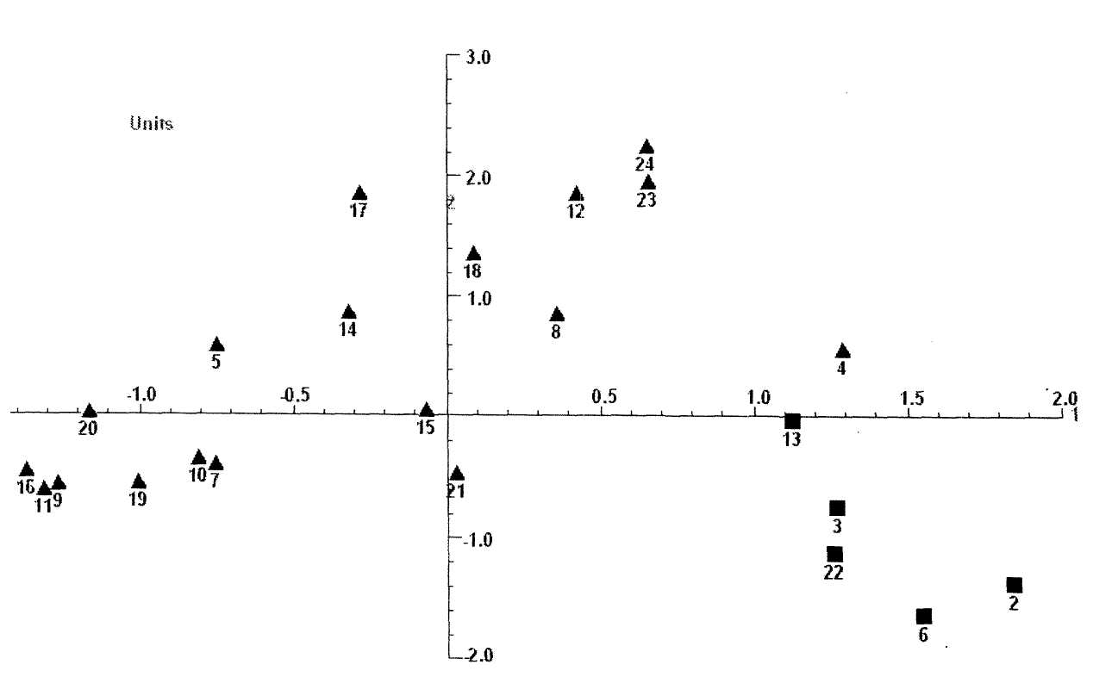
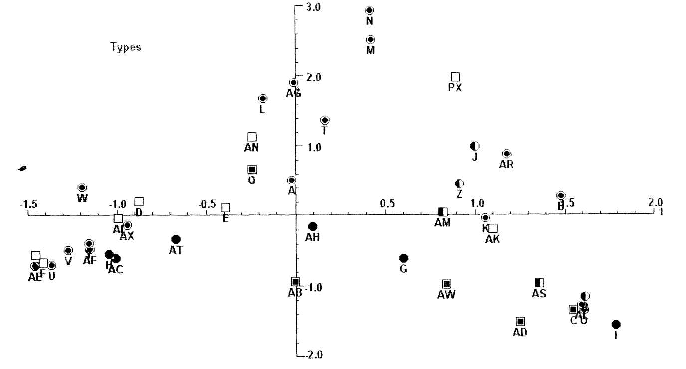
-1.5
ι
Barbarians on the frontier

Figure 26 Correspondence analysis of eighteen hoards of silver and bronze and five burials found in the area north of the Black Sea
2 - Dymovka; 3 - Glodosy; 4 - Veliki Kuchurov; 5 - Iakhniki; 6 - Iasinovo; 7 - Khacki; 8 -Kharyvki; 9 - Koloskovo; 10 - Gaponovo; 11 - Kozievka; 12 - Krylos; 13 - Malo Pereshchepino;
14 - Malii Rzhavec; 15 - Martynovka; 16 - Nova Odessa; 17 - Pastyrs'ke; 18 - Poltava; 19 -
Sudzha; 20 - Velikie Budki; 21 - Vyl'khovchik; 22 - Zachepilovki; 23 - Zalesie; 24 - Zemiansky
Vrbovok. Triangles represent hoards, rectangles represent burials
That Martynovka should be placed somewhere between the earliest and the latest hoards is suggested by the chronology of the nine anthropomorphic and zoomorphic mounts, traditionally said to have been used for the decoration of the saddle. Such mounts were found in late sixth-and early seventh-century burials at Pregradnaia and Kugul (North Caucasus), in association with "Martynovka mounts." Similar specimens come from three early seventh-century burials in the Castel Trosino cemetery in Italy. Moreover, zoomorphic mounts were also found in the Malo Pereshchepino assemblage, dated to the second half of the seventh century, and in a collection of mounts from Thessaly, also from the seventh century⁵⁴
The interpretation of this pattern is most difficult, because of the lack of contextual information. It is clear, however, that the meaning behind hoards of silver and/or bronze did not remain constant. That the same
³⁴ Saddle mounts: Laszlo 1955:276-84; Ambroz 1989:78-80; Swietoshwski 1993:284; Kidd and Pekarskaya 1995:352. See also Vallet 1995-335; Werner 1953 and 1984^29; Kidd 1992. For a saddle mount from Sardis wrongly interpreted as Tierfibel, see Waldbaum 1983:117 and pi. 43/688. For finds from the Crkvine cemetery near Salona, see Vinski 1967:17 and 1970:701-2 and 703 fig. 1. A bronze model for the production of saddle mounts was found in the Biskupija hoard (Croatia). See Korosec 1958b.
Figure 27 Correspondence analysis of artifact-categories from eighteen hoards of silver and bronze and five burials found in the area north of the Black Sea
A - armlet with enlarged ends; AB - spear; AC - "Martynovka mounts"; AD - bridle bit; AE -
brooch with bent stem; AF - "Slavic" bow brooch; AG - shield-shaped bow brooch; AH -
pseudo-buckle; AI - chain; AK - cup; AL - finger-ring; AM - horse-harness mounts; AN - silver
ingot; АО - neckring with embossed decoration; AP - collar; AR - necklace; AS - stirrup; AT -
silver sheet strapend; AV — cast strapend with scrollwork decoration; AW - sword; AX - earring
with spiral-end; AZ — seashells; В - hinge bracelet; С - arrow-head; D - amber beads; Ε - glass
beads; F —jingle bells; G — cast belt mounts; Η — buckle (Sucidava class); I - rectangular buckle; J
— chalice; К — silver or gold coin; L — silver wire earring; Μ - earring with star-shaped pendant;
N — earring with globe-pendant; О — earring with bead pendant; Ρ — silver goblet; Q - helmet
cheek-piece; R — jug; S — lead mounts; Τ — neckring with widened ends; U — hat-shaped
pendant; V — repousse bronze pendant; W — circular bronze pendant; Υ - spectacle-shaped
pendant; Ζ - silver plate
type of hoard may be found in areas hundreds of kilometers apart raises important questions about demographic mobility, spread of fashions, and, ultimately, the significance of hoards. It is also interesting to note that later hoards were found north of the Carpathian basin, while earlier ones cluster in the Middle Dnieper area. Spicyn's interpretation cannot be accepted, for the simple reason that no hoard can be dated earlier than с. боо. At that time, according to the literary sources analyzed in Chapter 3, the Antes had already ceased to exist politically. If not ethnicity, then what? There is nothing in these hoards that is obviously utilitarian, and in most cases we can use the evidence of contemporary funerary assemblages to infer that some, if not all, artifact-categories were female dress-accessories. Later hoards present some connections with contemporary, very rich, burials, which seem to have been male graves, for they produced weapons and horse gear. The lack of representation of high-status

220
221

Dymouka
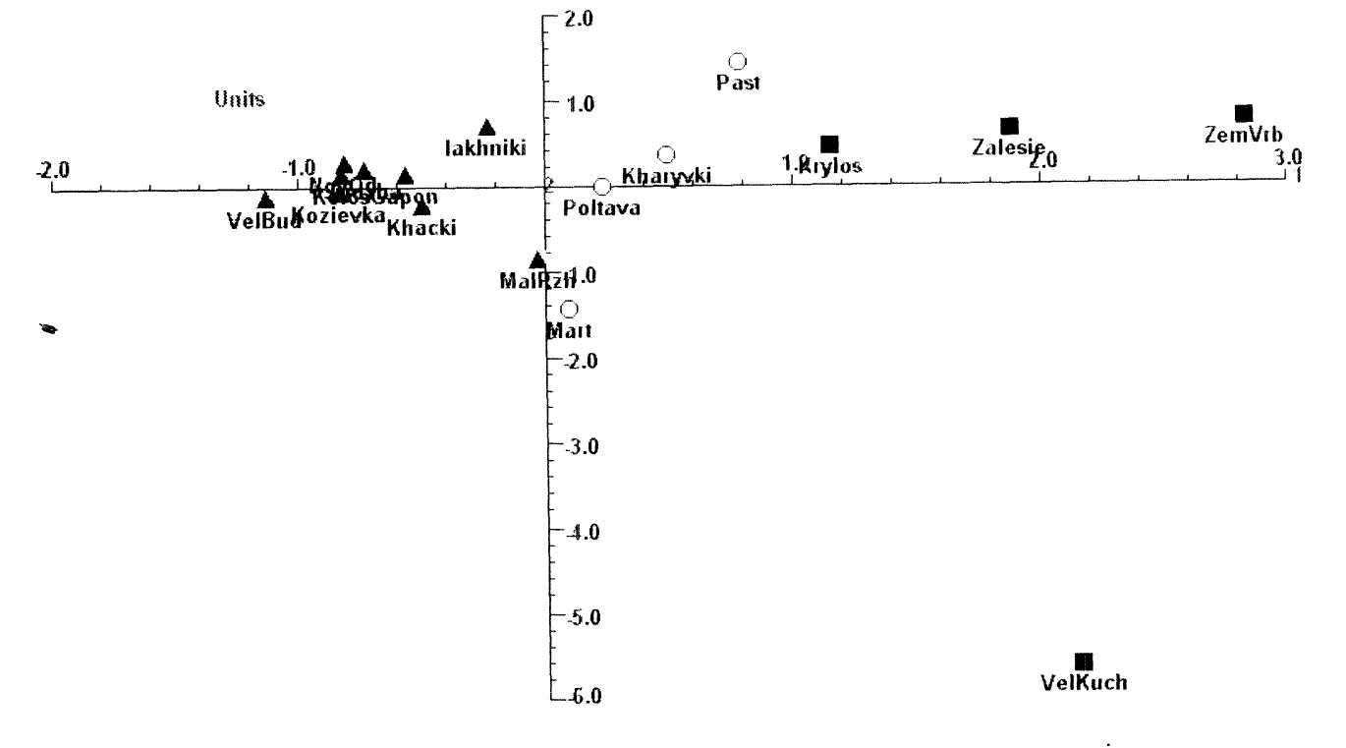
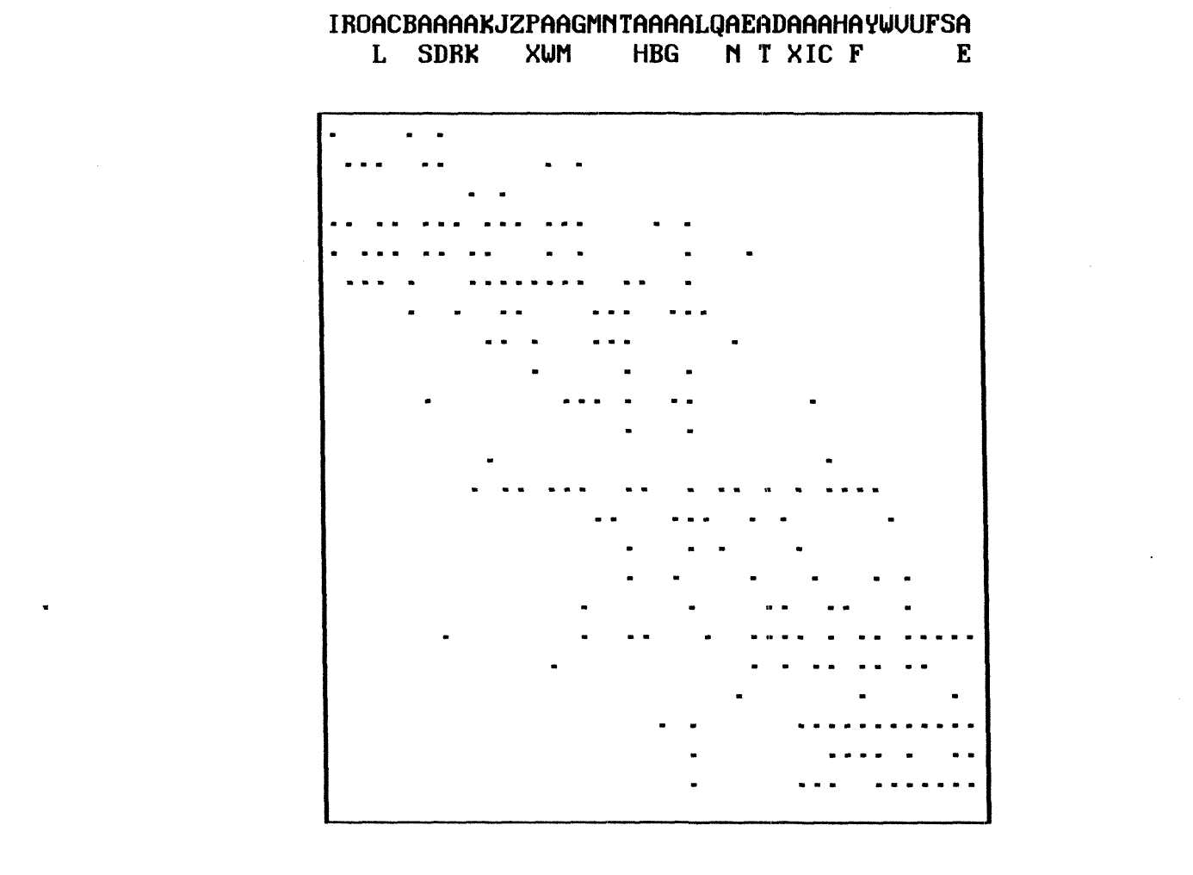
Barbarians on the frontier
The making of the Slavs
Input Correlation: 0.2624 Output Correlation: 8.8158 /. Uariance: 17.1961
Iasinouo
Ue1i к i Kuchuroυ
Glodosy
Zachepilouki
Maiо Pereshchepino
Zalesie
Zemiansky Urbouok
Krylos
Kharyuki
Poltaua
UyTkhouchik
Martynouka
Pastyrs"¹ ke
Malii Rzhauec
Iakhniki
Knack i
Gaponouo
Sudzha
Uelikie Budki
Koloskouo
Kozieuka
Moua Odessa
CO.O3D
Figure 28 Seriation of seventeen hoards found in the area north of the Black
Sea
For abbreviations, see Figure 27
women in burials at this time suggests that, unlike the situation in the Carpathian basin, women were not vehicles for displaying the status of their husbands. What, then, is the significance of hoards, at least of earlier ones, in which female dress accessories played such an important role?
Hoards of silver were certainly not collections of raw silver or "hack-silver." There are no broken objects and no metalworking residues. The deliberate choice of items, usually found in pairs or more than two specimens, and the value attached to Byzantine silver seem to indicate conspicuous consumption of a type known to anthropologists as potlatch. In times of social and political stress, such consumption may have served a number of functions, such as celebrating rites of passage or succession to office. It certainly was the privilege of an aristocratic group and probably involved the provision of food and of certain other valuables that did not
Figure 29 Correspondence analysis of seventeen hoards found in the area
north of the Black Sea
Legend: phase I - triangle; phase II - oval; phase III - rectangle
survive in the archaeological record.⁵⁵ Lavish offerings such as hoards of silver, involving the deposition in locations from which items could not be recovered, might have provided a way of fixing status and of claiming the prestige associated with it. Initially, female dress accessories were as common currency for this type of social behavior as women were for displaying the status of their husbands. Contemporary male burials (with or without horse skeletons) are comparatively much poorer than hoards of silver. In the late 600s, however, men assumed this role for themselves and extremely rich burials with a vast array of gold (rather than silver) grave-goods dwarfed displays of wealth through hoarded silver.
CONCLUSION
There are at least three important conclusions to be drawn from this sweeping survey of the archaeology of the Carpathian basin and the
⁵⁵ Artifacts in the Khacki hoard were wrapped in silk (Bobrinskii 1901:147)- It is tempting to associate the burial of earlier hoards, for which a date may be tentatively assigned to с 630, with the beginning of the civil war within the western division of the Gok Turk Empire and the subsequent rise of the Bulgar qaganate. However, both were located in Left Bank Ukraine and the steppe north of the Caucasus mountains, at a considerable distance from the main concentration of hoards in the Middle Dnieper area. Moreover, the hoarding phenomenon clearly continued through the second half of the seventh century, as hoards were buried in Volhynia and Slovakia.

222
7 ->
У 1 __._!
3

Figure 30 Correspondence analysis of seventeen hoards found in the area north of the Black Sea and their respective artifact-categories
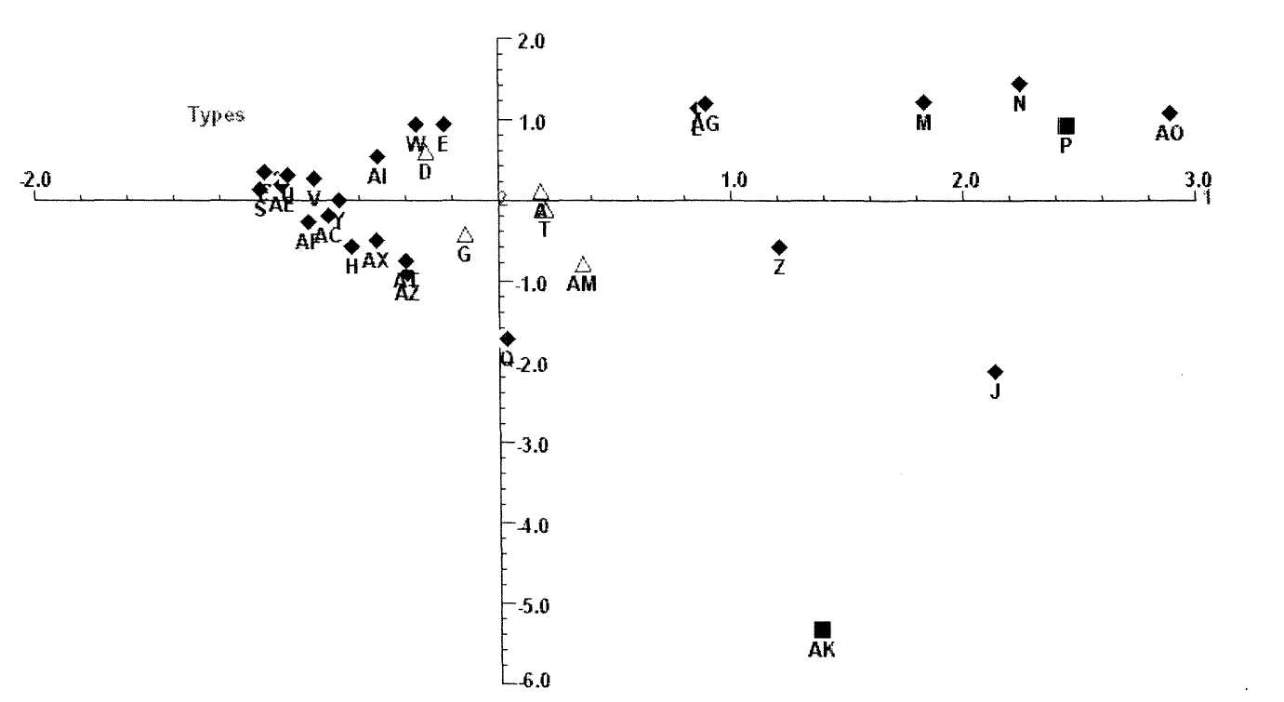
The making of the Slavs
For abbreviations, see Figure 27
steppe north of the Black Sea. First, in all cases discussed in this chapter, material culture may be and was indeed used for the construction of social identities. Despite interaction across the buffer zone between the Danube and the Tisza rivers, clear material culture distinctions were maintained in a wide range of artifacts. The nature and function of these distinctions is very similar to those identified by Ian Hodder in the Baringo district of Kenya. As in East Africa, material culture contrasts were maintained in order to justify between-group competition and negative reciprocity. Displays of emblemic styles were particularly important at the time of the Lombard—Gepid wars in the mid-5oos. More often than not, such styles were associated with the status of aristocratic women, wives, daughters, or mothers of "kings." This may be a result of the special emphasis laid on public representation of group identity, but may also be an indication of the intricate relationship between ethnic and gender identity.
The examination of hoards of silver and bronze also shows that women were symbolic vehicles for the construction of social identities. In this case, however, it is more difficult to decide precisely what kind of identity was constructed through displays of female dress accessories. Unlike the Carpathian basin, the specific way in which identity was expressed was not funerary assemblage but lavish offering of silver and bronze artifacts, which may have represented a particular form of potlatch.
224
Barbarians on the frontier
However, just as with displays of wealth in rich female graves, deposition of hoards may have served as "tournaments of value."⁵⁶ Like funerals, hoards were used for social display mainly during periods of instability when the status of the individual needed underlining. An important route to social advancement was most likely access to foreign goods, such as Byzantine silver plate. Within the Empire, the social status which silver plate conferred or reflected was often seen in terms of wealth and power. The donation of family silver to be recycled into liturgical silver or given to the poor became a literary topos. In "barbarian" contexts, transactions in which silver plate was symbolically displayed were certainly different. To claim that acquisition, imitation, and use of Roman silver plate reflects the degree to which barbarians were Romanized⁵⁷ is simply to ignore that the symbolic system changed with the changing contexts in which imported objects were employed. There can be no doubt, however, that Byzantine silver plate was viewed as "exotic" and "precious" for an image of power, for stamped objects were only produced for imperial distribution. The ability to acquire fine largitio objects carried a considerable premium. The same is true for objects of possibly Sassanian origin, such as the Zemiansky Vrbovok bowl. On the other hand, that hoards of silver conveyed an image of power much stronger than grave-goods may be deduced from the fact that some contain several sets of ornaments, which suggests that such collections were the property of more than one person. In other words, hoards of silver and bronze may have permitted a more "extravagant" display of metalwork than the provision of grave-goods.
Finally, the survey of the archaeological evidence from the Carpathian basin and the steppe north of the Black Sea strongly suggests that in order for material culture to participate in the construction of social identities, artifacts need to be given meaning in social context. Swords with P-shaped sheath attachments or stirrups with elongated attachment loops were not "Avar" because of being of Central Asian origin, but because of being used in a specific way in specific transactions (such as display of grave-goods) in the new social milieu in which Avar warriors found themselves after с 570. Similarly, there are no specific "Lombard" or "Gepid" brooches, for many fibulae found in female burials on both sides of the "no man's land" either were "imported" from distant locations or imitated such exotic imports. There is, therefore, no "phenotypic" expression of a preformed ethnic identity, though identity is constructed by manipulating certain artifact-categories. The value of each of these artifact-categories depended less on questions of supply and origin than on the social strategies employed by those who used them. On the other
^{л6} The phrase is that of Bradley 1990:139.
Mango 1995:81
225

The making of the Slavs
hand, objects that are the prerogative of an elite may be imitated by lower-ranking groups. "Citations" from the material culture discourse which can be identified in rich burials or hoards may be found in completely different contexts, such as settlements. As I will argue in the last chapter, just as in the case of "Lombard" and "Gepid" identities, Slavic ethnicity may have been communicated through displays of objects whose use was restricted to local elites. In such cases, artifacts similar to those found in Ukrainian hoards are not mere analogies. They have become metaphors.
Chapter 6
ELITES AND GROUP IDENTITY NORTH OF THE DANUBE FRONTIER: THE ARCHAEOLOGICAL EVIDENCE

If the social label of various ethnic identities in barbariatm, both East and West, can be pinned down to material culture, matters are more difficult when it comes to the symbols by which Slavic ethnicity may have been expressed. Archaeologists, from Ivan Borkovsky to Volodymyr Baran, have focused on specific artifacts, particularly pottery, in an effort to reconstruct a "Slavic culture" by which Slavic ethnicity may be then identified at any place and time. In the first chapter, I discussed the problems and difficulties involved in this approach. I will attempt now to show that, just as with contemporary Gepids, Lombards, or Bulgars, no particular item was ethnically specific to the Slavs. Material culture, nevertheless, played a crucial role in building ethnic boundaries. The social mechanisms by which artifacts were manipulated and used for statements of group identity may well have been at work in "Sclavinia," just as in "Lombardia" or "Gepidia."
A survey of Slavic archaeology is beyond the scope of this work. By default, a discussion of Slavic ethnicity will entail only certain aspects of the Slavic culture, if such a thing ever existed. Instead of a standard description of material culture items, which is the current practice with monographs on the Slavic culture,¹ I will focus on only three issues, which I believe are relevant for the formation of a Slavic ethnic.
First, I will examine problems of chronology, which are fundamental for the understanding of changes in material culture and their historical background. Much too often, archaeologists have imposed the rigid framework of written sources on the archaeological record, without acknowledging chronological discrepancies. Second, I will focus on a specific group of bow fibulae, which the German archaeologist Joachim Werner first called "Slavic" brooches.² More than any other artifact-category (with the exception, perhaps, of pottery), this group of fibulae
¹ E.g., Parczewski 1993. ² Werner 1950.

226
7 Ί
7

